**Part-A**

**Assignments based on the Hadoop**

Assignment: 1

**AIM:** Study of Hadoop Installation.

PROBLEM STATEMENT / DEFINITION:

1. Study of Hadoop Installation on Single Node.
2. Study of Hadoop Installation on Multiple Nodes.

OBJECTIVE:

1. To understand Installation & Configuration of Hadoop on single Node.
2. To understand Installation & Configuration of Hadoop on multiple nodes.

THEORY:

* 1. **THE Single Node:**

**------------------------------------------------------------------------------------------------------------------**

**-**

**Introduction**

Apache Hadoop is an open-source software framework written in Java for distributed storage and distributed processing of very large data sets on computer clusters built from commodity hardware. All the modules in Hadoop are designed with a fundamental assumption that hardware failures are common and should be automatically handled by the framework. The core of Apache Hadoop consists of a storage part, known as Hadoop Distributed File System (HDFS), and a processing part called MapReduce. Hadoop splits files into large blocks and distributes them across nodes in a cluster. To process data, Hadoop transfers packaged code for nodes to process in parallel based on the data that needs to be processed. This approach takes advantage of data locality— nodes manipulating the data they have access to— to allow the dataset to be processed faster and more efficiently than it would be in a more conventional supercomputer architecture that relies on a parallel file system where computation and data are distributed via high-speed networking. The base Apache Hadoop framework is composed of the following modules:

* **Hadoop Common** – contains libraries and utilities needed by other Hadoop modules;
* **Hadoop Distributed File System (HDFS)** – a distributed file-system that stores data on commodity machines, providing very high aggregate bandwidth across the cluster;
* **Hadoop YARN** – a resource-management platform responsible for managing computing resources in clusters and using them for scheduling of users' applications; and
* **Hadoop MapReduce** – an implementation of the MapReduce programming model for large scale data processing.
  1. **Apache Hadoop Installation**

**Steps:**

|  |
| --- |
| **Open Terminal**  **# Update the source list**  aaditya@laptop:~$ **sudo apt-get update** |
| # The OpenJDK project is the default version of Java  **Install JDK**  aaditya@laptop:~$ **sudo apt-get install default-jdk`**  aaditya@laptop:~$ **java -version**  java version "1.7.0_95" |
| **Adding a dedicated Hadoop user** aaditya@laptop:~$ **sudo addgroup hadoop** Adding group `hadoop' (GID 1002) ...  Done.  aaditya@laptop:~$ **sudo adduser --ingroup hadoop hduser (Press Enter)**  Is the information correct? [Y/n] Y  **Enter new password for new hduser**  aaditya@laptop:~$ **sudo adduser hduser sudo**  Adding user `hduser' to group `sudo' ... Adding user hduser to group sudo Done.  **Logout from current user and log in to hduser** |
| **Installing SSH**  aaditya@laptop:~$**su hduser**  hduser@laptop:~$ **sudo apt-get install ssh** |
| **Create and Setup SSH Certificates**  hduser@laptop:~$**cd /home/hduser/**  hduser@laptop:~$ **ssh-keygen -t rsa -P ""**  Generating public/private rsa key pair.  Enter file in which to save the key (/home/hduser/.ssh/id_rsa): **(**press enter)**  Created directory '/home/hduser/.ssh'.  Your identification has been saved in /home/hduser/.ssh/id_rsa. Your public key has been saved in /home/hduser/.ssh/id_rsa.pub. The key fingerprint is: 50:6b:f3:fc:0f:32:bf:30:79:c2:41:71:26:cc:7d:e3 hduser@laptop The key's randomart image is:  +--[ RSA 2048] +  | .oo.o |  | . .o=. o |  | . + . o . |  | o = E |  | S + |  | . + |  | O + |  | O o |  | o.. |  + +  hduser@laptop:$ **cat /home/hduser/.ssh/id_rsa.pub >> /home/hduser/.ssh/authorized_keys** |

|  |
| --- |
| hduser@laptop:$ **ssh localhost**  hduser@laptop:$ **exit**  hduser@laptop:$ **cd /home/hduser** |
| **Download Hadoop**  hduser@laptop:~$  **wget** [**http://mirrors.sonic.net/apache/hadoop/common/hadoop-2.7.2/hadoop-2.7.2.tar.gz**](http://mirrors.sonic.net/apache/hadoop/common/hadoop-2.7.2/hadoop-2.7.2.tar.gz)  Or from <http://www.apache.org/dyn/closer.cgi/hadoop/common/hadoop-2.7.2/hadoop-2.7.2.tar.gz> hduser@laptop:~$ **tar xvzf hadoop-2.8.3.tar.gz**  hduser@laptop:~$ **cd hadoop-2.8.3**  hduser@laptop:~$ **sudo mkdir /usr/local/hadoop**  hduser@laptop:~/hadoop-2.7.2$ **sudo mv * /usr/local/hadoop**  hduser@laptop:~/hadoop-2.7.2$ **sudo chown -R hduser:hadoop /usr/local/hadoop**  hduser@laptop:~/hadoop-2.7.2$ **sudo apt-get install vim Check Java**  hduser@laptop:~$ **readlink -f /usr/bin/javac**  /usr/lib/jvm/java-8-openjdk-amd64/bin/javac *** for 64 bit  /usr/lib/jvm/java-8-openjdk-i386/bin/javac ***for 32 bit |
| **Set-up the Configuration Files**  hduser@laptop:~$ **vim ~/.bashrc**  **#HADOOP VARIABLES START ****Append this at end of file********* export JAVA_HOME=/usr/lib/jvm/java-8-openjdk-amd64**  **export HADOOP_INSTALL=/usr/local/hadoop export PATH=$PATH:$HADOOP_INSTALL/bin export PATH=$PATH:$HADOOP_INSTALL/sbin**  **export HADOOP_MAPRED_HOME=$HADOOP_INSTALL export HADOOP_COMMON_HOME=$HADOOP_INSTALL export HADOOP_HDFS_HOME=$HADOOP_INSTALL export YARN_HOME=$HADOOP_INSTALL**  **export HADOOP_COMMON_LIB_NATIVE_DIR=$HADOOP_INSTALL/lib/native export HADOOP_OPTS="-Djava.library.path=$HADOOP_INSTALL/lib" #HADOOP VARIABLES END**  Save the file and Exit (**esc:wq!** to save the file in vim) hduser@laptop:~$ **source ~/.bashrc** |
| hduser@laptop:~$ **vim /usr/local/hadoop/etc/hadoop/hadoop-env.sh**  (Change existing JAVA_HOME to **/usr/lib/jvm/java-7-openjdk-amd64 if machine is 64 Bit** or  **If machine is 32 bit change it to /usr/lib/jvm/java-7-openjdk-i386**) **export JAVA_HOME=/usr/lib/jvm/java-8-openjdk-amd64**  **Save and Exit** |
| hduser@laptop:~$ **vim /usr/local/hadoop/etc/hadoop/yarn-site.xml**  **Open the file and enter the following in between <configuration></configuration> tag and save :** |

|  |
| --- |
| **<property>**  **<name>yarn.nodemanager.aux-services</name>**  **<value>mapreduce_shuffle</value>**  **</property>** |
| Create Temporary Directory to store App-data hduser@laptop:~$ **sudo mkdir -p /app/hadoop/tmp**  hduser@laptop:~$ **sudo chown hduser:hadoop /app/hadoop/tmp**  hduser@laptop:~$ **vim /usr/local/hadoop/etc/hadoop/core-site.xml**  **Open the file and enter the following in between the <configuration></configuration> tag:**  **<property>**  **<name>hadoop.tmp.dir</name>**  **<value>/app/hadoop/tmp</value>**  **<description>A base for other temporary directories.</description>**  **</property>**  **<property>**  **<name>fs.default.name</name>**  **<value>hdfs://localhost:54310</value></property>** |
| hduser@laptop:~$ **cp /usr/local/hadoop/etc/hadoop/mapred-site.xml.template**  **/usr/local/hadoop/etc/hadoop/mapred-site.xml**  hduser@laptop:~$ **vim /usr/local/hadoop/etc/hadoop/mapred-site.xml**  **Add these properties in <configuration></configuration> tag:**  **<property>**  **<name>mapred.job.tracker</name>**  **<value>localhost:54311</value>**  **</property>**  **<property>**  **<name>mapreduce.framework.name</name>**  **<value>yarn</value>**  **</property>**  Save and Exit |
| hduser@laptop:~$ **sudo mkdir -p /usr/local/hadoop_store/hdfs/namenode** |

|  |
| --- |
| hduser@laptop:~$ **sudo mkdir -p /usr/local/hadoop_store/hdfs/datanode**  hduser@laptop:~$ **sudo chown -R hduser:hadoop /usr/local/hadoop_store**  hduser@laptop:~$ **vim /usr/local/hadoop/etc/hadoop/hdfs-site.xm**l  **Open the file and add the following properties between the <configuration></configuration> tag:**  **<property>**  **<name>dfs.replication</name><value>1</value>**  **</property>**  **<property>**  **<name>dfs.namenode.name.dir</name>**  **<value>file:/usr/local/hadoop_store/hdfs/namenode</value>**  **</property>**  **<property>**  **<name>dfs.datanode.data.dir</name>**  **<value>file:/usr/local/hadoop_store/hdfs/datanode</value>**  **</property>** |
| hduser@laptop:~$ **hadoop namenode -format Starting Hadoop**  hduser@laptop$: **/usr/local/hadoop/sbin/start-all.sh We can check if it's really up and running:**  hduser@laptop$: **jps**  9026 NodeManager  7348 NameNode  9766 SecondaryNameNode  8887 ResourceManager  7507 DataNode  **Hadoop UI visible in browser at localhost:50070**  **MR Job progress and history UI visible atlocalhost:8088 To Stop Hadoop**  hduser@laptop$: **/usr/local/hadoop/sbin/stop-all.sh**  **\*\*\*\*\*\*\*\*\*\*\*\*\*\*\*\*\*\*\*\*\*\*\*\*\*\*\*\*\*\*\*\*\*\*\*\*\*\*\*\*\*\*\*Done\*\*\*\*\*\*\*\*\*\*\*\*\*\*\*\*\*\*\*\*\*\*\*\*\*\*\*\*\*\*\*\*\*\*\*\*\*\*\*\*\*\*\*\*\*\*\*\*\*\*** |

**Conclusion:** In this way single node Hadoop was installed & configured on Ubuntu for BigData analytics.

**Reference:**<http://hadoop.apache.org/docs/r2.7.1/hadoop-project-dist/hadoop-> common/SingleCluster.html

* 1. **Cloudera Hadoop Installation**

Downloading and Installing the Cloudera VM Instructions (Windows & Ubuntu)

Learning Goals

In this activity, you will:

* + Download and Install VirtualBox.
  + Download and Install Cloudera Virtual Machine (VM) Image.
  + Launch the Cloudera VM.

Hardware Requirements: (A) Quad Core Processor (VT-x or AMD-V support recommended), 64- bit; (B) 8 GB RAM; (C) 20 GB disk free. How to find your hardware information: Open System by clicking the Start button, right-clicking Computer, and then clicking Properties. Most computers with 8 GB RAM purchased in the last 3 years will meet the minimum requirements.You will need a high speed internet connection because you will be downloading files up to 4 Gb in size.

Instructions

Please use the following instructions to download and install the Cloudera Quickstart VM with VirutalBox before proceeding to the Getting Started with the Cloudera VM Environment video. The screenshots are from a Mac but the instructions should be the same for Windows. Please see the discussion boards if you have any issues.

1. **Install VirtualBox.** Go to https://[www.virtualbox.org/wiki/Downloads](http://www.virtualbox.org/wiki/Downloads) to download and install VirtualBox for your computer. The course uses Virtualbox 5.1.X, so we recommend clicking VirtualBox 5.1 builds on that page and downloading the older package for ease of following instructions and screenshots. However, it shouldn't be too different if you choose to use or upgrade to VirtualBox 5.2.X.

**For Windows**, select the link "**VirtualBox 5.1.X for Windows hosts x86/amd64**" where 'X' is the latest version.

**For Ubuntu Select VirtualBox 5.2.44** *(released July 14 2020) Virtual box for* Linux Hosts: Ubuntu 32bit|64bit

Open Terminal -

$ sudo apt-get update

$ sudo apt-get install VirtualBox 5.2

$ sudo apt-get -f install

1. **Download the Cloudera VM.** Download the Cloudera VM fromhttps://downloads.cloudera.com/demo_vm/virtualbox/cloudera-quickstart-vm-5.4.2-0- virtualbox.zip. The VM is over 4GB, so will take some time to download.
2. **Unzip the Cloudera VM**:

Right-click cloudera-quickstart-vm-5.4.2-0-virtualbox.zip and select “Extract All…”

14

4. **Start VirtualBox**.

1. **Begin importing**. Import the VM by going to File -> Import Appliance

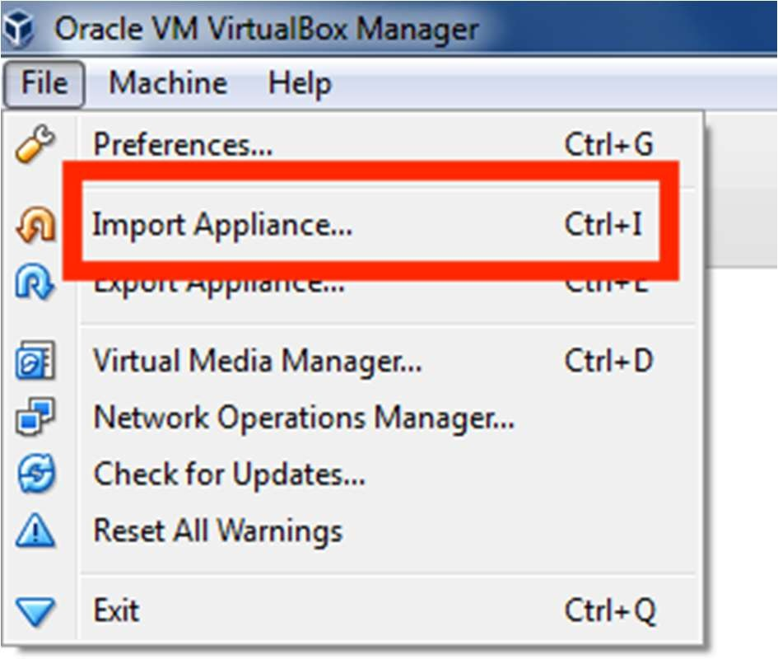

1. **Click the Folder icon.**

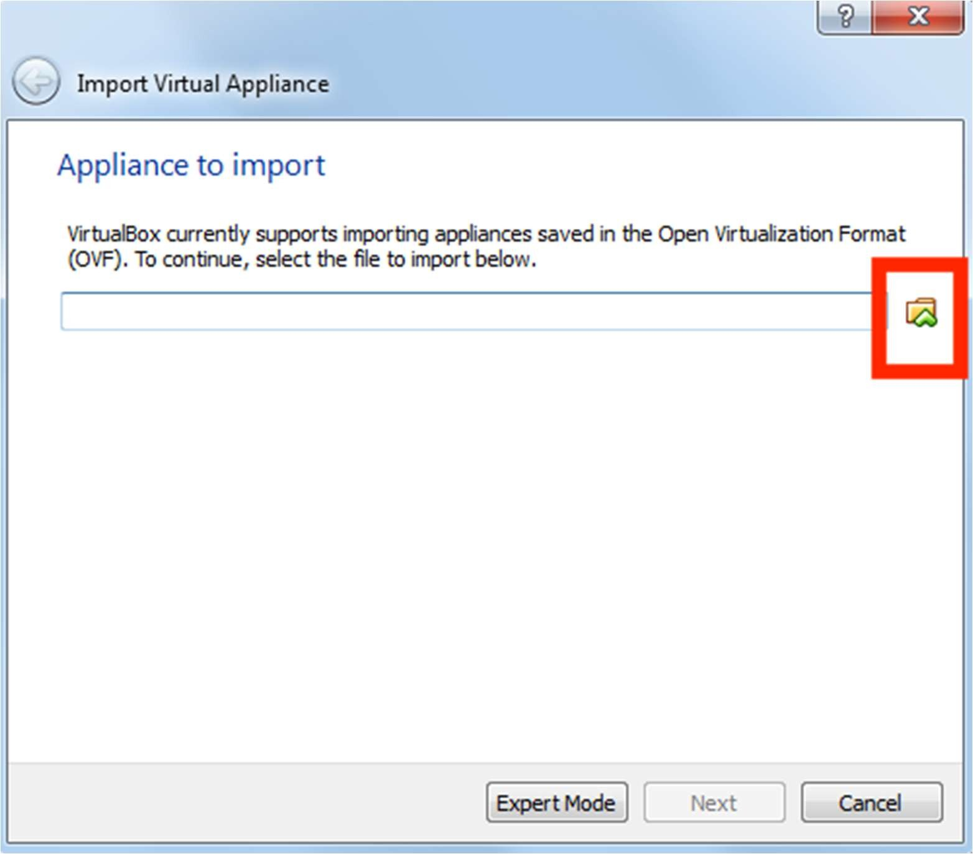

1. **Select the cloudera-quickstart-vm-5.4.2-0-virtualbox.ovf** from the Folder where you unzipped the VirtualBox VM and click Open.

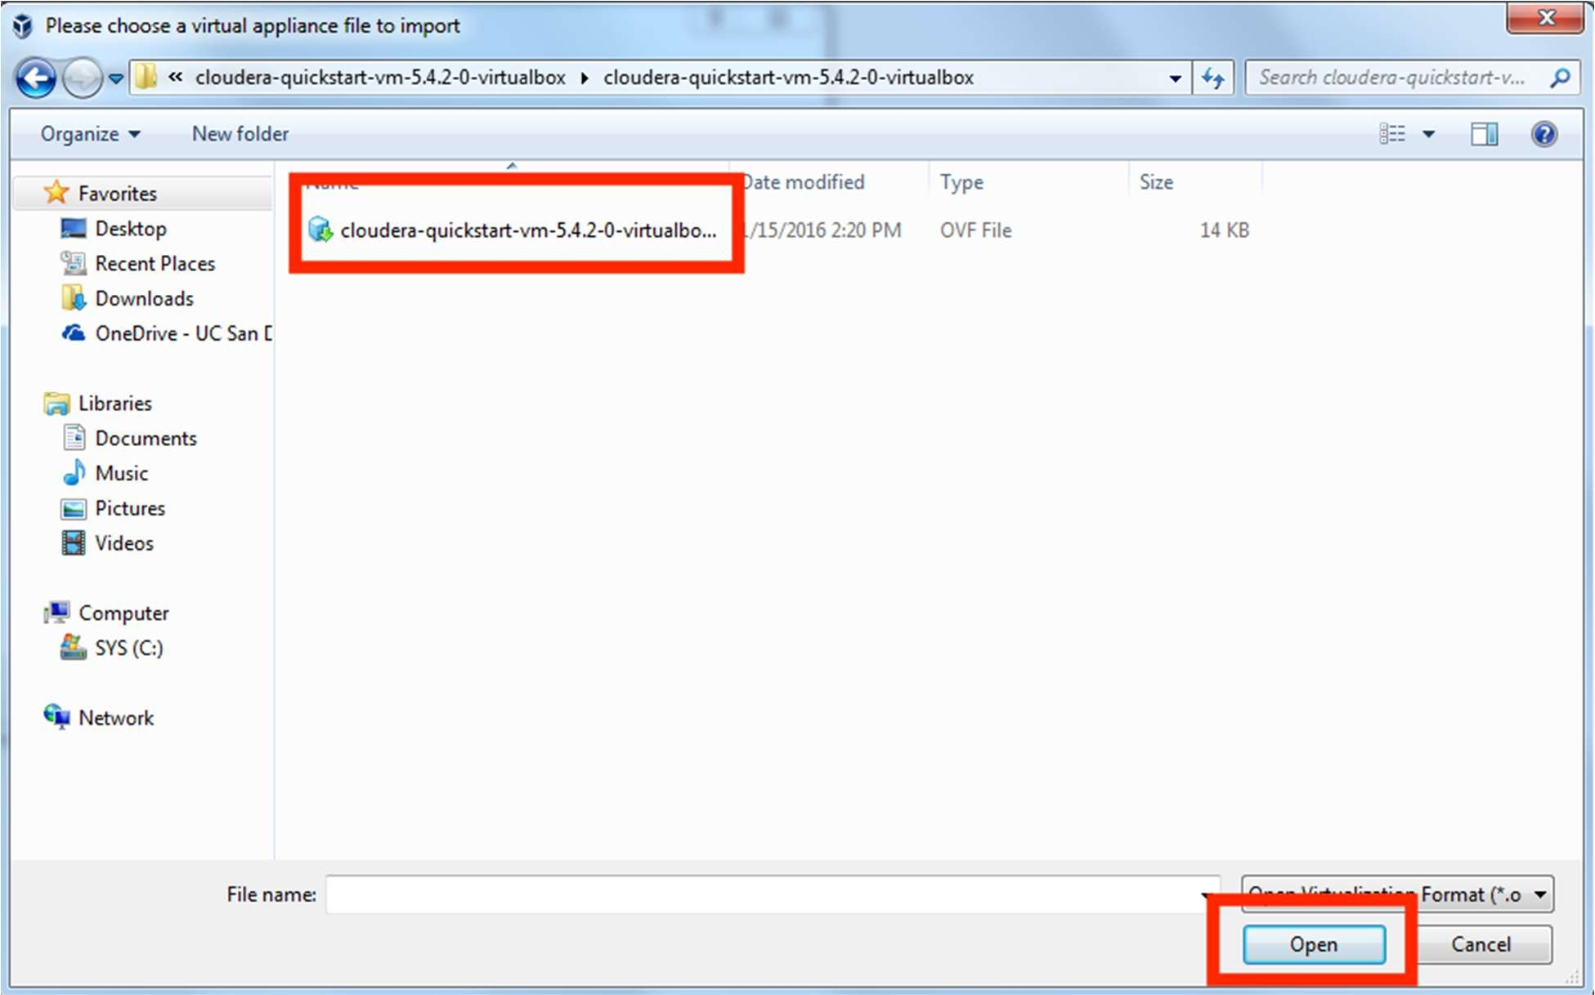

1. **Click Next** to proceed.

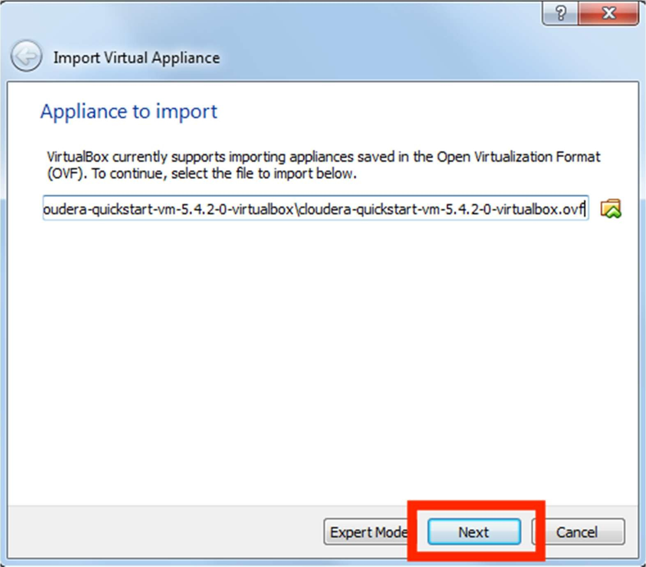

1. **Click Import.**

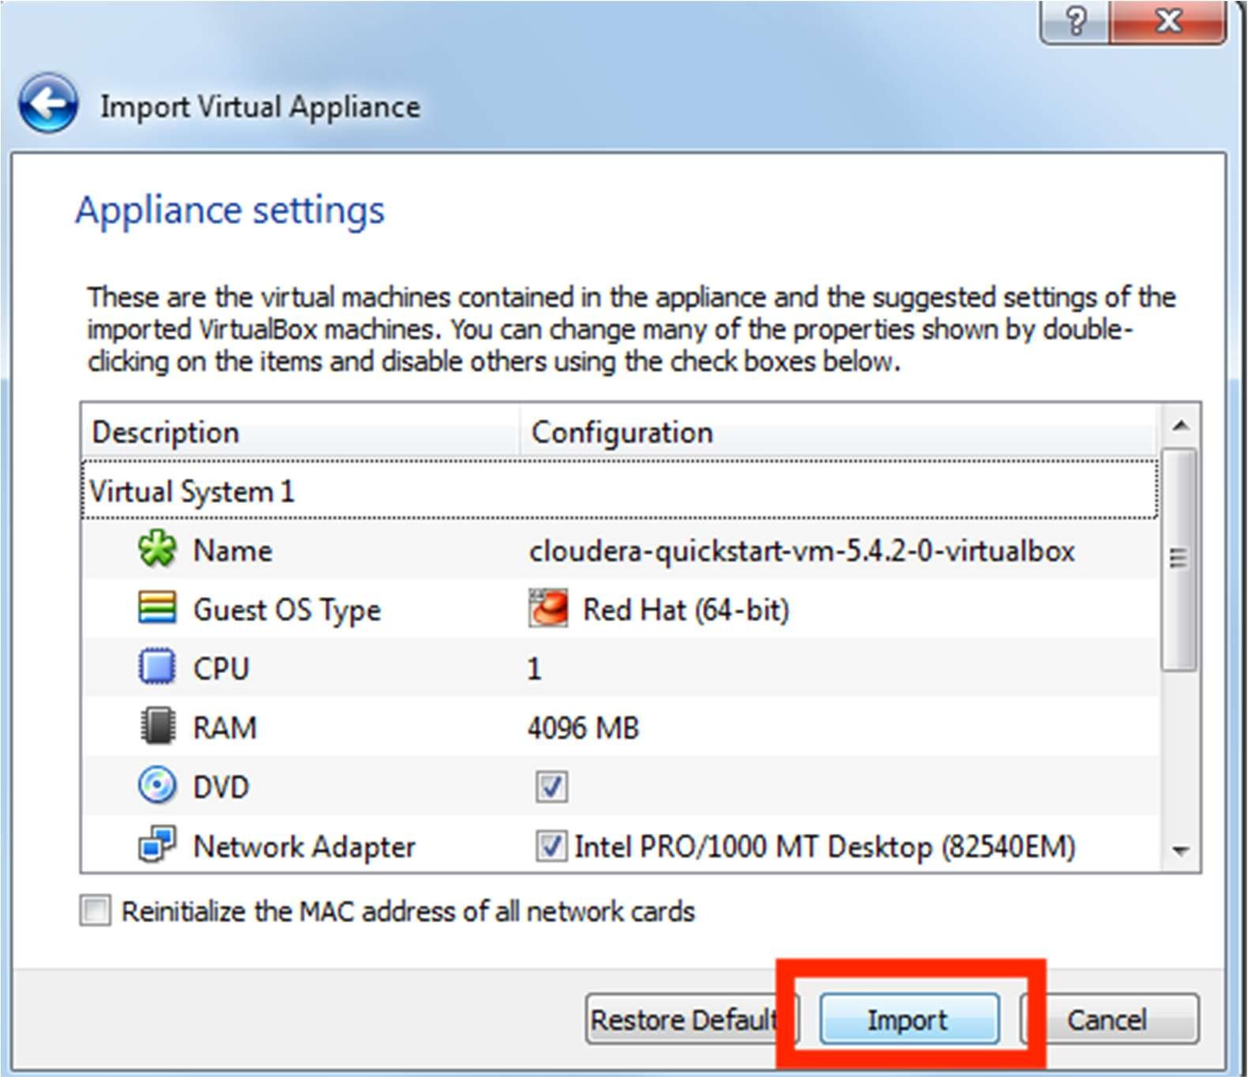

1. **The virtual machine image will be imported.** This can take several minutes.

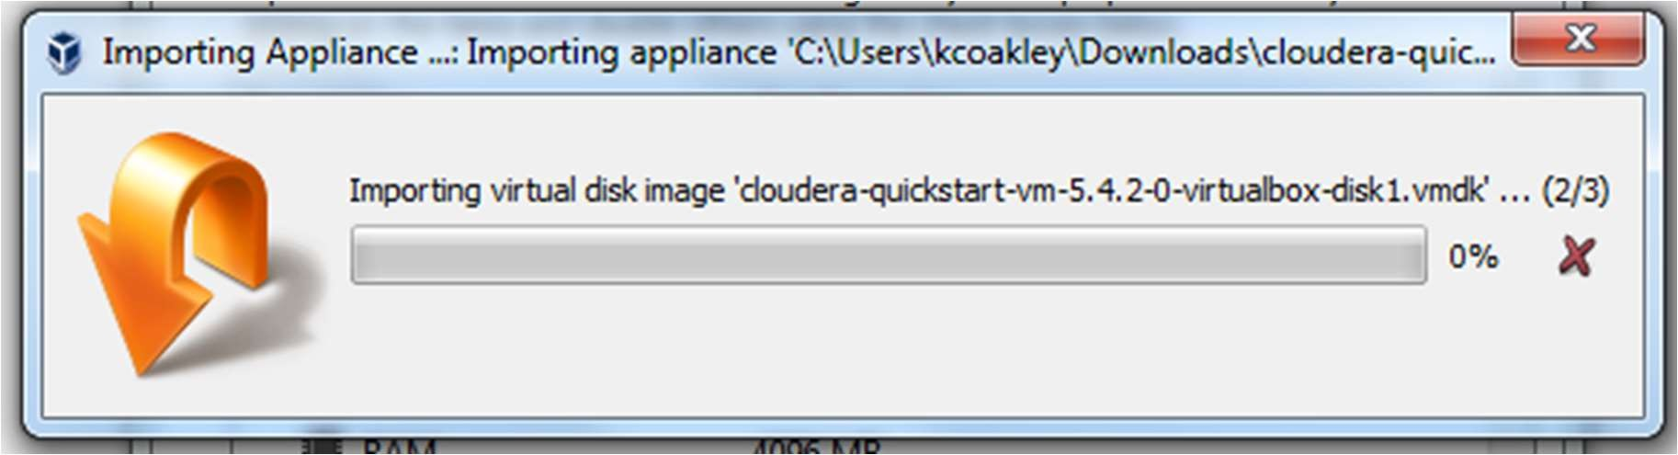

1. **Launch Cloudera VM.** When the importing is finished, the quickstart-vm-5.4.2-0 VM will appear on the left in the VirtualBox window. Select it and click the Start button to launch the VM.

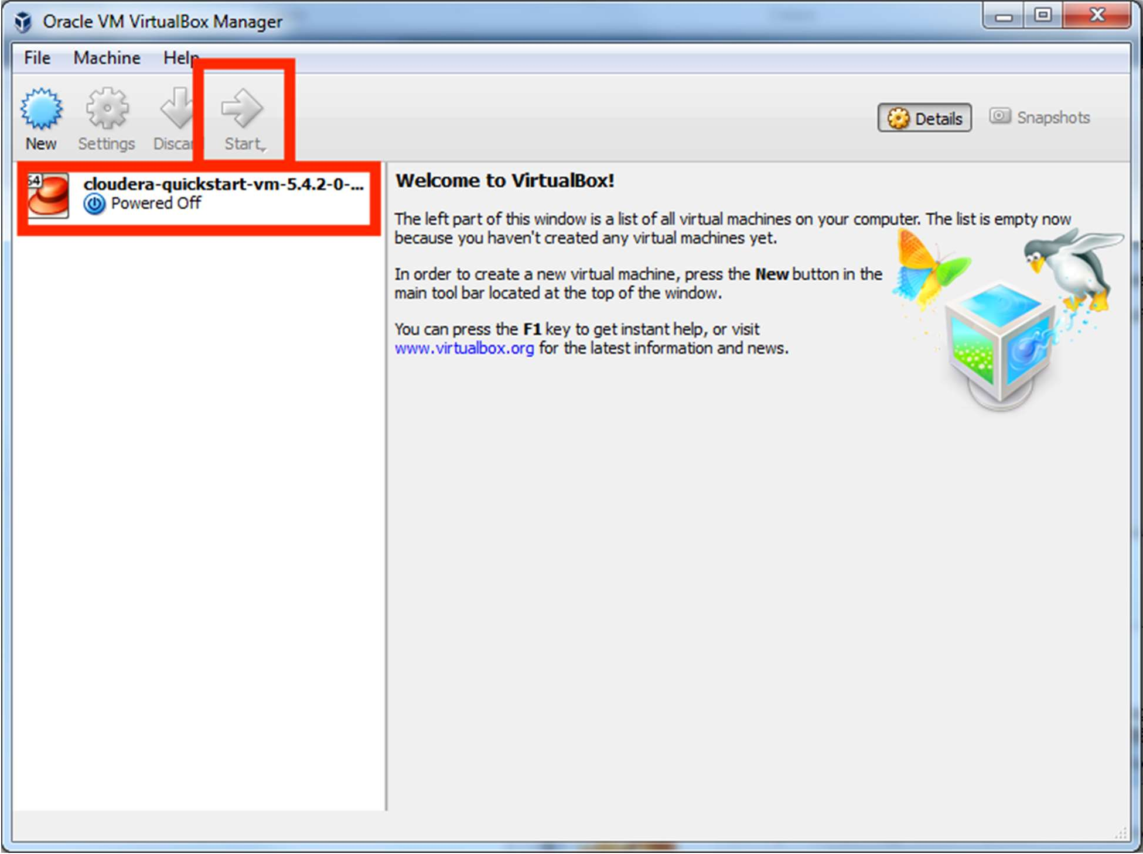

1. **Cloudera VM booting.** It will take several minutes for the Virtual Machine to start. The booting process takes a long time since many Hadoop tools are started.

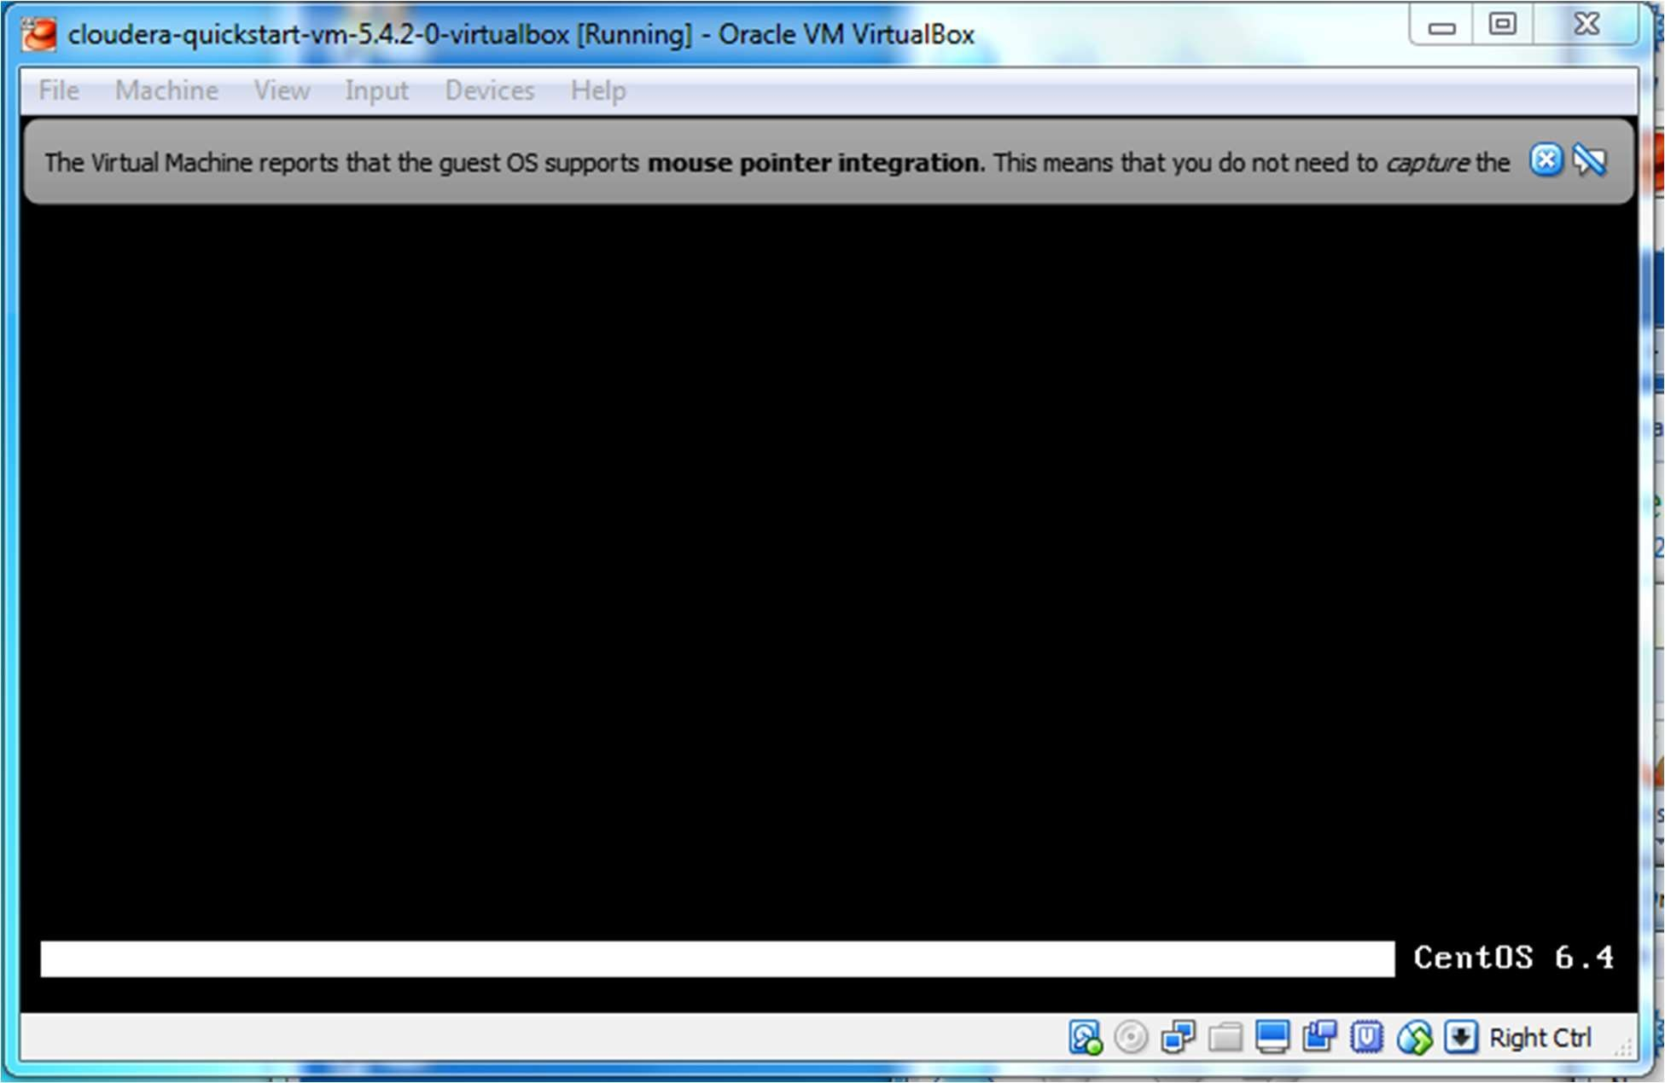

1. **The Cloudera VM desktop.** Once the booting process is complete, the desktop will appear with a browser.

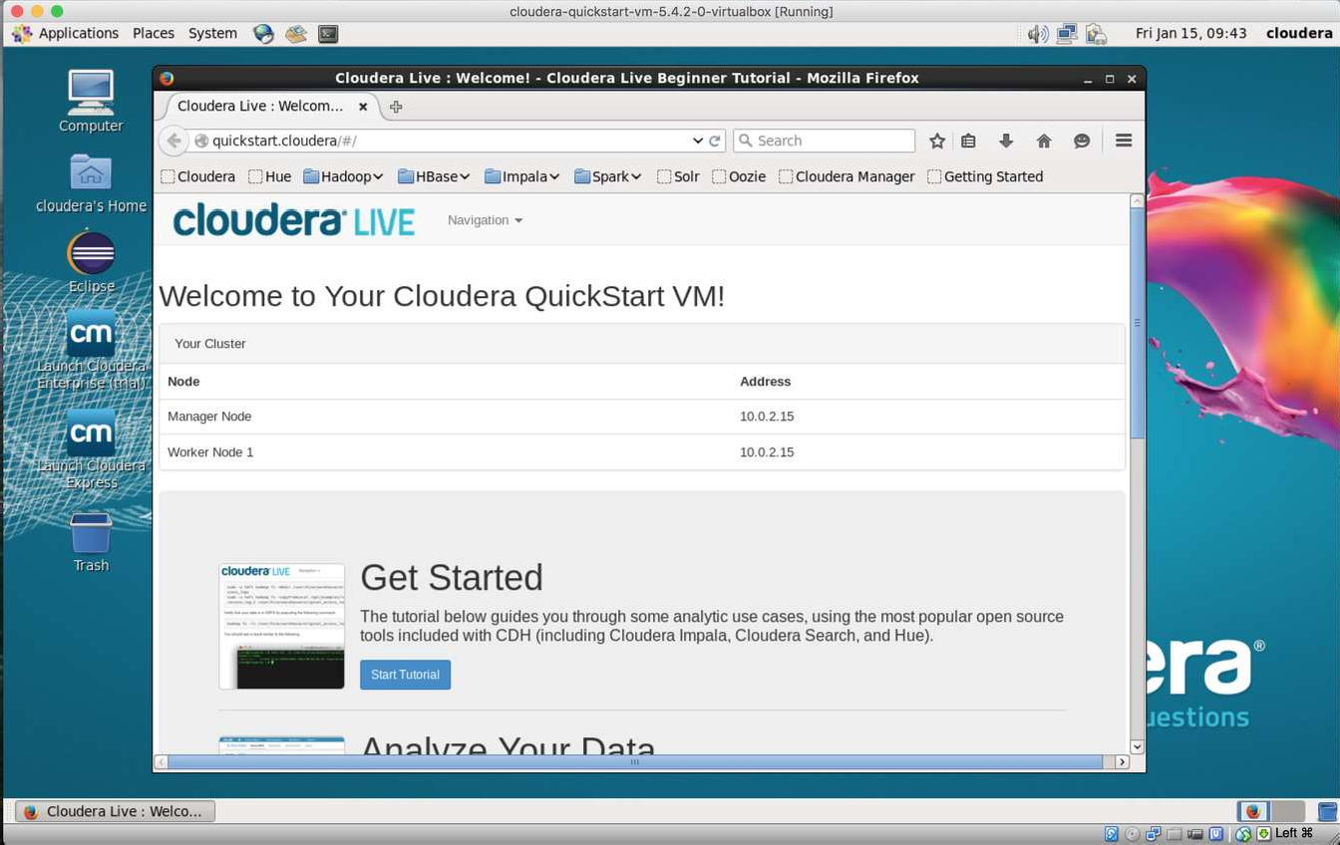

* 1. **MultipleNodes:**

Install a Multi Node Hadoop Cluster on Ubuntu 16.04

This article is about multi-node installation of Hadoop cluster. You would need minimum of 2 ubuntu machines or virtual images to complete a multi-node installation. If you want to just try out a single node cluster, follow this article on Installing Hadoop on Ubuntu 16.04.

I used Hadoop Stable version 2.6.0 for this article. I did this setup on a 3 node cluster. For simplicity, i will designate one node as **master,** and 2 nodes as **slaves (slave-1, and slave- 2)**. Make sure all slave nodes are reachable from master node. To avoid any unreachable hosts error, make sure you add the slave hostnames and ip addresses in **/etc/hosts** file.

Similarly, slave nodes should be able to resolve **master** hostname.

**Installing Java on Master and Slaves**

$sudo add-apt-repository ppa:webupd8team/java

$sudo apt-get update

$sudo apt-get install oracle-java7-installer

# Updata Java runtime

$sudo update-java-alternatives -s java-7-oracle

**Disable IPv6**

As of now Hadoop does not support IPv6, and is tested to work only on IPv4 networks. If you are using IPv6, you need to switch Hadoop host machines to use IPv4. The Hadoop Wiki link provides a one liner command to disable the IPv6. If you are not using IPv6, skip this step:

sudo**sed** -i '**s**/net.ipv6.bindv6only\ =\ 1/net.ipv6.bindv6only\ =\ 0/'\

/etc/sysctl.d/bindv6only.conf&& sudo invoke-rc**.**d procps restart

Setting up a Hadoop User

Hadoop talks to other nodes in the cluster using no-password ssh. By having Hadoop run under a specific user context, it will be easy to distribute the ssh keys around in the Hadoop cluster. Lets’s create a user **hadoopuser** on **master** as well as **slave** nodes.

# Create hadoopgroup

$sudo addgroup hadoopgroup

# Create hadoopuser user

$sudo adduser —ingroup hadoopgroup hadoopuser

Our next step will be to generate a ssh key for password-less login between master and

slave nodes. Run the following commands only on **master** node. Run the last two commands for each slave node. Password less ssh should be working before you can proceed with further steps.

# Login as hadoopuser

$su - hadoopuser

#Generate a ssh key for the user

$ ssh-keygen -t rsa -P ""

#Authorize the key to enable password less ssh

$cat/home/hadoopuser/**.**ssh/id_rsa.pub>>/home/hadoopuser/**.**ssh/authorized_keys

$chmod600 authorized_keys

#Copy this key to slave-1 to enable password less ssh

$ssh-copy-id -i ~/**.**ssh/id_rsa.pub slave-1

#Make sure you can do a password less ssh using following command.

$ssh slave-1

Download and Install Hadoop binaries on Master and Slave nodes

Pick the best mirror site to download the binaries from Apache Hadoop, and download the stable/hadoop-2.6.0.tar.gz for your installation. **Do this step on master and every slave node.** You can download the file once and the distribute to each slave node using scp command.

$**cd**/home/hadoopuser

$wget <http://www.webhostingjams.com/mirror/apache/hadoop/core/stable/hadoop-2.2.0.tar.gz>

$ tar xvf hadoop-2**.**2**.**0**.**tar**.**gz

$mv hadoop-2**.**2**.**0 hadoop

Setup Hadoop Environment on Master and Slave Nodes

Copy and paste following lines into your .bashrc file under /home/hadoopuser. **Do this step on master and every slave node.**

# Set HADOOP_HOME

**export**HADOOP_HOME=/home/hduser/hadoop # Set JAVA_HOME

**export**JAVA_HOME=/usr/lib/jvm/java-7-oracle # Add Hadoop bin and sbin directory to PATH

**export**PATH=$PATH:$HADOOP_HOME/bin;$HADOOP_HOME/sbin

Update hadoop-env.sh on Master and Slave Nodes

Update JAVA_HOME in /home/hadoopuser/hadoop/etc/hadoop/hadoop_env.sh to following. **Do this step on master and every slave node.**

**export**JAVA_HOME=/usr/lib/jvm/java-7-oracle

Common Terminologies

Before we start getting into configuration details, lets discuss some of the basic terminologies used in Hadoop.

* **Hadoop Distributed File System**: A distributed file system that provides high- throughput access to application data. A HDFS cluster primarily consists of a NameNode that manages the file system metadata and DataNodes that store the actual data. If you compare HDFS to a traditional storage structures ( e.g. FAT,

NTFS), then NameNode is analogous to a Directory Node structure, and DataNode is analogous to actual file storage blocks.

* **Hadoop YARN**: A framework for job scheduling and cluster resource management.
* **Hadoop MapReduce**: A YARN-based system for parallel processing of large data sets.

Update Configuration Files

Add/update core-site.xml on **Master and Slave nodes** with following options. Master and slave nodes should all be using the same value for this property **fs.defaultFS,** and should be pointing to master node only.

<property>

<name>hadoop.tmp.dir</name>

<value>/home/hadoopuser/tmp</value>

<description>Temporary Directory.</description>

</property>

<property>

<name>fs.defaultFS</name>

<value>hdfs://master:54310</value>

<description>Use HDFS as file storage engine</description>

</property>

**/home/hadoopuser/hadoop/etc/hadoop/core-site.xml (Other Options)**

Add/update mapred-site.xml on **Master node only** with following options.

<property>

<name>mapreduce.jobtracker.address</name>

<value>master:54311</value>

<description>The host and port that the MapReduce job tracker runs at. If “local”, then jobs are run in-process as a single map

and reduce task.

</description>

</property>

<property>

<name>mapreduce.framework.name</name>

<value>yarn</value>

<description>The framework for running mapreduce jobs</description>

</property>

**/home/hadoopuser/hadoop/etc/hadoop/mapred-site.xml (Other Options)**

Add/update hdfs-site.xml on **Master and Slave Nodes.** We will be adding following three entries to the file.

* **dfs.replication**– Here I am using a replication factor of 2. That means for every file stored in HDFS, there will be one redundant replication of that file on some other node in the cluster.
* **dfs.namenode.name.dir –** This directory is used by Namenode to store its metadata file. Here i manually created this directory /hadoop- data/hadoopuser/hdfs/namenode on master and slave node, and use the directory location for this configuration.
* **dfs.datanode.data.dir –** This directory is used by Datanode to store hdfs data blocks. Here i manually created this directory /hadoop- data/hadoopuser/hdfs/datanode on master and slave node, and use the directory location for this configuration.

<property>

<name>dfs.replication</name>

<value>2</value>

**/home/hadoopuser/hadoop/etc/hadoop/hdfs-site.xml (Other Options)**

<description>Default block replication.

The actual number of replications can be specified when the file is created. The default is used if replication is not specified in create time.

</description>

</property>

<property>

<name>dfs.namenode.name.dir</name>

<value>/hadoop-data/hadoopuser/hdfs/namenode</value>

<description>Determines where on the local filesystem the DFS name node should store the name table(fsimage). If this is a comma-delimited list of directories then the name table is replicated in all of the directories, for redundancy.

</description>

</property>

<property>

<name>dfs.datanode.data.dir</name>

<value>/hadoop-data/hadoopuser/hdfs/datanode</value>

<description>Determines where on the local filesystem an DFS data node should store its blocks. If this is a comma-delimited list of directories, then data will be stored in all named directories, typically on different devices. Directories that do not exist are ignored.

</description>

</property>

Add yarn-site.xml on **Master and Slave Nodes**. This file is required for a Node to work as a Yarn Node. Master and slave nodes should all be using the same value for the following properties**,** and should be pointing to master node only.

**/home/hadoopuser/hadoop/etc/hadoop/yarn-site.xml**

<property>

<name>yarn.nodemanager.aux-services</name>

<value>mapreduce_shuffle</value>

</property>

<property>

<name>yarn.resourcemanager.scheduler.address</name>

<value>master:8030</value>

</property>

<property>

<name>yarn.resourcemanager.address</name>

<value>master:8032</value>

</property>

<property>

<name>yarn.resourcemanager.webapp.address</name>

<value>master:8088</value>

</property>

<property>

<name>yarn.resourcemanager.resource-tracker.address</name>

<value>master:8031</value>

</property>

<property>

<name>yarn.resourcemanager.admin.address</name>

<value>master:8033</value>

</property>

Add/update **slaves** file on Master node only. Add just name, or ip addresses of master and all slave node. If file has an entry for localhost, you can remove that. This file is just

helper file that are used by hadoop scripts to start appropriate services on master and slave nodes.

master slave-1

slave-2

**/home/hadoopuser/hadoop/etc/hadoop/slave**

Format the Namenode

Before starting the cluster, we need to format the Namenode. Use the following command only on **master node**:

$ hdfs namenode -format

Start the Distributed Format System

Run the following on **master node** command to start the DFS.

$**.**/home/hadoopuser/hadoop/sbin/start-dfs.sh You should observe the output to ascertain that it tries to start datanode on slave nodes one by one. To validate the success, run following command on master nodes, and slave node.

$ su - hadoopuser

$ jps

The output of this command should list ***NameNode*, *SecondaryNameNode, DataNode*** on **master** node, and ***DataNode*** on all slave nodes. If you don’t see the expected output, review the log files listed in Troubleshooting section.

Start the Yarn MapReduce Job tracker

Run the following command to start the Yarn mapreduce framework.

$**.**/home/hadoopuser/hadoop/sbin/start-yarn.sh

To validate the success, run **jps** command again on master nodes, and slave node.The output of this command should list ***NodeManager,***

***ResourceManager*** on **master** node, and ***NodeManager,*** on all **slave** nodes. If you don’t see the expected output, review the log files listed in Troubleshooting section.

Review Yarn Web console

If all the services started successfully on all nodes, then you should see all of your nodes listed under Yarn nodes. You can hit the following url on your browser and verify that:

http://master:8088/cluster/nodes

Lets’s execute a MapReduce example now

You should be all set to run a MapReduce example now. Run the following command

$hadoop jar share/hadoop/mapreduce/hadoop-mapreduce-examples-2.2.0.jar pi 30100 Once the job is submitted you can validate that its running on the cluster by accessing following url.

http://master:8088/cluster/apps

Troubleshooting

Hadoop uses $HADOOP_HOME/logs directory. In case you get into any issues with your installation, that should be the first point to look at. In case, you need help with anything else, do leave me a comment.

**REFERENCE BOOK:**

<http://hadoop.apache.org/docs/current/hadoop-project-dist/hadoop-> common/ClusterSetup.html

**CONCLUSION:**

Thus we have successfully installed and tested single and multimode cluster.

**Assignment: 2 AIM:**Design a distributed application using MapReduce. **PROBLEM STATEMENT /DEFINITION**

Design a distributed application using MapReduce which processes a log file of a system. List out the users who have logged for maximum period on the system. Use simple log file from the Internet and process it using a pseudo distribution mode on Hadoop platform.

**OBJECTIVE:**

* To understand the concept of Map Reduce.
* To understand the details of Hadoop File system
* To understand the technique for log file processing
* Analyze the performance of hadoop file system
* To understand use of distributed processing

**THEORY:**

What is MapReduce?

MapReduce is a processing technique and a program model for distributed computing based on java. The MapReduce algorithm contains two important tasks, namely Map and Reduce. Map takes a set of data and converts it into another set of data, where individual elements are broken down into tuples (key/value pairs). Secondly, reduce task, which takes the output from a map as an input and combines those data tuples into a smaller set of tuples. As the sequence of the name MapReduce implies, the reduce task is always performed after the map job.

The major advantage of MapReduce is that it is easy to scale data processing over multiple computing nodes. Under the MapReduce model, the data processing primitives are called mappers and reducers. Decomposing a data processing application into mappers and reducers is sometimes nontrivial. But, once we write an application in the MapReduce form, scaling the application to run over hundreds, thousands, or even tens of thousands of machines in a cluster is merely a configuration change. This simple scalability is what has attracted many programmers to use the MapReduce model.

### The Algorithm

* Generally MapReduce paradigm is based on sending the computer to where the data resides!
* MapReduce program executes in three stages, namely map stage, shuffle stage, and reduce stage.
  + **Map stage** : The map or mapper’s job is to process the input data. Generally the input data is in the form of file or directory and is stored in the Hadoop file system (HDFS). The input file is passed to the mapper function line by line. The mapper processes the data and creates several small chunks of data.
  + **Reduce stage** : This stage is the combination of the **Shuffle**stage and the **Reduce** stage. The Reducer’s job is to process the data that comes from the mapper. After processing, it produces a new set of output, which will be stored in the HDFS.
* During a MapReduce job, Hadoop sends the Map and Reduce tasks to the appropriate servers in the cluster.
* The framework manages all the details of data-passing such as issuing tasks, verifying task completion, and copying data around the cluster between the nodes.
* Most of the computing takes place on nodes with data on local disks that reduces the network traffic.
* After completion of the given tasks, the cluster collects and reduces the data to form an appropriate result, and sends it back to the Hadoop server.

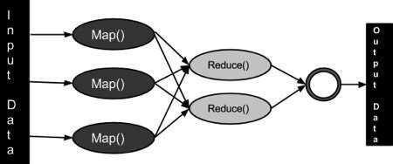

Fig.1. Map Reduce job processing

### Inputs and Outputs (Java Perspective)

The MapReduce framework operates on <key, value> pairs, that is, the framework views the input to the job as a set of <key, value> pairs and produces a set of <key, value> pairs as the output of the job, conceivably of different types.

The key and the value classes should be in serialized manner by the framework and hence, need to implement the Writable interface. Additionally, the key classes have to implement the Writable-Comparable interface to facilitate sorting by the framework. Input and Output types of a MapReduce job: (Input) <k1, v1> -> map -><k2, v2>-> reduce -><k3, v3>(Output).



|  |  |  |
| --- | --- | --- |
|  | **Input** | **Output** |
|  | <k1, v1> | list (<k2, v2>) |
| **Map** |
|  | <k2, list(v2)> | list (<k3, v3>) |
| **Reduce** |

### Terminology

* **PayLoad** - Applications implement the Map and the Reduce functions, and form the core of the job.
* **Mapper** - Mapper maps the input key/value pairs to a set of intermediate key/value pair.
* **NamedNode** - Node that manages the Hadoop Distributed File System (HDFS).
* **DataNode** - Node where data is presented in advance before any processing takes place.
* **MasterNode** - Node where JobTracker runs and which accepts job requests from clients.
* **SlaveNode** - Node where Map and Reduce program runs.
* **JobTracker** - Schedules jobs and tracks the assign jobs to Task tracker.
* **Task Tracker** - Tracks the task and reports status to JobTracker.
* **Job** - A program is an execution of a Mapper and Reducer across a dataset.
* **Task** - An execution of a Mapper or a Reducer on a slice of data.
* **Task Attempt** - A particular instance of an attempt to execute a task on a SlaveNode.

### Example Scenario

Given below is the data regarding the electrical consumption of an organization. It contains the monthly electrical consumption and the annual average for various years.



|  |  |  |  |  |  |  |  |  |  |  |  |  |  |
| --- | --- | --- | --- | --- | --- | --- | --- | --- | --- | --- | --- | --- | --- |
|  | | | | | | | | **Aug** |  | | | **Dec** |  |
|  | **Jan** | **Feb** | **Mar** | **Apr** | **May** | **Jun** | **Jul** | **Sep** | **Oct** | **Nov** | **Avg** |
| 1979 | 23 | 23 | 2 | 43 | 24 | 25 | 26 | 26 | 26 | 26 | 25 | 26 | 25 |
| 1980 | 26 | 27 | 28 | 28 | 28 | 30 | 31 | 31 | 31 | 30 | 30 | 30 | 29 |
| 1981 | 31 | 32 | 32 | 32 | 33 | 34 | 35 | 36 | 36 | 34 | 34 | 34 | 34 |
| 1984 | 39 | 38 | 39 | 39 | 39 | 41 | 42 | 43 | 40 | 39 | 38 | 38 | 40 |
| 1985 | 38 | 39 | 39 | 39 | 39 | 41 | 41 | 41 | 00 | 40 | 39 | 39 | 45 |

If the above data is given as input, we have to write applications to process it and produce results such as finding the year of maximum usage, year of minimum usage, and so on. This is a walkover for the programmers with finite number of records. They will simply write the logic to produce the required output, and pass the data to the application written.

But, think of the data representing the electrical consumption of all the largescale industries of a particular state, since its formation.

When we write applications to process such bulk data,

* They will take a lot of time to execute.
* There will be a heavy network traffic when we move data from source to network server and so on.

To solve these problems, we have the MapReduce framework.

##### Input Data

The above data is saved as **sample.txt**and given as input. The input file looks as shown below.

19792323243242526262626252625

198026272828283031313130303029

198131323232333435363634343434

198439383939394142434039383840

198538393939394141410040393945

##### Example Program

Given below is the program to the sample data using MapReduce framework.

package hadoop;

import java.util.*;

import java.io.IOException;

import java.io.IOException;

import org.apache.hadoop.fs.Path;

import org.apache.hadoop.conf.*;

import org.apache.hadoop.io.*;

import org.apache.hadoop.mapred.*;

import org.apache.hadoop.util.*;

publicclassProcessUnits

{

//Mapper class

publicstaticclass E_EMapper extendsMapReduceBaseimplements

Mapper<LongWritable,/*Input key Type */

Text,/*Input value Type*/

Text,/*Output key Type*/

IntWritable>/*Output value Type*/

{

//Map function

publicvoid map(LongWritable key,Text value,

OutputCollector<Text,IntWritable> output,

Reporter reporter)throwsIOException

{

String line =value.toString();

String lasttoken =null;

StringTokenizer s =newStringTokenizer(line,"\t");

String year =s.nextToken();

while(s.hasMoreTokens())

{

lasttoken=s.nextToken();

}

int avgprice =Integer.parseInt(lasttoken);

output.collect(newText(year),newIntWritable(avgprice));

}

}

//Reducer class

publicstaticclass E_EReduce extendsMapReduceBaseimplements

Reducer<Text,IntWritable,Text,IntWritable>

{

//Reduce function

publicvoid reduce(Text key,Iterator<IntWritable> values,

OutputCollector<Text,IntWritable> output,Reporter reporter)throwsIOException

{

int maxavg=30;

int val=Integer.MIN_VALUE;

while(values.hasNext())

{

if((val=values.next().get())>maxavg)

{

output.collect(key,newIntWritable(val));

}

}

}

}

//Main function

publicstaticvoid main(String args[])throwsException

{

JobConf conf =newJobConf(ProcessUnits.class);

conf.setJobName("max_eletricityunits"); conf.setOutputKeyClass(Text.class); conf.setOutputValueClass(IntWritable.class); conf.setMapperClass(E_EMapper.class); conf.setCombinerClass(E_EReduce.class); conf.setReducerClass(E_EReduce.class); conf.setInputFormat(TextInputFormat.class); conf.setOutputFormat(TextOutputFormat.class);

FileInputFormat.setInputPaths(conf,newPath(args[0])); FileOutputFormat.setOutputPath(conf,newPath(args[1]));

JobClient.runJob(conf);

}

}

Save the above program as **ProcessUnits.java.** The compilation and execution of the program is explained below.

### Compilation and Execution of Process Units Program

Let us assume we are in the home directory of a Hadoop user (e.g. /home/hadoop). Follow the steps given below to compile and execute the above program.

##### Step 1

The following command is to create a directory to store the compiled java classes.

$ mkdir units

##### Step 2

Download **Hadoop-core-1.2.1.jar,** which is used to compile and execute the MapReduce program. Visit the following link <http://mvnrepository.com/artifact/org.apache.hadoop/hadoop-core/1.2.1to> download the jar. Let us assume the downloaded folder is **/home/hadoop/.**

##### Step 3

The following commands are used for compiling the **ProcessUnits.java**program and creating a jar for the program.

$ javac-classpath hadoop-core-1.2.1.jar-d units ProcessUnits.java

$ jar -cvf units.jar -C units/.

##### Step 4

The following command is used to create an input directory in HDFS.

$HADOOP_HOME/bin/hadoop fs -mkdir input_dir

##### Step 5

The following command is used to copy the input file named **sample.txt**in the input directory of HDFS.

$HADOOP_HOME/bin/hadoop fs -put /home/hadoop/sample.txt input_dir

##### Step 6

The following command is used to verify the files in the input directory.

$HADOOP_HOME/bin/hadoop fs -ls input_dir/

##### Step 7

The following command is used to run the Eleunit_max application by taking the input files from the input directory.

$HADOOP_HOME/bin/hadoop jar units.jar hadoop.ProcessUnits input_dir output_dir

Wait for a while until the file is executed. After execution, as shown below, the output will contain the number of input splits, the number of Map tasks, the number of reducer tasks, etc.

INFO mapreduce.Job:Job job_1414748220717_0002 completed successfully

14/10/3106:02:52

INFO mapreduce.Job:Counters:49 FileSystemCounters

FILE:Number of bytes read=61 FILE:Number of bytes written=279400 FILE:Number of read operations=0 FILE:Number of large read operations=0 FILE:Number of write operations=0 HDFS:Number of bytes read=546 HDFS:Number of bytes written=40 HDFS:Number of read operations=9 HDFS:Number of large read operations=0

HDFS:Number of write operations=2JobCounters

Launched map tasks=2

Launched reduce tasks=1

Data-local map tasks=2

Total time spent by all maps in occupied slots (ms)=146137

Total time spent by all reduces in occupied slots (ms)=441

Total time spent by all map tasks (ms)=14613

Total time spent by all reduce tasks (ms)=44120

Total vcore-seconds taken by all map tasks=146137

Total vcore-seconds taken by all reduce tasks=44120

Total megabyte-seconds taken by all map tasks=149644288

Total megabyte-seconds taken by all reduce tasks=45178880

Map-ReduceFramework

Map input records=5

Map output records=5

Map output bytes=45

Map output materialized bytes=67

Input split bytes=208

Combine input records=5

Combine output records=5

Reduce input groups=5

Reduce shuffle bytes=6

Reduce input records=5

Reduce output records=5

SpilledRecords=10

ShuffledMaps=2

FailedShuffles=0

MergedMap outputs=2

GC time elapsed (ms)=948

CPU time spent (ms)=5160

Physical memory (bytes) snapshot=47749120

Virtual memory (bytes) snapshot=2899349504

Total committed heap usage (bytes)=277684224

FileOutputFormatCounters BytesWritten=40

##### Step 8

The following command is used to verify the resultant files in the output folder.

$HADOOP_HOME/bin/hadoop fs -ls output_dir/

##### Step 9

The following command is used to see the output in **Part-00000** file. This file is generated by HDFS.

$HADOOP_HOME/bin/hadoop fs -cat output_dir/part-00000

Below is the output generated by the MapReduce program.

198134

198440

198545

##### Step 10

The following command is used to copy the output folder from HDFS to the local file system for analyzing.

$HADOOP_HOME/bin/hadoop fs -cat output_dir/part-00000/bin/hadoop dfs get output_dir /home/hadoop

### Important Commands

All Hadoop commands are invoked by the **$HADOOP_HOME/bin/hadoop**command. Running the Hadoop script without any arguments prints the description for all commands.

**Usage** : hadoop [--config confdir] COMMAND

The following table lists the options available and their description.



|  |  |
| --- | --- |
| **Options** | **Description** |
| namenode -format | Formats the DFS filesystem. |
| secondarynamenode | Runs the DFS secondary namenode. |
| namenode | Runs the DFS namenode. |
| datanode | Runs a DFS datanode. |

|  |  |
| --- | --- |
| dfsadmin | Runs a DFS admin client. |
| mradmin | Runs a Map-Reduce admin client. |
| fsck | Runs a DFS filesystem checking utility. |
| fs | Runs a generic filesystem user client. |
| balancer | Runs a cluster balancing utility. |
| oiv | Applies the offline fsimage viewer to an fsimage. |
| fetchdt | Fetches a delegation token from the NameNode. |
| jobtracker | Runs the MapReduce job Tracker node. |
| pipes | Runs a Pipes job. |
| tasktracker | Runs a MapReduce task Tracker node. |
| historyserver | Runs job history servers as a standalone daemon. |
| job | Manipulates the MapReduce jobs. |
| queue | Gets information regarding JobQueues. |
| version | Prints the version. |
| jar <jar> | Runs a jar file. |
| distcp <srcurl><desturl> | Copies file or directories recursively. |
| distcp2 <srcurl><desturl> | DistCp version 2. |
| archive -archiveName NAME - p | Creates a hadoop archive. |

|  |  |
| --- | --- |
| <parent path><src>* <dest> |  |
| classpath | Prints the class path needed to get the Hadoop jar and the required libraries. |
| daemonlog | Get/Set the log level for each daemon |

### How to Interact with MapReduce Jobs

Usage: hadoop job [GENERIC_OPTIONS]

The following are the Generic Options available in a Hadoop job.



|  |  |
| --- | --- |
| **GENERIC_OPTIONS** | **Description** |
| -submit <job-file> | Submits the job. |
| -status <job-id> | Prints the map and reduce completion percentage and all job counters. |
| -counter <job-id><group- name><countername> | Prints the counter value. |
| -kill <job-id> | Kills the job. |
| -events <job-id><fromevent- #><#-of-events> | Prints the events' details received by jobtracker for the given range. |
| -history [all] <jobOutputDir> - history < jobOutputDir> | Prints job details, failed and killed tip details. More details about the job such as successful tasks and task attempts made for each task can be viewed by specifying the [all] option. |
| -list[all] | Displays all jobs. -list displays only jobs which are yet to complete. |
| -kill-task <task-id> | Kills the task. Killed tasks are NOT counted against failed attempts. |
| -fail-task <task-id> | Fails the task. Failed tasks are counted against failed attempts. |
| -set-priority <job-id><priority> | Changes the priority of the job. Allowed priority values are VERY_HIGH, HIGH, NORMAL, LOW, VERY_LOW |

##### To see the status of job

$ $HADOOP_HOME/bin/hadoop job -status <JOB-ID> e.g.

$ $HADOOP_HOME/bin/hadoop job -status job_201310191043_0004

To see the history of job output-dir

$ $HADOOP_HOME/bin/hadoop job -history <DIR-NAME> e.g.

$ $HADOOP_HOME/bin/hadoop job -history /user/expert/output

To kill the job

$ $HADOOP_HOME/bin/hadoop job -kill <JOB-ID> e.g.

$ $HADOOP_HOME/bin/hadoop job -kill job_201310191043_0004

**2. MapReduce (Log File)**

**Use Hadoop to Analyze Java Logs (Tomcat catalina.out)**

One of the Java applications I develop deploys in Tomcat and is load-balanced across a couple dozen servers. Each server can produce gigabytes of log output daily due to the high volume. This post demonstrates simple use of hadoop to quickly extract useful and relevant information from catalina.out files using Map Reduce. I followed Hadoop: The Definitive Guide for setup and example code.

**Get some seed data**

Now that Hadoop is all setup, I need some seed data to operate on. For this I just reached out and grabbed a log file from one of my production servers.

**[**watrous**@**myhost ~**]**$ **mkdir** input

**[**watrous**@**myhost ~**]**$ **scp** watrous**@**mywebhost.com:**/**var**/**lib**/**tomcat**/**logs**/**catalina.out .**/**input**/**

## Creating Map Reduce Classes

The most simple operation in Hadoop requires a Mapper class, a Reducer class and a third class that identifies the Mapper and Reducer including the datatypes that connect them. The examples below required two jars from the release downloaded above:

* hadoop-2.2.0.tar.gz\hadoop-2.2.0.tar\hadoop-2.2.0\share\hadoop\common\hadoop- common-2.2.0.jar
* hadoop-2.2.0.tar.gz\hadoop-2.2.0.tar\hadoop-2.2.0\share\hadoop\mapreduce\hadoop- mapreduce-client-core-2.2.0.jar

I also use regular expressions in Java to analyze each line in the log. Regular expressions can be more resilient to variations and allow for grouping, which gives easy access to specific data elements. As always, I used Kodos to develop the regular expression.

In the example below, I don’t actually use the log value, but instead I just count up how many occurrences there are by key.

**Mapper class**

**import**java.io.IOException; **import**java.util.regex.Matcher; **import**java.util.regex.Pattern; **import**org.apache.hadoop.io.IntWritable; **import**org.apache.hadoop.io.LongWritable; **import**org.apache.hadoop.io.Text; **import**org.apache.hadoop.mapreduce.Mapper;

**publicclass** TomcatLogErrorMapper **extends** Mapper<LongWritable, Text, Text, Text>{

String pattern ="([0-9]{4}-[0-9]{2}-[0-9]{2}**\\**s[0-9]{2}:[0-9]{2}:[0-9]{2}.[0-9]{3})**\\**s*([a-zA-Z]+)**\\**s*([a-zA-Z.]+)**\\**s*-**\\**s*(.+)$";

*// Create a Pattern object*

Pattern r = Pattern.compile(pattern);

@Override

**publicvoid** map(LongWritable key, Text value, Context context)

**throws**IOException, InterruptedException{ String line = value.toString();

Matcher m = r.matcher(line);

**if**(m.find()){

*// only consider ERRORs for this example*

**if**(m.group(2).contains("ERROR")){

*// example log line*

*// 2013-11-08 04:06:56,586 DEBUG component.helpers.GenericSOAPConnector - Attempting to connect to: https://remotehost.com/app/rfc/entry/msg_status*

*// System.out.println("Found value: " + m.group(0)); //complete line*

*// System.out.println("Found value: " + m.group(1)); // date*

*// System.out.println("Found value: " + m.group(2)); // log level*

*// System.out.println("Found value: " + m.group(3)); // class*

*// System.out.println("Found value: " + m.group(4)); // message*

context.write(**new** Text(m.group(1)), **new** Text(m.group(2)+ m.group(3)+ m.group(4)));

}

}

}

}

###### Reducer class

**import**java.io.IOException; **import**org.apache.hadoop.io.IntWritable; **import**org.apache.hadoop.io.Text; **import**org.apache.hadoop.mapreduce.Reducer;

**publicclass** TomcatLogErrorReducer **extends** Reducer<Text, Text, Text, IntWritable>{ @Override

**publicvoid** reduce(Text key, Iterable<Text> values, Context context)

**throws**IOException, InterruptedException{

**int** countValue =0;

**for**(Text value : values){

countValue++;

}

context.write(key, **new** IntWritable(countValue));

}

}

**Job class with main**

**import**org.apache.hadoop.fs.Path; **import**org.apache.hadoop.io.IntWritable; **import**org.apache.hadoop.io.Text; **import**org.apache.hadoop.mapreduce.Job; **import**org.apache.hadoop.mapreduce.lib.input.FileInputFormat; **import**org.apache.hadoop.mapreduce.lib.output.FileOutputFormat;

**publicclass** TomcatLogError {

**publicstaticvoid** main(String[] args)**throws**Exception{

**if**(args.length!=2){

System.err.println("Usage: TomcatLogError <input path><output path>"); System.exit(-1);

}

Job job =**new** Job(); job.setJarByClass(TomcatLogError.**class**); job.setJobName("Tomcat Log Error"); FileInputFormat.addInputPath(job, **new** Path(args[0])); FileOutputFormat.setOutputPath(job, **new** Path(args[1])); job.setMapperClass(TomcatLogErrorMapper.**class**); job.setReducerClass(TomcatLogErrorReducer.**class**); job.setOutputKeyClass(Text.**class**); job.setOutputValueClass(Text.**class**);

System.exit(job.waitForCompletion(**true**)?0:1);

}

}

## Running Hadoop

In netbeans I made sure that the Main Class was TomcatLogError in the compiled jar. I then ran Clean and Build to get a jar which I transferred up to the server where I installed Hadoop.

**[**watrous**@**myhost ~**]**$ hadoop **jar** HadoopExample.jar input**/**catalina.out ~**/**output

13**/**11**/**1119:20:52 WARN util.NativeCodeLoader: Unable to load native-hadoop library **for** your platform... using builtin-java classes where applicable

13**/**11**/**1119:20:52 INFO Configuration.deprecation: session.id is deprecated. Instead, use dfs.metrics.session-id

...

13**/**11**/**1118:36:57 INFO mapreduce.Job: Job job_local1725513594_0001 completed successfully 13**/**11**/**1118:36:57 INFO mapreduce.Job: Counters: 27

File System Counters

FILE: Number of bytes read=430339145 FILE: Number of bytes written=1057396 FILE: Number of **read**operations=0 FILE: Number of large **read**operations=0 FILE: Number of **write**operations=0

Map-Reduce Framework

Map input records=1101516 Map output records=105 Map output bytes=20648

Map output materialized bytes=20968 Input **split**bytes=396

Combine input records=0 Combine output records=0

Reduce input groups=23 Reduce shuffle bytes=0 Reduce input records=105 Reduce output records=23 Spilled Records=210 Shuffled Maps =0

Failed Shuffles=0 Merged Map outputs=0

GC **time** elapsed **(**ms**)**=234 CPU **time** spent **(**ms**)**=0

Physical memory **(**bytes**)**snapshot=0 Virtual memory **(**bytes**)**snapshot=0

Total committed heap usage **(**bytes**)**=1827143680 File Input Format Counters

Bytes Read=114455257 File Output Format Counters

Bytes Written=844

The output folder now contains a file named **part-r-00000** with the results of the processing.

**[**watrous**@**c0003913 ~**]**$ **more** output**/**part-r-00000 2013-11-08 04:04:51,8942

2013-11-08 05:04:52,7112

2013-11-08 05:33:23,073 3

2013-11-08 06:04:53,6892

2013-11-08 07:04:54,3663

2013-11-08 08:04:55,096 2

2013-11-08 13:34:28,9362

2013-11-08 17:32:31,6293

2013-11-08 18:51:17,3571

2013-11-08 18:51:17,4231

2013-11-08 18:51:17,4911

2013-11-08 18:51:17,4991

2013-11-08 18:51:17,5001

2013-11-08 18:51:17,5021

2013-11-08 18:51:17,5031

2013-11-08 18:51:17,5041

2013-11-08 18:51:17,5061

2013-11-08 18:51:17,6516

2013-11-08 18:51:17,65223

2013-11-08 18:51:17,65325

2013-11-08 18:51:17,65419

2013-11-08 19:01:13,7712

2013-11-08 21:32:34,5222

Based on this analysis, there were a number of errors produced around the hour **18:51:17**. It is then easy to change the Mapper class to emit based on a different key, such as Class or Message to identify more precisely what the error is, now that I know when the errors happened.

References:

https://hadoop.apache.org/docs/current/hadoop-mapreduce-client/hadoop- mapreduce-client-core/MapReduceTutorial.html

CONCLUSION:

**Assignment: 3**

**AIM:** Write an application using HiveQL for flight information system

PROBLEM STATEMENT /DEFINITION

Write an application using HiveQL for flight information system which will include

1. Creating, Dropping, and altering Database tables.
2. Creating an external Hive table.
3. Load table with data, insert new values and field in the table, Join tables with Hive
4. Create index on Flight Information Table
5. Find the average departure delay per day in 2008.

OBJECTIVE

* + To understand various NOSQL database
  + To understand the integration of NOSQL database with Hadoop.
  + To analyze the performance of distributed processing with NOSQL.

THEORY:

* + - Hive and HBase Architecture
    - Explanation of Hive Architecture
    - HBase Architecture
    - Explanation of HBase Architecture
    - List and details of DDL and DML Commands in HBase and Hive

SQL queries are submitted to Hive and they are executed as follows:

1. Hive compiles the query.
2. An execution engine, such as Tez or MapReduce, executes the compiled query.
3. The resource manager, YARN, allocates resources for applications across the cluster.
4. The data that the query acts upon resides in HDFS (Hadoop Distributed File System). Supported data formats are ORC, AVRO, Parquet, and text.
5. Query results are then returned over a JDBC/ODBC connection.

A simplified view of this process is shown in the following figure. Figure 1.1. SQL Query Execution Process

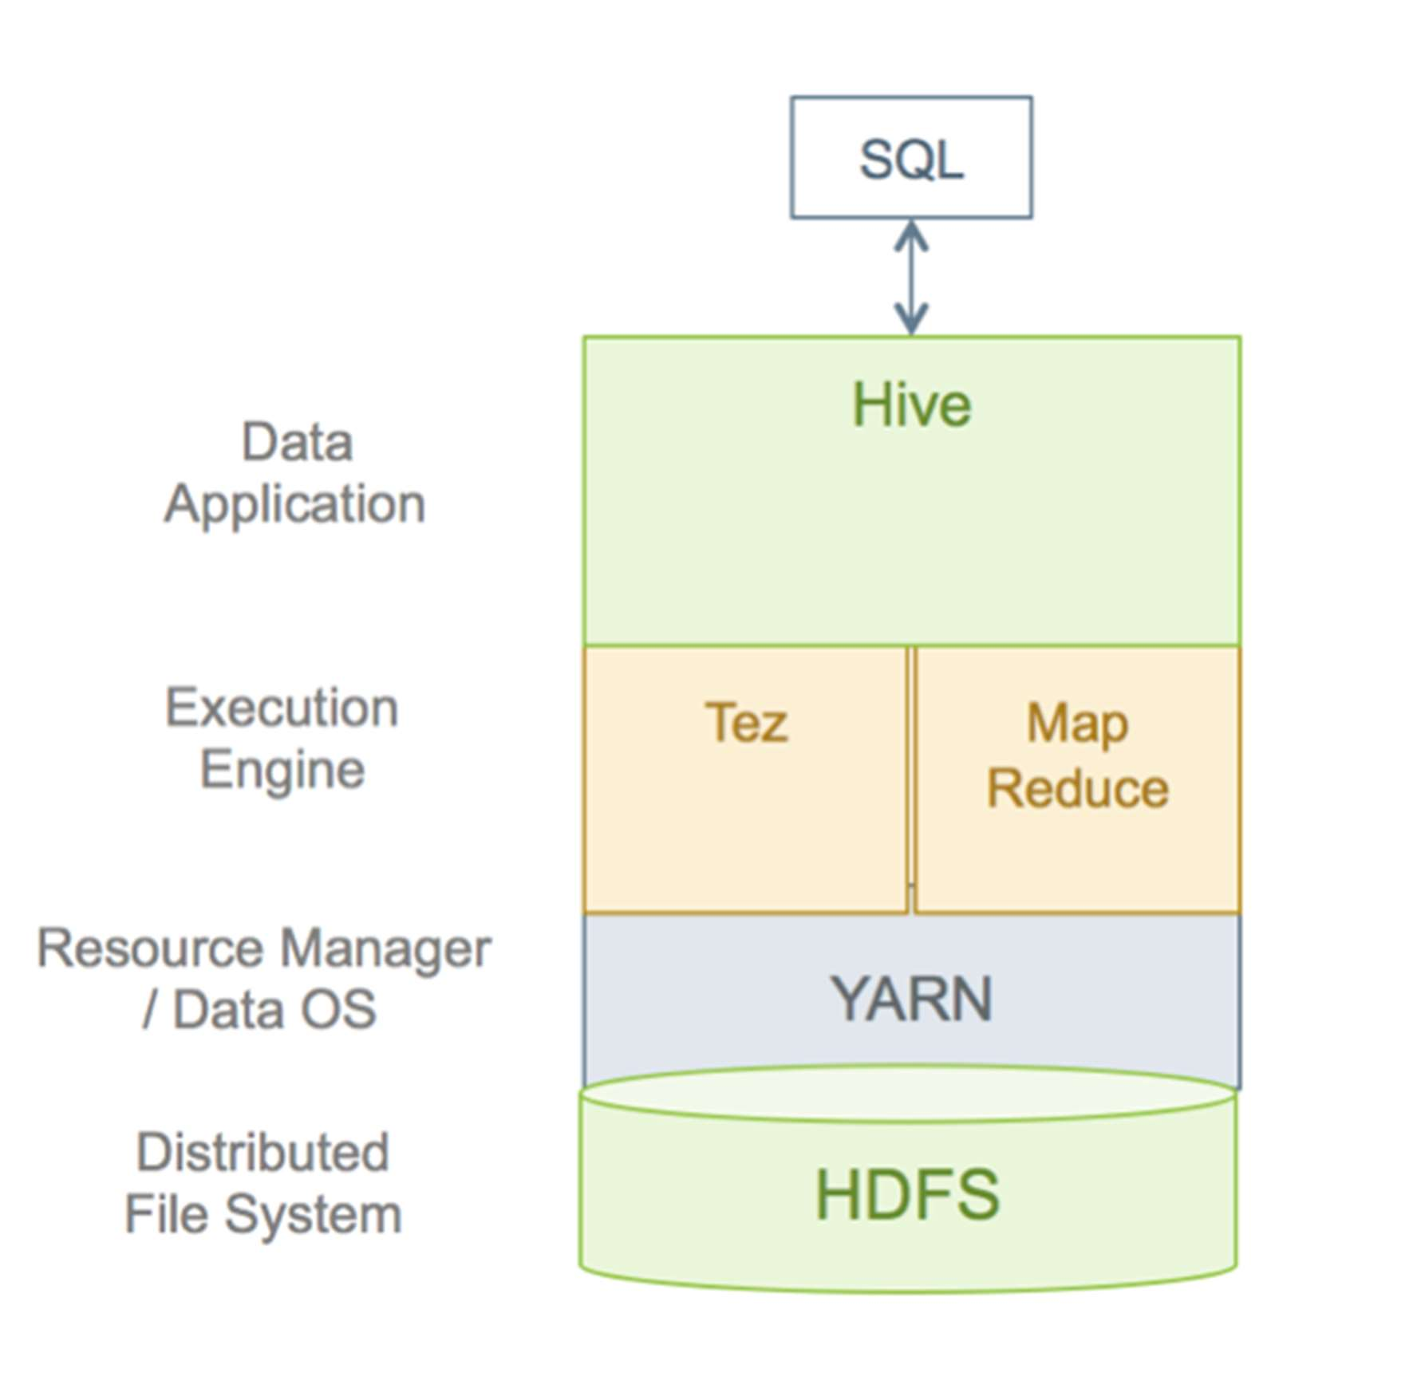

*Detailed Query Execution Architecture*

The following diagram shows a detailed view of the HDP query execution architecture: Figure 1.2. SQL Query Execution Process

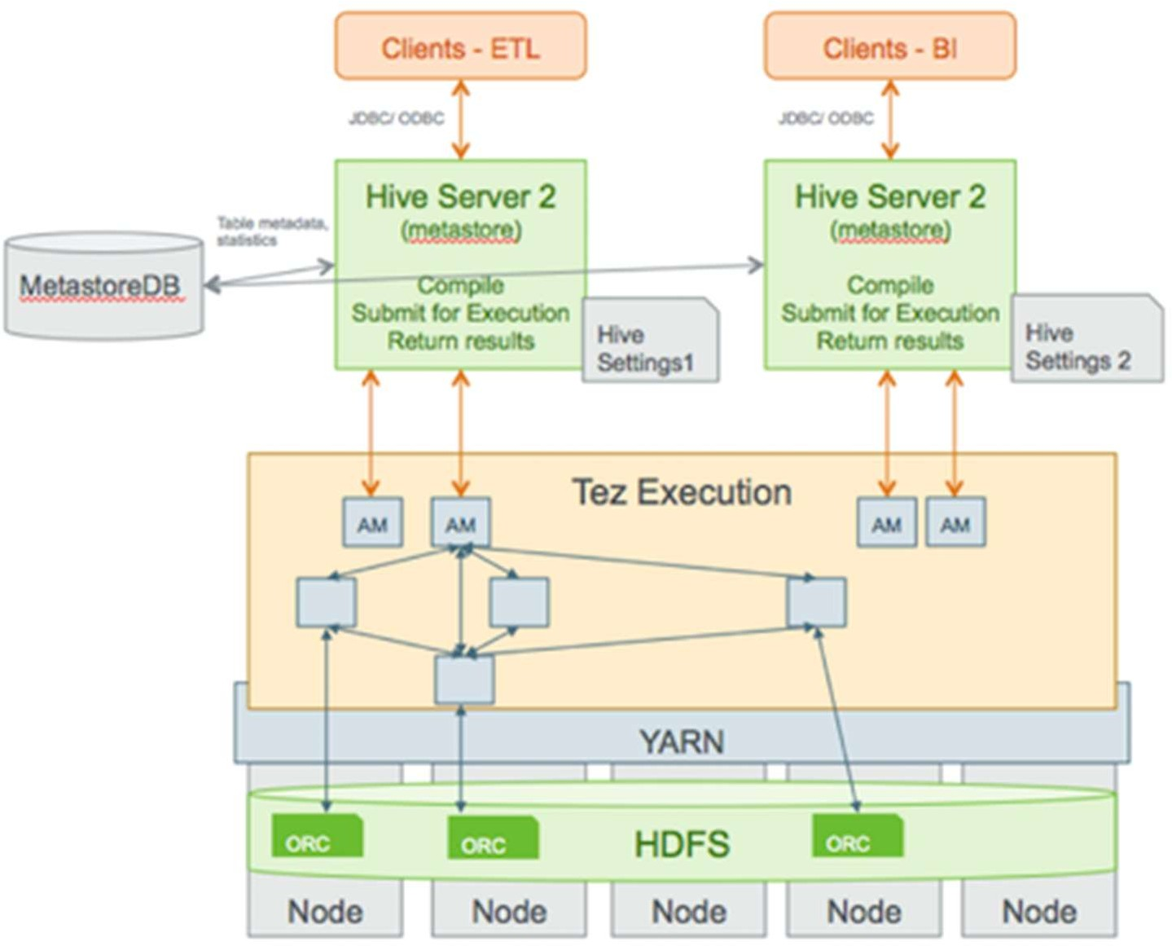

The following sections explain major parts of the query execution architecture. Hive Clients

You can connect to Hive using a JDBC/ODBC driver with a BI tool, such as Microstrategy, Tableau, BusinessObjects, and others, or from another type of application that can access Hive over a JDBC/ODBC connection. In addition, you can also use a command-line tool, such as Beeline, that uses JDBC to connect to Hive. The Hive command-line interface (CLI) can also be used, but it has been deprecated in the current release and Hortonworks does not recommend that you use it for security reasons.

SQL in Hive

Hive supports a large number of standard SQL dialects. In a future release, when SQL:2011 is adopted, Hive will support ANSI-standard SQL.

HiveServer2

Clients communicate with HiveServer2 over a JDBC/ODBC connection, which can handle multiple user sessions, each with a different thread. HiveServer2 can also handle long-running sessions with asynchronous threads. An embedded metastore, which is different from the MetastoreDB, also runs in HiveServer2. This metastore performs the following tasks:

* Get statistics and schema from the MetastoreDB
* Compile queries
* Generate query execution plans
* Submit query execution plans
* Return query results to the client

Multiple HiveServer2 Instances for Different Workloads Multiple HiveServer2 instances can be used for:

* Load-balancing and high availability using ZooKeeper
* Running multiple applications with different settings

Because HiveServer2 uses its own settings file, using one for ETL operations and another for interactive queries is a common practice. All HiveServer2 instances can share the same MetastoreDB. Consequently, setting up multiple HiveServer2 instances that have embedded metastores is a simple operation.

Tez Execution

After query compilation, HiveServer2 generates a Tez graph that is submitted to YARN. A Tez Application Master (AM) monitors the query while it is running.

Security

HiveServer2 performs standard SQL security checks when a query is submitted, including connection authentication. After the connection authentication check, the server runs authorization checks to make sure that the user who submits the query has permission to access the databases, tables, columns, views, and other resources required by the query. Hortonworks recommends that you use SQLStdAuth or Ranger to implement security. Storage-based access controls, which is suitable for ETL workloads only, is also available.

File Formats

Hive supports many file formats. You can write your own SerDes (Serializers, Deserializers) interface to support new file formats.

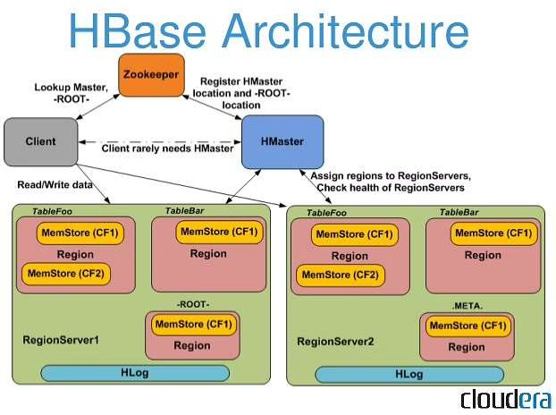

Components of Apache HBase Architecture

HBase architecture has 3 important components- HMaster, Region Server and ZooKeeper.

i. HMaster

HBase HMaster is a lightweight process that assigns regions to region servers in the Hadoop cluster for load balancing. Responsibilities of HMaster –

* Manages and Monitors the Hadoop Cluster
* Performs Administration (Interface for creating, updating and deleting tables.)
* Controlling the failover
* DDL operations are handled by the HMaster
* Whenever a client wants to change the schema and change any of the metadata operations, HMaster is responsible for all these operations.
* Region Server

These are the worker nodes which handle read, write, update, and delete requests from clients. Region Server process, runs on every node in the hadoop cluster. Region Server runs on HDFS DataNode and consists of the following components –

* Block Cache – This is the read cache. Most frequently read data is stored in the read cache and whenever the block cache is full, recently used data is evicted.
* MemStore- This is the write cache and stores new data that is not yet written to the disk. Every column family in a region has a MemStore.
* Write Ahead Log (WAL) is a file that stores new data that is not persisted to permanent storage.
* HFile is the actual storage file that stores the rows as sorted key values on a disk.

i. Zookeeper

HBase uses ZooKeeper as a distributed coordination service for region assignments and to recover any region server crashes by loading them onto other region servers that are functioning. ZooKeeper is a centralized monitoring server that maintains configuration information and provides distributed synchronization. Whenever a client wants to communicate with regions, they have to approach Zookeeper first. HMaster and Region servers are registered with ZooKeeper service, client needs to access ZooKeeper quorum in order to connect with region servers and HMaster. In case of node failure within an HBase cluster, ZKquoram will trigger error messages and start repairing failed nodes.

Build an Awesome Job Winning Project Portfolio with Solved End-to-End Big Data Projects

ZooKeeper service keeps track of all the region servers that are there in an HBase cluster-

tracking information about how many region servers are there and which region servers are holding which DataNode. HMaster contacts ZooKeeper to get the details of region servers. Various services that Zookeeper provides include –

* Establishing client communication with region servers.
* Tracking server failure and network partitions.
* Maintain Configuration Information
* Provides ephemeral nodes, which represent different region servers.

Implementation

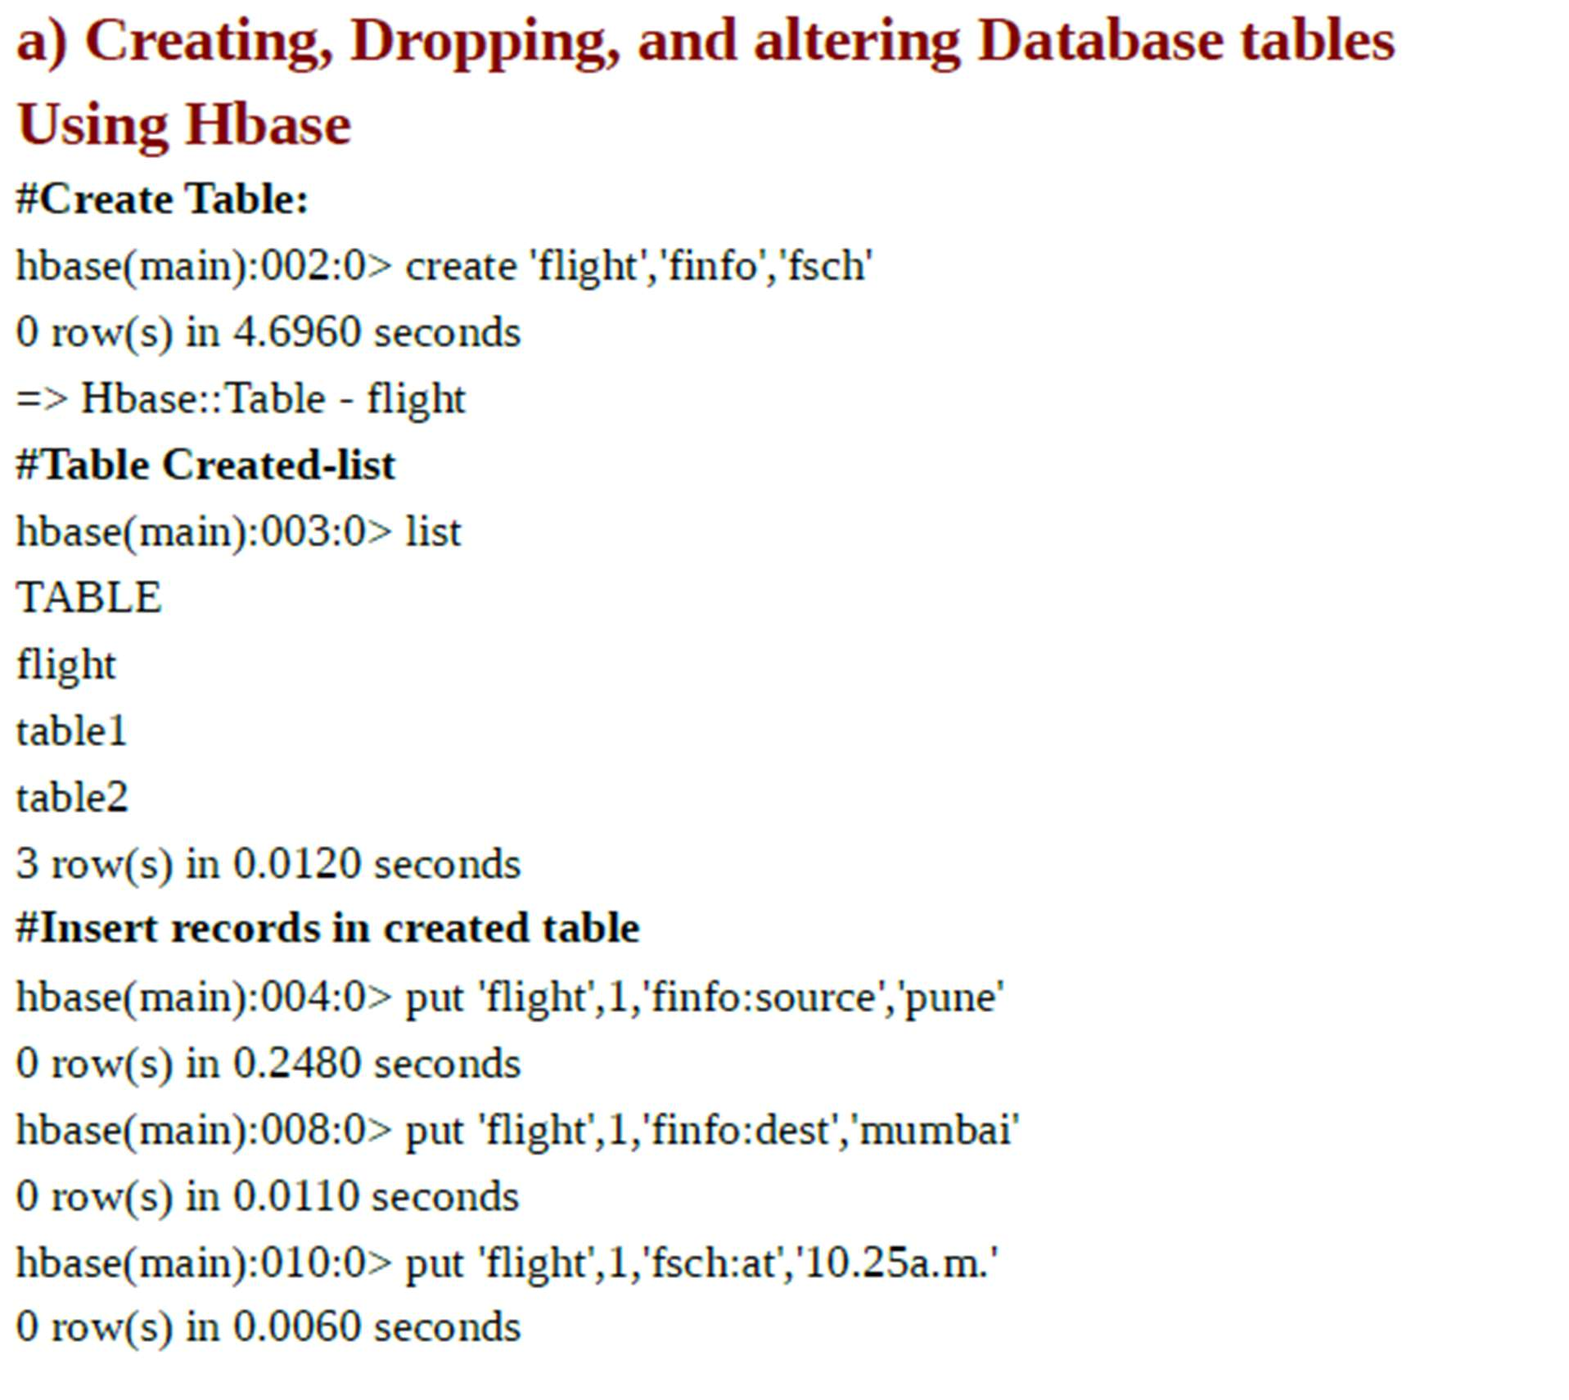

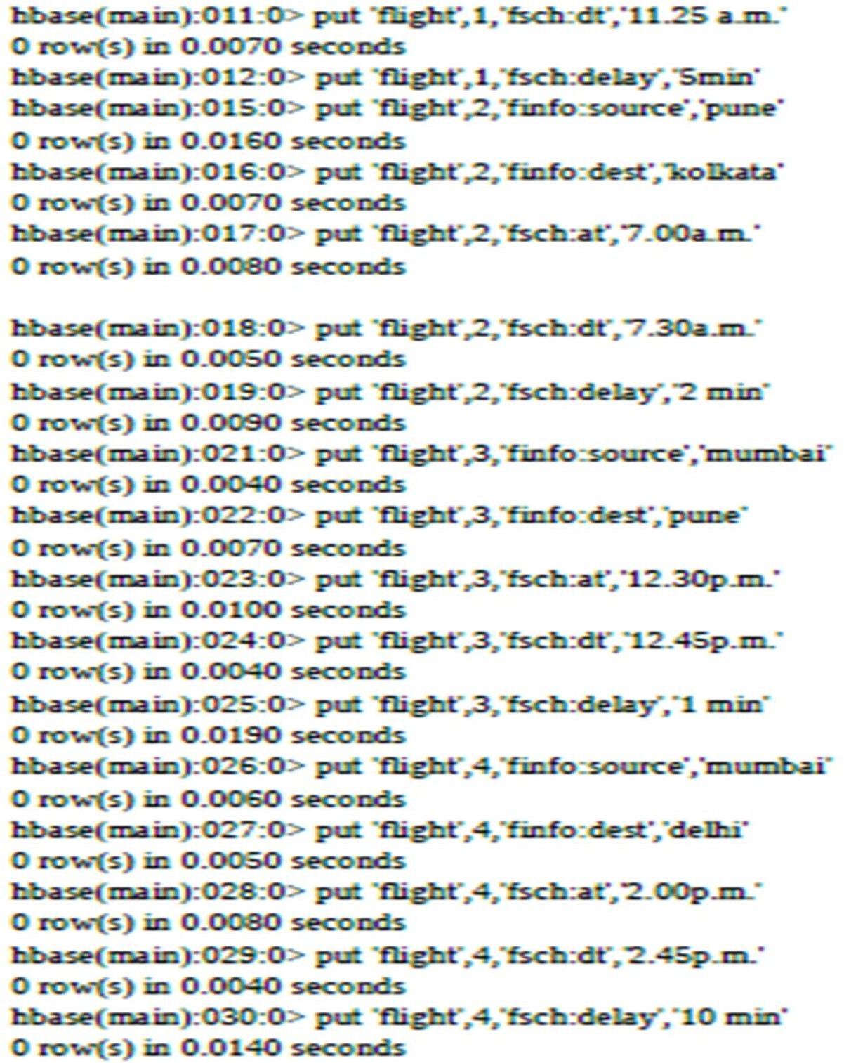

**#Display Records from Table ‘flight’**

hbase(main):031:0> scan 'flight' ROW

**COLUMN+CELL**

1 column=finfo:dest, timestamp=1521312730758, value=mumbai

**1 column=finfo:source, timestamp=1521312493881, value=pune**

1 column=fsch:at, timestamp=1521312789417, value=10.25a.m.

**1 column=fsch:delay, timestamp=1521312850594, value=5min**

1. **column=fsch:dt, timestamp=1521312823256, value=11.25 a.m. 2 column=finfo:dest, timestamp=1521313135697, value=kolkata 2 column=finfo:source, timestamp=1521313092772, value=pune 2 column=fsch:at, timestamp=1521313166540, value=7.00a.m.**
2. **column=fsch:delay, timestamp=1521313229963, value=2 min 2 column=fsch:dt, timestamp=1521313202767, value=7.30a.m.**
3. **column=finfo:dest, timestamp=1521313310302, value=pune**

**3 column=finfo:source, timestamp=1521313290906, value=mumbai 3 column=fsch:at, timestamp=1521313333432, value=12.30p.m.**

1. **column=fsch:delay, timestamp=1521313379725, value=1 min 3 column=fsch:dt, timestamp=1521313353804, value=12.45p.m. 4 column=finfo:dest, timestamp=1521313419679, value=delhi**
2. **column=finfo:source, timestamp=1521313404831, value=mumbai 4 column=fsch:at, timestamp=1521313440328, value=2.00p.m.**

**4 column=fsch:delay, timestamp=1521313472389, value=10 min 4 column=fsch:dt, timestamp=1521313455226, value=2.45p.m. 4 row(s) in 0.0300 seconds**

**#Alter Table (add one more column family) hbase(main):036:0> alter 'flight',NAME=>'revenue' Updating all regions with the new schema...**

**0/1 regions updated. 1/1 regions updated. Done.**

1. **row(s) in 3.7640 seconds hbase(main):037:0> scan 'flight' ROW COLUMN+CELL**
2. **column=finfo:dest, timestamp=1521312730758, value=mumbai 1 column=finfo:source, timestamp=1521312493881, value=pune 1 column=fsch:at, timestamp=1521312789417, value=10.25a.m. 1 column=fsch:delay, timestamp=1521312850594, value=5min**
3. **column=fsch:dt, timestamp=1521312823256, value=11.25 a.m. 2 column=finfo:dest, timestamp=1521313135697, value=kolkata 2 column=finfo:source, timestamp=1521313092772, value=pune 2 column=fsch:at, timestamp=1521313166540, value=7.00a.m.**
4. **column=fsch:delay, timestamp=1521313229963, value=2 min**
5. **column=fsch:dt, timestamp=1521313202767, value=7.30a.m. 3 column=finfo:dest, timestamp=1521313310302, value=pune**
6. **column=finfo:source, timestamp=1521313290906, value=mumbai 3 column=fsch:at, timestamp=1521313333432, value=12.30p.m.**
7. **column=fsch:delay, timestamp=1521313379725, value=1 min 3 column=fsch:dt, timestamp=1521313353804, value=12.45p.m. 4 column=finfo:dest, timestamp=1521313419679, value=delhi**
8. **column=finfo:source, timestamp=1521313404831, value=mumbai 4 column=fsch:at, timestamp=1521313440328, value=2.00p.m.**

**4 column=fsch:delay, timestamp=1521313472389, value=10 min 4 column=fsch:dt, timestamp=1521313455226, value=2.45p.m. 4 row(s) in 0.0290 seconds**

**#Insert records into added column family hbase(main):038:0> put 'flight',4,'revenue:rs','45000' 0 row(s) in 0.0100 seconds**

**#Check the updates hbase(main):039:0> scan 'flight' ROW COLUMN+CELL**

**1 column=finfo:dest, timestamp=1521312730758, value=mumbai 1 column=finfo:source, timestamp=1521312493881, value=pune 1 column=fsch:at, timestamp=1521312789417, value=10.25a.m. 1 column=fsch:delay, timestamp=1521312850594, value=5min**

1. **column=fsch:dt, timestamp=1521312823256, value=11.25 a.m. 2 column=finfo:dest, timestamp=1521313135697, value=kolkata 2 column=finfo:source, timestamp=1521313092772, value=pune 2 column=fsch:at, timestamp=1521313166540, value=7.00a.m.**
2. **column=fsch:delay, timestamp=1521313229963, value=2 min 2 column=fsch:dt, timestamp=1521313202767, value=7.30a.m. 3 column=finfo:dest, timestamp=1521313310302, value=pune**
3. **column=finfo:source, timestamp=1521313290906, value=mumbai 3 column=fsch:at, timestamp=1521313333432, value=12.30p.m.**
4. **column=fsch:delay, timestamp=1521313379725, value=1 min 3 column=fsch:dt, timestamp=1521313353804, value=12.45p.m. 4 column=finfo:dest, timestamp=1521313419679, value=delhi**
5. **column=finfo:source, timestamp=1521313404831, value=mumbai 4 column=fsch:at, timestamp=1521313440328, value=2.00p.m.**

**4 column=fsch:delay, timestamp=1521313472389, value=10 min 4 column=fsch:dt, timestamp=1521313455226, value=2.45p.m. 4 column=revenue:rs, timestamp=1521314406914, value=45000 4 row(s) in 0.0340 seconds**

**#Delete Column family**

**hbase(main):040:0> alter 'flight',NAME=>'revenue',METHOD=>'delete' Updating all regions with the new schema...**

**0/1 regions updated. 1/1 regions updated. Done.**

1. **row(s) in 3.7880 seconds #changes Reflected in Table hbase(main):041:0> scan 'flight' ROW COLUMN+CELL**
2. **column=finfo:dest, timestamp=1521312730758, value=mumbai 1 column=finfo:source, timestamp=1521312493881, value=pune 1 column=fsch:at, timestamp=1521312789417, value=10.25a.m. 1 column=fsch:delay, timestamp=1521312850594, value=5min**
3. **column=fsch:dt, timestamp=1521312823256, value=11.25 a.m. 2 column=finfo:dest, timestamp=1521313135697, value=kolkata 2 column=finfo:source, timestamp=1521313092772, value=pune 2 column=fsch:at, timestamp=1521313166540, value=7.00a.m.**
4. **column=fsch:delay, timestamp=1521313229963, value=2 min 2 column=fsch:dt, timestamp=1521313202767, value=7.30a.m. 3 column=finfo:dest, timestamp=1521313310302, value=pune**
5. **column=finfo:source, timestamp=1521313290906, value=mumbai 3 column=fsch:at, timestamp=1521313333432, value=12.30p.m.**
6. **column=fsch:delay, timestamp=1521313379725, value=1 min 3 column=fsch:dt, timestamp=1521313353804, value=12.45p.m. 4 column=finfo:dest, timestamp=1521313419679, value=delhi**
7. **column=finfo:source, timestamp=1521313404831, value=mumbai 4 column=fsch:at, timestamp=1521313440328, value=2.00p.m.**

**4 column=fsch:delay, timestamp=1521313472389, value=10 min 4 column=fsch:dt, timestamp=1521313455226, value=2.45p.m. 4 row(s) in 0.0280 seconds**

#Drop Table

**#Create Table for dropping hbase(main):046:0* create 'tb1','cf' 0 row(s) in 2.3120 seconds**

**=> Hbase::Table - tb1 hbase(main):047:0> list TABLE**

**flight table1 table2 tb1**

**4 row(s) in 0.0070 seconds**

**=> ["flight", "table1", "table2", "tb1"] #Drop Table**

**hbase(main):048:0> drop 'tb1'**

**ERROR: Table tb1 is enabled. Disable it first.**

**Here is some help for this command:**

**Drop the named table. Table must first be disabled: hbase> drop 't1'**

**hbase> drop 'ns1:t1' #Disable table**

**hbase(main):049:0> disable 'tb1' 0 row(s) in 4.3480 seconds hbase(main):050:0> drop 'tb1'**

**0 row(s) in 2.3540 seconds hbase(main):051:0> list TABLE**

**flight table1 table2**

**3 row(s) in 0.0170 seconds**

**=> ["flight", "table1", "table2"] #Read data from table for row key 1: hbase(main):052:0> get 'flight',1 COLUMN CELL**

**finfo:dest timestamp=1521312730758, value=mumbai finfo:source timestamp=1521312493881, value=pune fsch:at timestamp=1521312789417, value=10.25a.m. fsch:delay timestamp=1521312850594, value=5min fsch:dt timestamp=1521312823256, value=11.25 a.m. 5 row(s) in 0.0450 seconds**

**Read data for particular column from HBase table: hbase(main):053:0> get 'flight','1',COLUMN=>'finfo:source' COLUMN CELL**

**finfo:source timestamp=1521312493881, value=pune**

**1 row(s) in 0.0110 seconds**

**Read data for multiple columns in HBase Table:**

**hbase(main):054:0> get 'flight','1',COLUMN=>['finfo:source','finfo:dest'] COLUMN CELL**

**finfo:dest timestamp=1521312730758, value=mumbai finfo:source timestamp=1521312493881, value=pune 2 row(s) in 0.0190 seconds**

**hbase(main):055:0> scan 'flight',COLUMNS=>'finfo:source' ROW COLUMN+CELL**

**1 column=finfo:source, timestamp=1521312493881, value=pune 2 column=finfo:source, timestamp=1521313092772, value=pune**

**3 column=finfo:source, timestamp=1521313290906, value=mumbai 4 column=finfo:source, timestamp=1521313404831, value=mumbai 4 row(s) in 0.0320 seconds**

1. **Creating an external Hive table to connect to the HBase for Customer Information Table**

Covers===>

1. **Load table with data, insert new values and field in the table, Join tables with**

Hive

**# Create the external table emp using hive**

**hive>create external table empdata2 ( ename string, esal int)**

**row format delimited fields terminated by "," stored as textfile location "/home/hduser/Desktop/empdata2";**

**hive>load data local inpath '/home/hduser/Desktop/empdb.txt' into table empdata2;**

#Create External Table in hive referring to hbase table

**# create hbase table emphive first hbase(main):003:0> create 'emphive', 'cf' 0 row(s) in 4.6260 seconds**

**#create hive external table**

**CREATE external TABLE hive_table_emp(id int, name string, esal string) STORED BY 'org.apache.hadoop.hive.hbase.HBaseStorageHandler'**

**WITH SERDEPROPERTIES ("hbase.columns.mapping" = ":key,cf:name,cf:esal") TBLPROPERTIES ("hbase.table.name" = "emphive");**

# load data into hive_table_emp

**(Hive doesn’t allow directly inserting data into external hive table)**

**#for that create one hive table(managed table in hive)**

**Managed table and External table in Hive. There are two types of tables in Hive ,one is Managed**

**table and second is external table. the difference is , when you drop a table, if it is managed table**

**hive deletes both data and meta data,if it is external table Hive only deletes metadata.**

**hive>create table empdbnew(eno int, ename string, esal int) row format delimited fields terminated**

**by ',' stored as textfile; #load data in managed table**

**hive>load data local inpath '/home/hduser/Desktop/empdbnew.txt' into table empdbnew; #Load data in external table from managed table.**

**hive>INSERT INTO hive_table_emp select * from empdbnew; hive> select * from hive_table_emp;**

**OK**

1. **deepali120000**
2. **mahesh 30000**
3. **mangesh 25000**

**4 ram 39000**

**5 brijesh 40000**

**6 john 300000**

**Time taken: 0.52 seconds, Fetched: 6 row(s) #display records where salary is greater than 40000**

**hive> select * from hive_table_emp where esal>40000; OK**

**1 deepali120000**

**6 john 300000**

**Time taken: 0.546 seconds, Fetched: 2 row(s)**

**#Check hbase for updates(The records are available in associated Hbase table) hbase(main):008:0> scan 'emphive'**

**ROW COLUMN+CELL**

**1 column=cf:esal, timestamp=1522212425665, value=120000**

1. **column=cf:name, timestamp=1522212425665, value=deepali 2 column=cf:esal, timestamp=1522212425665, value=30000**
2. **column=cf:name, timestamp=1522212425665, value=mahesh 3 column=cf:esal, timestamp=1522212425665, value=25000**
3. **column=cf:name, timestamp=1522212425665, value=mangesh 4 column=cf:esal, timestamp=1522212425665, value=39000**
4. **column=cf:name, timestamp=1522212425665, value=ram 5 column=cf:esal, timestamp=1522212425665, value=40000**
5. **column=cf:name, timestamp=1522212425665, value=brijesh 6 column=cf:esal, timestamp=1522212425665, value=300000 6 column=cf:name, timestamp=1522212425665, value=john**
6. **row(s) in 0.0700 seconds**

# Creating external table in Hive referring to Hbase #referring to flight table created in Hbase

**CREATE external TABLE hbase_flight_new(fno int, fsource string,fdest string,fsh_at string,fsh_dt string,fsch_delay**

**string,delay int)**

**STORED BY 'org.apache.hadoop.hive.hbase.HBaseStorageHandler' WITH SERDEPROPERTIES ("hbase.columns.mapping" = ":key,finfo:source,finfo:dest,fsch:at,fsch:dt,fsch:delay,delay:dl") TBLPROPERTIES ("hbase.table.name" = "flight");**

**hive> CREATE external TABLE hbase_flight_new(fno int, fsource string,fdest string,fsh_at string,fsh_dt string,fsch_delay string,delay int)**

* **STORED BY 'org.apache.hadoop.hive.hbase.HBaseStorageHandler'**
* **WITH SERDEPROPERTIES ("hbase.columns.mapping"**

**=":key,finfo:source,finfo:dest,fsch:at,fsch:dt,fsch:delay,delay:dl")**

* **TBLPROPERTIES ("hbase.table.name" = "flight");**

**OK**

**Time taken: 0.361 seconds #table created in hive hive> show tables;**

**OK**

**abc ddl_hive emp empdata empdata1 empdata2 empdbnew hbase_flight**

**hbase_flight1 hbase_flight_new hbase_table_1 hive_table_emp**

**Time taken: 0.036 seconds, Fetched: 12 row(s) # Display records from that table**

**hive> select * from hbase_flight_new; OK**

1. **pune mumbai 10.25a.m. 11.25 a.m. 5min 10**
2. **pune kolkata7.00a.m. 7.30a.m. 2 min 4**
3. **mumbai pune 12.30p.m. 12.45p.m. 1 min 5**
4. **mumbai delhi 2.00p.m. 2.45p.m. 10 min 16 Time taken: 0.581 seconds, Fetched: 4 row(s)**

#### e) Find the average departure delay per day in 2008.

**#calculate average delay**

**hive> select sum(delay) from hbase_flight_new;**

**WARNING: Hive-on-MR is deprecated in Hive 2 and may not be available in the future versions.**

**Consider using a different execution engine (i.e. spark, tez) or using Hive 1.X releases. Query ID = hduser_20180328130004_47384e9a-7490-4dfb-809d-ae240507bfab**

**Total jobs = 1 Launching Job 1 out of 1**

**Number of reduce tasks determined at compile time: 1**

**In order to change the average load for a reducer (in bytes):**

**set hive.exec.reducers.bytes.per.reducer=<number> In order to limit the maximum number of reducers:**

**set hive.exec.reducers.max=<number>**

**In order to set a constant number of reducers:**

**set mapreduce.job.reduces=<number>**

**Starting Job = job_1522208646737_0003, Tracking URL = http://localhost:8088/proxy/application_1522208646737_0003/**

**Kill Command = /usr/local/hadoop/bin/hadoop job -kill job_1522208646737_0003 Hadoop job information for Stage-1: number of mappers: 1; number of reducers: 1 2018-03-28 13:00:20,256 Stage-1 map = 0%, reduce = 0%**

**2018-03-28 13:00:28,747 Stage-1 map = 100%, reduce = 0%, Cumulative CPU 3.68 sec**

**2018-03-28 13:00:35,101 Stage-1 map = 100%, reduce = 100%, Cumulative CPU 6.26 sec MapReduce Total cumulative CPU time: 6 seconds 260 msec**

**Ended Job = job_1522208646737_0003 MapReduce Jobs Launched:**

**Stage-Stage-1: Map: 1 Reduce: 1 Cumulative CPU: 6.26 sec HDFS Read: 9095 HDFS Write:**

**102 SUCCESS**

**Total MapReduce CPU Time Spent: 6 seconds 260 msec OK**

**35**

**Time taken: 31.866 seconds, Fetched: 1 row(s) hive>**

#### d) Create index on Flight information Table

**#create index on hbase_flight_new CREATE INDEX hbasefltnew_index ON TABLE hbase_flight_new (delay)**

**AS 'org.apache.hadoop.hive.ql.index.compact.CompactIndexHandler' WITH DEFERRED REBUILD;**

**SHOW INDEX ON hbase_flight_new; #create index on table hbase_flight_new hive> CREATE INDEX hbasefltnew_index**

* **ON TABLE hbase_flight_new (delay)**
* **AS 'org.apache.hadoop.hive.ql.index.compact.CompactIndexHandler'**
* **WITH DEFERRED REBUILD; OK**

**Time taken: 0.74 seconds**

**#show index on table hbase_flight_new hive> SHOW INDEX ON hbase_flight_new; OK**

**hbasefltnew_index hbase_flight_new delay**

**default hbase_flight_new_hbasefltnew_index compact Time taken: 0.104 seconds, Fetched: 1 row(s)**

**#join two tables in Hive**

**#create table B for join**

**hive> create table empinfo(empno int, empgrade string) row format delimited fields terminated by**

**',' stored as textfile; #Load Data into table**

**hive> load data local inpath '/home/hduser/Desktop/empinfo.txt' into table empinfo; Loading data to table default.empinfo**

**OK**

**Time taken: 0.552 seconds #insert data into the table**

**hive> load data local inpath '/home/hduser/Desktop/empinfo.txt' into table empinfo; # Table A empdbnew**

**hive> select * from empdbnew; OK**

1. **deepali120000**
2. **mahesh 30000**
3. **mangesh 25000**

**4 ram 39000**

**5 brijesh 40000**

**6 john 300000**

**Time taken: 0.258 seconds, Fetched: 6 row(s) # Table B empinfo**

**hive> select * from empinfo; OK**

1. **A**
2. **B**
3. **B**
4. **B**
5. **B**
6. **A**

**Time taken: 0.207 seconds, Fetched: 6 row(s)**

**#Join two tables(empdbnew with empinfo on empno)**

**hive> SELECT eno, ename, empno, empgrade FROM empdbnew JOIN empinfo ON eno**

**= empno; #Join==> Result**

**hive> SELECT eno, ename, empno, empgrade**

* **FROM empdbnew JOIN empinfo ON eno = empno;**

**WARNING: Hive-on-MR is deprecated in Hive 2 and may not be available in the future versions.**

**Consider using a different execution engine (i.e. spark, tez) or using Hive 1.X releases. Query ID = hduser_20180328153258_bc345f46-a1f1-4589-ac5e-4c463834731a**

**Total jobs = 1 Launching Job 1 out of 1**

**Number of reduce tasks not specified. Estimated from input data size: 1 In order to change the average load for a reducer (in bytes):**

**set hive.exec.reducers.bytes.per.reducer=<number> In order to limit the maximum number of reducers:**

**set hive.exec.reducers.max=<number>**

**In order to set a constant number of reducers:**

**set mapreduce.job.reduces=<number>**

**Starting Job = job_1522208646737_0005, Tracking URL = http://localhost:8088/proxy/application_1522208646737_0005/**

**Kill Command = /usr/local/hadoop/bin/hadoop job -kill job_1522208646737_0005 Hadoop job information for Stage-1: number of mappers: 2; number of reducers: 1 2018-03-28 15:33:09,615 Stage-1 map = 0%, reduce = 0%**

**2018-03-28 15:33:18,231 Stage-1 map = 100%, reduce = 0%, Cumulative CPU 8.17 sec**

**2018-03-28 15:33:24,476 Stage-1 map = 100%, reduce = 100%, Cumulative CPU 10.61 sec MapReduce Total cumulative CPU time: 10 seconds 610 msec**

**Ended Job = job_1522208646737_0005 MapReduce Jobs Launched:**

**Stage-Stage-1: Map: 2 Reduce: 1 Cumulative CPU: 10.61 sec HDFS Read: 15336 HDFS Write:**

**235 SUCCESS**

**Total MapReduce CPU Time Spent: 10 seconds 610 msec OK**

1. **deepali1 A**
2. **mahesh 2 B**
3. **mangesh 3 B**
4. **ram 4 B**
5. **brijesh 5 B**
6. **john 6 A**

**Time taken: 26.915 seconds, Fetched: 6 row(s)**

REFERENCES:

https://cwiki.apache.org/confluence/display/Hive/Tutorial

https://cwiki.apache.org/confluence/display/Hive/GettingStarted

https://docs.cloudera.com/HDPDocuments/HDP2/HDP-2.5.0/bk_hive- performance-tuning/content/ch_hive_architectural_overview.html

https://hbase.apache.org/book.html

CONCLUSION:

Understand to use various aggregate functions using map reduce.

**PartB**

**Assignments based on Data Analytics using Python**

Assignment: 4

**AIM:** Perform the different operations using Python on the Facebook metrics data set.

**PROBLEM STATEMENT /DEFINITION**

Perform the following operations using R/Python on the Amazon book review and facebook metrics data sets

* 1. Create data subsets
  2. Merge Data
  3. Sort Data
  4. Transposing Data
  5. Melting Data to long format Casting data to wide format **OBJECTIVE:**

To learn Python programming

To learn different data preprocessing techniques.

**THEORY:**

* + 1. Create data subsets

1. Create a subset of a Python dataframe using the loc() function

Python loc() function enables us to form a subset of a data frame according to a specific row or column or a combination of both.

The loc() function works on the basis of labels i.e. we need to provide it with the label of the row/column to choose and create the customized subset.

Syntax: pandas.dataframe.loc[]

1. Using Python iloc() function to create a subset of a dataframe

**Python iloc() function enables us to create subset choosing specific values from rows and columns based on indexes. That is, unlike loc() function which works on labels, iloc() function works on index values. We can choose and create a subset of a Python dataframe from the data providing the index numbers of the** rows and columns.

Syntax: pandas.dataframe.iloc[]

1. Indexing operator to create a subset of a dataframe

**In a simple manner, we can make use of an indexing operator i.e. square brackets to create a subset of the data.**

**Syntax:dataframe[['col1','col2','colN']]**

* + 1. Merge Data

**Pandas has full-featured, high performance in-memory join operations idiomatically very similar to relational databases like SQL.**

Pandas provides a single function, merge, as the entry point for all standard database join operations between DataFrame objects −

**pd.merge(left, right, how='inner', on=None, left_on=None, right_on=None,**

**left_index=False, right_index=False, sort=True)**

Here, we have used the following parameters −

* left − A DataFrame object.
* right − Another DataFrame object.
* on − Columns (names) to join on. Must be found in both the left and right DataFrame objects.
* left_on − Columns from the left DataFrame to use as keys. Can either be column names or arrays with length equal to the length of the DataFrame.
* right_on − Columns from the right DataFrame to use as keys. Can either be column names or arrays with length equal to the length of the DataFrame.
* left_index − If True, use the index (row labels) from the left DataFrame as its join key(s). In case of a DataFrame with a MultiIndex (hierarchical), the number of levels must match the number of join keys from the right DataFrame.
* right_index − Same usage as left_index for the right DataFrame.
* how − One of 'left', 'right', 'outer', 'inner'. Defaults to inner. Each method has been described below.
* sort − Sort the result DataFrame by the join keys in lexicographical order. Defaults to True, setting to False will improve the performance substantially in many cases.
  + 1. Sort Data

**pandas.DataFrame.sort_values**

**DataFrame.sort_values(by, axis=0, ascending=True, inplace=False, kind='quicksort', na_position='last', ignore_index=False, key=None)[source]**

**Sort by the values along either axis.**

* + 1. Transposing Data

pandas.DataFrame.transpose

**DataFrame.transpose(*\*args*, *copy=False*)[source]**

63

**Transpose index and columns.**

**Reflect the DataFrame over its main diagonal by writing rows as columns and vice-versa. The property T is an accessor to the method transpose().**

**Parameters**

**\*args*tuple, optional***

**Accepted for compatibility with NumPy. copy*bool, default False***

**Whether to copy the data after transposing, even for DataFrames with a single dtype.**

**Note that a copy is always required for mixed dtype DataFrames, or for DataFrames with any extension types.**

**Returns DataFrame**

**The transposed DataFrame.**

* + 1. Melting Data to long format

pandas.melt

**pandas.melt(*frame*, *id_vars=None*, *value_vars=None*, *var_name=None*, *value_name='value'*, *col_level=None*, *ignore_index=True*)**

**Unpivot a DataFrame from wide to long format, optionally leaving identifiers set.**

**This function is useful to massage a DataFrame into a format where one or more columns are identifier variables (id_vars), while all other columns, considered measured variables (value_vars), are “unpivoted” to the row axis, leaving just two non-identifier columns, ‘variable’ and ‘value’.**

**Parameters**

**id_vars*tuple, list, or ndarray, optional***

**Column(s) to use as identifier variables. value_vars*tuple, list, or ndarray, optional***

**Column(s) to unpivot. If not specified, uses all columns that are not set as id_vars. var_name*scalar***

**Name to use for the ‘variable’ column. If None it uses frame.columns.name or ‘variable’.**

**value_name*scalar, default ‘value’***

**Name to use for the ‘value’ column.**

**col_level*int or str, optional***

**If columns are a MultiIndex then use this level to melt.**

**ignore_index*bool, default True***

**If True, original index is ignored. If False, the original index is retained. Index labels will be repeated as necessary.**

**Returns**

**DataFrame**

**Unpivoted DataFrame.**

pandas.DataFrame.pivot

**DataFrame.pivot(*index=None*, *columns=None*, *values=None*)**

**Return reshaped DataFrame organized by given index / column values.**

**Reshape data (produce a “pivot” table) based on column values. Uses unique values from specified index / columns to form axes of the resulting DataFrame. This function does not support data aggregation, multiple values will result in a MultiIndex in the columns. See the User Guide for more on reshaping.**

**Parameters**

**index*str or object or a list of str, optional***

**Column to use to make new frame’s index. If None, uses existing index. columns*str or object or a list of str***

**Column to use to make new frame’s columns.**

**values*str, object or a list of the previous, optional***

**Column(s) to use for populating new frame’s values. If not specified, all remaining columns will be used and the result will have hierarchically indexed columns.**

**Returns DataFrame**

**Returns reshaped DataFrame. Raises**

**ValueError:**

**When there are any index, columns combinations with multiple values. DataFrame.pivot_table when you need to aggregate.**

Implementation

**import pandas as pd**

**from google.colab import files uploaded = files.upload() import io**

**df = pd.read_csv(io.BytesIO(uploaded['dataset_Facebook.csv']),sep = ';') #print(df)**

**df.head(5) df['Type'] video_sub=df['Type'] print(df.columns)**

**Bydf_subset = df[['like','share']] print(Bydf_subset)**

**Hydf_subset1 = df[df['like']>100] print(Hydf_subset1) df.loc[1:7,['like','share']] df.sort_values(by = "like",ascending= False) df.sort_values("like")**

**df.sort_values(by = "like",ascending= False, kind="mergesort") Byresult = df.transpose()**

**print(Byresult)**

**selective_df = pd.DataFrame(df,columns**

**=['like','share','Category','Type']) selective_df.head(5)**

**pivot_table = pd.pivot_table(selective_df,index= ['Category','like']) print(pivot_table)**

REFERENCES:

**https://pandas.pydata.org/docs/reference/api/pandas.DataFrame.pivot.html**

CONCLUSION:

**Understand different data preprocessing techniques**

Assignment: 5

**AIM:** Perform different data cleaning and data model building operations using Python

**PROBLEM STATEMENT /DEFINITION**

Perform the following operations using Python on the Air quality and Heart Diseases data sets

* + - 1. Data cleaning
      2. Data integration
      3. Data transformation
      4. Error correcting
      5. Data model building

**OBJECTIVE:**

To learn data processing methods To learn building data model **THEORY:**

Statistical analysis in five steps In this tutorial a statistical analysis is viewed as the result of a number of data processing steps where each step increases the ``value'' of the data* . Raw data . Technically correct data Consistent data Statistical results Formatted output type checking, normalizing fix and impute estimate, analyze, derive, etc. tabulate, plot data cleaning

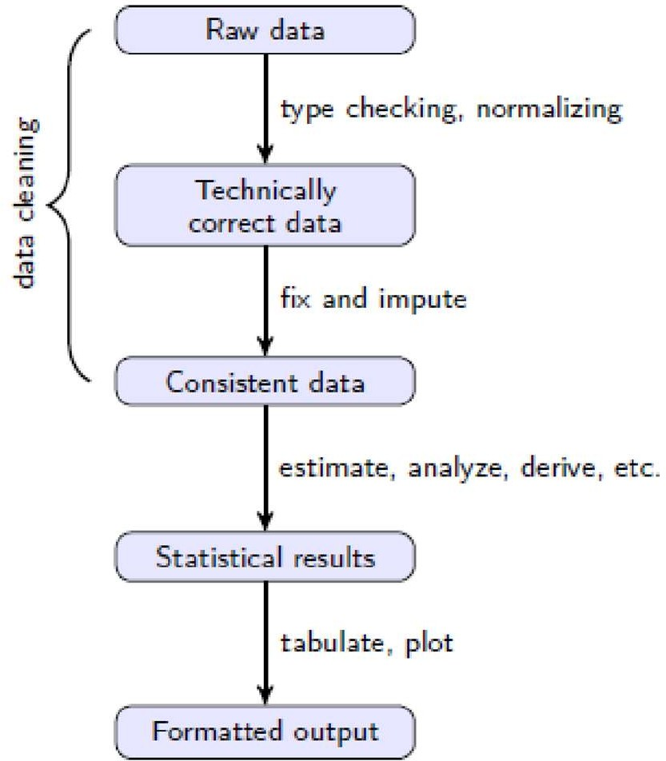

Fig. 1 Statistical analysis value chain

Figure 1 shows an overview of a typical data analysis project. Each rectangle represents data in a certain state while each arrow represents the activities needed to get from one state to the other. The first state (Raw data) is the data as it comes in. Raw data files may lack headers, contain wrong data types (e.g. numbers stored as strings), wrong category labels, unknown or unexpected character encoding and so on.

* + 1. Variable types and indexing techniques

If you had to choose to be proficient in just one R-skill, it should be indexing. By indexing we mean all the methods and tricks in R that allow you to select and manipulate data using logical, integer or named indices. Since indexing skills are important for data cleaning, we quickly

review vectors, data.frames and indexing techniques. The most basic variable in R is a vector. An R vector is a sequence of values of the same type. All basic operations in R act on vectors (think of the element-wise arithmetic, for example). The basic types in R are as follows. numeric Numeric data (approximations of the real numbers, ℝ) integer Integer data (whole numbers, ℤ) factor Categorical data (simple classifications, like gender) ordered Ordinal data (ordered classifications, like educational level) character Character data (strings) raw Binary data All basic operations in R work element-wise on vectors where the shortest argument is recycled if necessary. This goes for arithmetic operations (addition, subtraction,…), comparison operators (==, <=,…), logical operators (&, |, !,…) and basic math functions like sin, cos, exp and so on. If you want to brush up your basic knowledge of vector and recycling properties, you can execute the following code and think about why it works the way it does.

# vectors have variables of _one_ type c(1, 2, "three")

# shorter arguments are recycled (1:3) * 2

(1:4) * c(1, 2)

# warning! (why?) (1:4) * (1:3)

Each element of a vector can be given a name. This can be done by passing named arguments to the c() function or later with the names function. Such names can be helpful giving meaning to your variables. For example compare the vector

x <- c("red", "green", "blue") with the one below.

capColor = c(huey = "red", duey = "blue", louie = "green")

Obviously the second version is much more suggestive of its meaning. The names of a vector need not be unique, but in most applications you'll want unique names (if any). Elements of a vector can be selected or replaced using the square bracket operator [ ]. The square brackets accept either a vector of names, index numbers, or a logical. In the case of a logical, the index is recycled if it is shorter than the indexed vector. In the case of numerical indices, negative indices omit, in stead of select elements. Negative and positive indices are not allowed in the same index vector. You can repeat a name or an index number, which results in multiple instances of the same value. You may check the above by predicting and then verifying the result of the following statements.

capColor["louie"] names(capColor)[capColor == "blue"] x <- c(4, 7, 6, 5, 2, 8)

I <- x < 6 J <- x > 7

x[I | J]

x[c(TRUE, FALSE)]

x[c(-1, -2)]

Replacing values in vectors can be done in the same way. For example, you may check that in the following assignment

x <- 1:10

x[c(TRUE, FALSE)] <- 1

every other value of x is replaced with 1. A list is a generalization of a vector in that it can contain objects of different types, including other lists. There are two ways to index a list. The single bracket operator always returns a sub-list of the indexed list. That is, the resulting type is again a list. The double bracket operator ([[ ]]) may only result in a single item, and it returns the object in the list itself. Besides indexing, the dollar operator $ can be used to retrieve a single element. To understand the above, check the results of the following statements.

L <- list(x = c(1:5), y = c("a", "b", "c"), z = capColor) L[[2]]

L$y L[c(1, 3)]

L[c("x", "y")]

L[["z"]]

Especially, use the class function to determine the type of the result of each statement. A data.frame is not much more than a list of vectors, possibly of different types, but with every vector (now columns) of the same length. Since data.frames are a type of list, indexing them with a single index returns a sub-data.frame; that is, a data.frame with less columns. Likewise, the dollar operator returns a vector, not a sub-data.frame. Rows can be indexed using two indices in the bracket operator, separated by a comma. The first index indicates rows, the second indicates columns. If one of the indices is left out, no selection is made (so everything is returned). It is important to realize that the result of a two-index selection is simplified by R as much as possible. Hence, selecting a single column using a two-index results in a vector. This behaviour may be switched off using drop=FALSE as an extra parameter. Here are some short examples demonstrating the above.

d <- data.frame(x = 1:10, y = letters[1:10], z = LETTERS[1:10]) d[1]

d[, 1]

d[, "x", drop = FALSE] d[c("x", "z")]

d[d$x > 3, "y", drop = FALSE] d[2, ]

* + 1. Special values Like most programming languages, R has a number of Special values that are exceptions to the normal values of a type. These are NA, NULL, ±Inf and NaN. Below, we quickly illustrate the meaning and differences between them. NA Stands for not available. NA is a placeholder for a missing value. All basic operations in R handle NA without crashing and mostly return NA as an answer whenever one of the input arguments is NA. If you understand NA, you should be able to predict the result of the following R statements.

NA + 1

sum(c(NA, 1, 2))

median(c(NA, 1, 2, 3), na.rm = TRUE)

length(c(NA, 2, 3, 4))

3 == NA NA == NA TRUE | NA

The function is.na can be used to detect NA's. NULL You may think of NULL as the empty set from mathematics. NULL is special since it has no class (its class is NULL) and has length 0 so it does not take up any space in a vector. In particular, if you understand NULL, the result of the following statements should be clear to you without starting R.

length(c(1, 2, NULL, 4))

sum(c(1, 2, NULL, 4)) x <- NULL

c(x, 2)

The function is.null can be used to detect NULL variables. Inf Stands for infinity and only applies to vectors of class numeric. A vector of class integer can never be Inf. This is because the Inf in R is directly derived from the international standard for floating point arithmetic 1 . Technically, Inf is a valid numeric that results from calculations like division of a number by zero. Since Inf is a numeric, operations between Inf and a finite numeric are well-defined and comparison operators work as expected. If you understand Inf, the result of the following statements should be clear to you.

pi/0

1. * Inf

Inf - 1e+10 Inf + Inf

1. < -Inf Inf == Inf

NaN Stands for not a number. This is generally the result of a calculation of which the result is unknown, but it is surely not a number. In particular operations like 0/0, Inf-Inf and Inf/Inf result in NaN. Technically, NaN is of class numeric, which may seem odd since it is used to indicate that something is not numeric. Computations involving numbers and NaN always result in NaN, so the result of the following computations should be clear.

NaN + 1

exp(NaN)

The function is.nan can be used to detect NaN's.

c.Data Transformations

A number of reasons can be attributed to when a predictive model crumples such as:

* + Inadequate data pre-processing
  + Inadequate model validation
  + Unjustified extrapolation
  + Over-fitting (Kuhn, 2013)

Before we dive into data preprocessing, let me quickly define a few terms that I will be commonly using.

* + *Predictor/Independent/Attributes/Descriptors* – are the different terms that are used as input for the prediction equation.
  + *Response/Dependent/Target/Class/Outcome* – are the different terms that are referred to the outcome event that is to be predicted.

In this article, I am going to summarize some common data pre-processing approaches with examples in R

1. Centering and Scaling

Variable centering is perhaps the most intuitive approach used in predictive modeling. To center a predictor variable, the average predictor value is subtracted from all the values. as a result of centering, the predictor has zero mean.

To scale the data, each predictor value is divided by its standard deviation (sd). This helps in coercing the predictor value to have a *sd* of one. Needless to mention, centering and scaling will work for continuous data. The drawback of this activity is loss of interpretability of the individual values.

An R example:

1

2

3

4

5

6

7

* 1. # Load the default datasets
  2. > library(datasets)

1 > data(mtcars)

0 > dim(mtcars)

1 32 11

* str(mtcars)

1

'data.frame': 32 obs. of 11 variables:

1 $ mpg : num 21 21 22.8 21.4 18.7 18.1 14.3 24.4 22.8 19.2 ...

2 $ cyl : num 6 6 4 6 8 6 8 4 4 6 ...

1 $ disp: num 160 160 108 258 360 ...

3 $ hp : num 110 110 93 110 175 105 245 62 95 123 ...

$ drat: num 3.9 3.9 3.85 3.08 3.15 2.76 3.21 3.69 3.92 3.92 ...

1

$ wt : num 2.62 2.88 2.32 3.21 3.44 ...

4 $ qsec: num 16.5 17 18.6 19.4 17 ...

1 $ vs : num 0 0 1 1 0 1 0 1 1 1 ...

5 $ am : num 1 1 1 0 0 0 0 0 0 0 ...

1 $ gear: num 4 4 4 3 3 3 3 4 4 4 ...

$ carb: num 4 4 1 1 2 1 4 2 2 4 ...

1. > cov(mtcars$disp, mtcars$cyl) # check for covariance

1 [1] 199.6603

1. > mtcars$disp.scl<-scale(mtcars$disp, center = TRUE, scale = TRUE) > mtcars$cyl.scl<-

1 check for covariance in scaled data

[,1]

8

[1,] 0.9020329

1

9

2

0

2

1

2

2

1. Resolving Skewness

Skewness is a measure of shape. A common appraoch to check for skewness is to plot the predictor variable. As a rule, negative skewness indicates that the mean of the data values is less than the median, and the data distribution is left-skewed. Positive skewness would indicates that the mean of the data values is larger than the median, and the data distribution is right-skewed.

* If the skewness of the predictor variable is 0, the data is perfectly symmetrical,
* If the skewness of the predictor variable is less than -1 or greater than +1, the data is highly skewed,
* If the skewness of the predictor variable is between -1 and -1/2 or between +1 and +1/2 then the data is moderately skewed,
* If the skewness of the predictor variable is -1/2 and +1/2, the data is approximately symmetric.

I will use the function skewness from the e1071 package to compute the skewness coefficient An R example:

1 > library(e1071)

* + engine.displ<-skewness(mtcars$disp) >

2

engine.displ

3 [1] 0.381657

So the variable displ is moderately positively skewed.

1. Resolving Outliers

The outliers package provides a number of useful functions to systematically extract outliers. Some of these are convenient and come handy, especially the outlier() and scores() functions.

Outliers

The function outliers() gets the extreme most observation from the mean. If you set the argument opposite=TRUE, it fetches from the other side.

An R example:

* + > set.seed(4680) # for code reproducibility
  + > y<- rnorm(100) # create some dummy data > library(outliers) # load the library
  + > outlier(y)

4 [1] 3.581686

1. > dim(y)<-c(20,5) # convert it to a matrix > head(y,2)# Look at the first 2 rows of
2. data

7

|  |  |  |  |  |
| --- | --- | --- | --- | --- |
| [1,] 0.5850232 | 1.7782596 | 2.051887 | 1.061939 | -0.4421871 |
| [2,] 0.5075315 | -0.4786253 | -1.885140 | -0.582283 | 0.8159582 |

8

[,1] [,2] [,3] [,4] [,5]

9 > outlier(y) # Now, check for outliers in the matrix

10 [1] -1.902847 -2.373839 3.581686 1.583868 1.877199

* outlier(y, opposite = TRUE)

11

[1] 1.229140 2.213041 -1.885140 -1.998539 -1.571196

12

There are two aspects the the scores() function.

Compute the normalised scores based on “z”, “t”, “chisq” etc

Find out observations that lie beyond a given percentile based on a given score.

1 > set.seed(4680)

1. > x = rnorm(10)
2. > scores(x) # z-scores => (x-mean)/sd

[1] 0.9510577 0.8691908 0.6148924 -0.4336304 -1.6772781...

4

* + scores(x, type="chisq") # chi-sq scores => (x - mean(x))^2/var(x)

5 [1] 0.90451084 0.75549262 0.37809269 0.18803531 2.81326197 . . .

6 > scores(x, type="t") # t scores

7 [1] 0.9454321 0.8562050 0.5923010 -0.4131696 -1.9073009

1. > scores(x, type="chisq", prob=0.9) # beyond 90th %ile based on chi-
2. sq
   1. FALSEFALSEFALSEFALSE TRUEFALSEFALSEFALSEFALSEFALSE

10

* scores(x, type="chisq", prob=0.95) # beyond 95th %ile

1. [1] FALSEFALSEFALSEFALSEFALSEFALSEFALSEFALSEFALSEFALSE
2. > scores(x, type="z", prob=0.95) # beyond 95th %ile based on z-scores
3. [1] FALSEFALSEFALSEFALSE TRUEFALSEFALSEFALSEFALSEFALSE
4. > scores(x, type="t", prob=0.95) # beyond 95th %ile based on t-scores
   1. FALSEFALSEFALSEFALSE TRUEFALSEFALSEFALSEFALSEFALSE
   2. Outlier Treatment

Once the outliers are identified, you may rectify it by using one of the following approaches.

* + - A. Imputation

Imputation with mean / median / mode.

* + - B. Capping

For missing values that lie outside the 1.5 * IQR limits, we could cap it by replacing those observations outside the lower limit with the value of 5th %ile and those that lie above the upper limit, with the value of 95th %ile. For example, it can be done like this as shown;

1

* + - * par(mfrow=c(1, 2)) # for side by side plotting

2

* + - * x <- mtcars$mpg > plot(x)

1. > qnt <- quantile(x, probs=c(.25, .75), na.rm = T)
2. > caps <- quantile(x, probs=c(.05, .95), na.rm = T)

5 > H <- 1.5 * IQR(x, na.rm = T)

6 > x[x < (qnt[1] - H)] <- caps[1]

> x[x > (qnt[2] + H)] <- caps[2]

7

> plot(x)

8

1. Missing value treatment
   * A. Impute Missing values with median or mode
   * B. Impute Missing values based on K-nearest neighbors

Use the library DMwR or mice or rpart. If using DMwR, for every observation to be imputed, it identifies ‘k’ closest observations based on the euclidean distance and computes the weighted average (weighted based on distance) of these ‘k’ obs. The advantage is that you could impute all the missing values in all variables with one call to the function. It takes the whole data frame as the argument and you don’t even have to specify which variabe you want to impute. But be cautious not to include the response variable while imputing.

There are many other types of transformations like treating colinearity, dummy variable encoding, covariance treatment

REFERENCES:

https://cran.r-project.org/doc/contrib/de_Jonge+van_der_Loo-

Introduction_to_data_cleaning_with_R.pdf https://[www.r-bloggers.com/data-transformations/](http://www.r-bloggers.com/data-transformations/)

CONCLUSION:

Understand different data preprocessing techniques

Assignment: 6

**Aim:** Integrate Python and Hadoop and perform the following operations on forest fire dataset

1. Data analysis using the Map Reduce in PyHadoop
2. Data mining in Hive

**Theory: Example**

REFERENCES: CONCLUSION:

**Assignment: 6 AIM** : To Perform Data Preprocessing and model building. **PROBLEM STATEMENT /DEFINITION**

Perform the following operations using Python on the Air quality and Heart Diseases data sets

* 1. Data cleaning
  2. Data integration
  3. Data transformation
  4. Error correcting
  5. Data model building

OBJECTIVE

* To understand the concept of Data Preprocessing
* To understand the methods of Data preprocessing.

THEORY:

Data Preprocessing:

Data preprocessing is the process of transforming raw data into an understandable format. It is also an important step in data mining as we cannot work with raw data. The quality of the data should be checked before applying machine learning or data mining algorithms.

Preprocessing of data is mainly to check the data quality. The quality can be checked by the following

* Accuracy: To check whether the data entered is correct or not.
* Completeness: To check whether the data is available or not recorded.
* Consistency: To check whether the same data is kept in all the places that do or do not match.
* Timeliness: The data should be updated correctly.
* Believability: The data should be trustable.
* Interpretability: The understandability of the data.

*Major Tasks in Data Preprocessing:*

1. Data cleaning
2. Data integration
3. Data transformation
4. Error correcting
5. 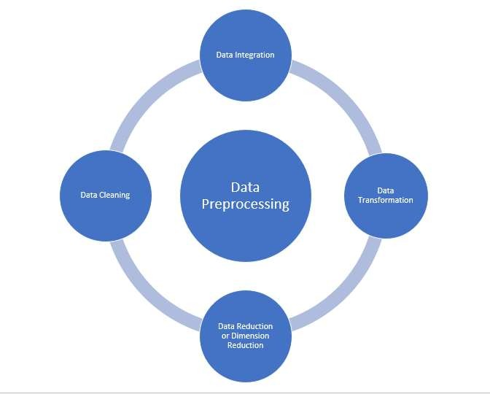Data model building

Let's discuss each of these points in detail:

Before Data Preprocessing. The necessary libraries and dataset have to be imported.

import pandas as pd import numpy as np

import matplotlib.pyplot as plt import seaborn as sns

%matplotlib inline url='/content/drive/MyDrive/heart.csv' df=pd.read_csv(url)

1. ***Data cleaning:***

Data Cleaning means the process of identifying the incorrect, incomplete, inaccurate, irrelevant or missing part of the data and then modifying, replacing or deleting them according to the necessity. Data cleaning is considered a foundational element of basic data science.

**Different Ways of Cleaning Data**

Now let’s take a closer look in the different ways of cleaning data.

**Changing the Datatype of the columns:**

*The variables types are in heart dataset are:*

* + Binary: sex, fbs, exang, target
  + Categorical: cp, restecg, slope, ca, thal
  + Continuous: age, trestbps, chol, thalac, oldpeak But, df.info() gives the following output.

<class 'pandas.core.frame.DataFrame'> RangeIndex: 303 entries, 0 to 302 Data columns (total 14 columns):

# Column Non-Null Count Dtype

- - -

1. age 303 non-null int64
2. sex 303 non-null int64
3. cp 303 non-null int64
4. trestbps 303 non-null int64
5. chol 303 non-null int64
6. fbs 303 non-null int64
7. restecg 303 non-null int64
8. thalach 303 non-null int64
9. exang 303 non-null int64
10. oldpeak 303 non-null float64
11. slope 303 non-null int64
12. ca 303 non-null int64
13. thal 303 non-null int64
14. target 303 non-null int64 dtypes: float64(1), int64(13) memory usage: 33.3 KB

Hence, We will change the Datatypes of columns to appropriate types.

df['sex'] = df['sex'].astype('object')

df['cp'] = df['cp'].astype('object')

df['fbs'] = df['fbs'].astype('object') df['restecg'] = df['restecg'].astype('object') df['exang'] = df['exang'].astype('object')

df['slope'] = df['slope'].astype('object')

df['ca'] = df['ca'].astype('object')

df['thal'] = df['thal'].astype('object') df.dtypes

**Inconsistent column :**

If your DataFrame contains columns that are irrelevant or you are never going to use them then you can drop them to give more focus on the columns you will work on. Let’s see an example of how to deal with such a data set.

From the Air Quality dataset,

**Dropping of less valued columns:** stn_code, agency, sampling_date, location_monitoring_agency do not add much value to the dataset in terms of information. Therefore, we can drop those columns.

**Changing the types to uniform format:** When you see the dataset, you may notice that the ‘type’ column has values such as ‘Industrial Area’ and ‘Industrial Areas’ — both actually mean the same, so let’s remove such type of stuff and make it uniform.

**Creating a year column** To view the trend over a period of time, we need year values for each row and also when you see in most of the values in date column only has ‘year’ value. So, let’s create a new column holding year values.

1. stn_code, agency, sampling_date, location_monitoring_agency do not add much value to the dataset in terms of information. Therefore, we can drop those columns.
2. Dropping rows where no date is available.

df=df.drop(['stn_code', 'agency','sampling_date','location_monitoring_station'], axis = 1) #dropping columns that aren't required

df=df.dropna(subset=['date']) # dropping rows where no date is available

**Missing data:**

It is rare to have a real world dataset without having any missing values. When you start to work with real world data, you will find that most of the dataset contains missing values. Handling missing values is very important because if you leave the missing values as it is, it may affect your analysis and machine learning models. So, you need to be sure that your dataset contains missing values or not. If you find missing values in your dataset you must handle it. If you find any missing values in the dataset you can perform any of these three task on it:

1. Leave as it is
2. Filling the missing values
3. Drop them

For filling the missing values we can perform different methods. For example, Figure 4 shows that airquality dataset has missing values.

The column such as SO2, NO2, rspm, spm, pm2_5 are the ones which contribute much to our analysis. So, we need to remove null from those columns to avoid inaccuracy in the prediction. We use the Imputer from sklearn.preprocessing to fill the missing values in every column with the mean.

# defining columns of importance, which shall be used reguarly COLS = ['so2', 'no2', 'rspm', 'spm', 'pm2_5']

from sklearn.impute import SimpleImputer

# invoking SimpleImputer to fill missing values

imputer = SimpleImputer(missing_values=np.nan, strategy='mean') df[COLS] = imputer.fit_transform(df[COLS])

Outliers:

“*In statistics, an* ***outlier*** *is a data point that differs significantly from other observations.*”

78

That means an outlier indicates a data point that is significantly different from the other data points in the data set. Outliers can be created due to the errors in the experiments or the variability in the measurements. Let’s look an example to clear the concept.

So, now the question is how can we detect the outliers in the dataset. For detecting the outliers we can use :

* 1. Box Plot
  2. Scatter plot
  3. Z-score etc.

Before we plot the outliers, let's change the labeling for better visualization and interpretation for heart dataset.

df['target'] = df.target.replace({1: "Disease", 0: "No_disease"}) df['sex'] = df.sex.replace({1: "Male", 0: "Female"})

df['cp'] = df.cp.replace({0: "typical_angina",

1: "atypical_angina", 2:"non-anginal pain", 3: "asymtomatic"})

df['exang'] = df.exang.replace({1: "Yes", 0: "No"})

df['fbs'] = df.fbs.replace({1: "True", 0: "False"}) df['slope'] = df.slope.replace({0: "upsloping", 1: "flat",2:"downsloping"})

df['thal'] = df.thal.replace({1: "fixed_defect", 2: "reversable_defect", 3:"normal"})

import matplotlib.pyplot as plt import seaborn as sb

bxplt = sb.boxplot(df["target"],df["chol"]) plt.show()

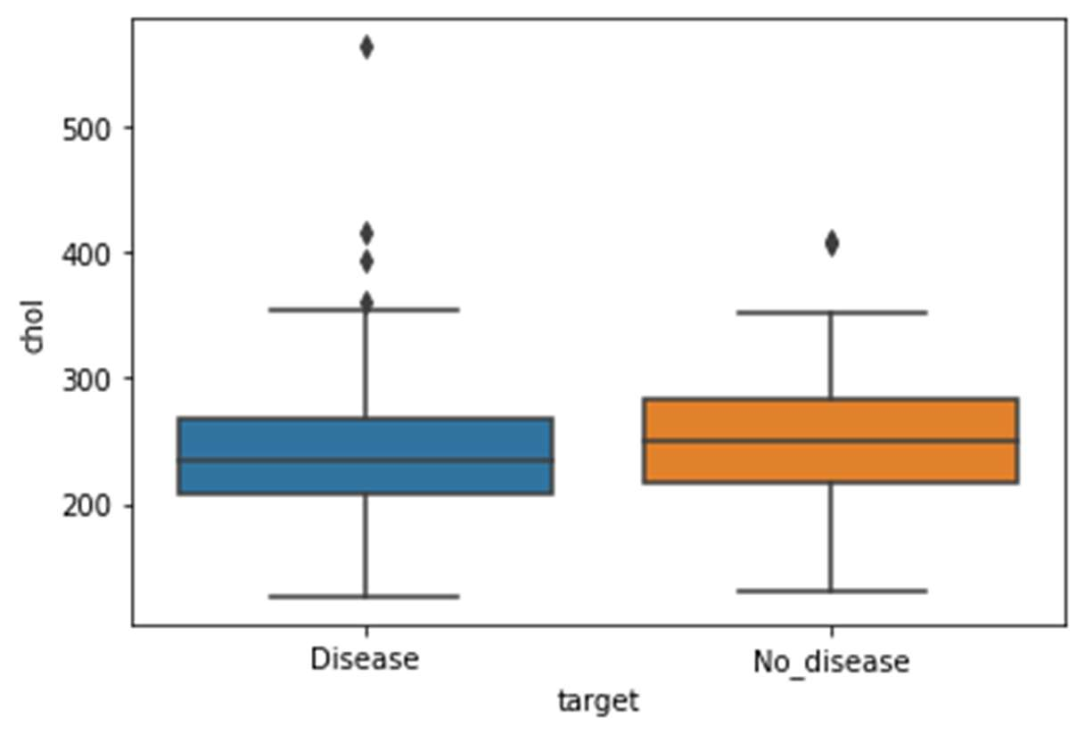

sb.boxplot(x='target', y='oldpeak', data=df)

<matplotlib.axes._subplots.AxesSubplot at 0x7f95fceb7e10>

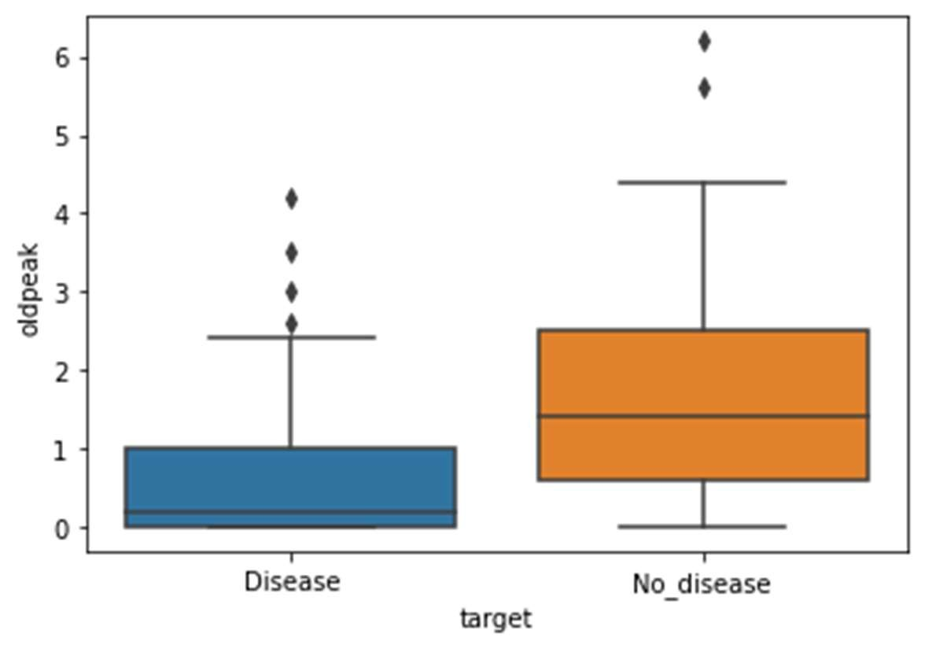

define continuous variable & plot

continous_features = ['age','trestbps','chol','thalach','oldpeak'] def outliers(df_out, drop = False):

for each_feature in df_out.columns: feature_data = df_out[each_feature]

Q1 = np.percentile(feature_data, 25.) # 25th percentile of the data of the given feature

Q3 = np.percentile(feature_data, 75.) # 75th percentile of the data of the given feature

IQR = Q3-Q1 #Interquartile Range

outlier_step = IQR * 1.5 #That's we were talking about above outliers = feature_data[~((feature_data >= Q1 - outlier_step) &

(feature_data <= Q3 + outlier_step))].index.tolist() if not drop:

print('For the feature {}, No of Outliers is

{}'.format(each_feature, len(outliers))) if drop:

df.drop(outliers, inplace = True, errors = 'ignore') print('Outliers from {} feature

removed'.format(each_feature)) outliers(df[continous_features])

For the feature age, No of Outliers is 0

For the feature trestbps, No of Outliers is 9 For the feature chol, No of Outliers is 5 For the feature thalach, No of Outliers is 1 For the feature oldpeak, No of Outliers is 5

**Drop Outliers**

**outliers(df[continous_features],drop=True) Outliers from age feature removed Outliers from trestbps feature removed Outliers from chol feature removed Outliers from thalach feature removed Outliers from oldpeak feature removed**

**Duplicate rows:**

Datasets may contain duplicate entries. It is one of the easiest tasks to delete duplicate rows. To delete the duplicate rows you can use —***dataset_name.drop_duplicates().***

We have used another approach on the heart dataset. Checking for the duplicate rows duplicated=df.duplicated().sum()

if duplicated:

print("Duplicated rows :{}".format(duplicated)) else:

print("No duplicates")

Duplicated rows :1

Displaying duplicate rows duplicates=df[df.duplicated(keep=False)] duplicates.head()

Remove the duplicate rows using the above mentioned method.

1. **Data integration**

So far, we've made sure to remove the impurities in data and make it clean. Now, the next step is to combine data from different sources to get a unified structure with more meaningful and valuable information. This is mostly used if the data is segregated into different sources. To make it simple, let's assume we have data in CSV format in different places, all talking about the same scenario.

Say we have some data about an employee in a database. We can't expect all the data about the employee to reside in the same table. It's possible that the employee's personal data will be located in one table, the employee's project history will be in a second table, the employee's time-in and time-out details will be in another table, and so on. So, if we want to do some analysis about the employee, we need to get all the employee data in one common place. This process of bringing data together in one place is called data integration. To do data integration, we can merge multiple pandas DataFrames using the merge function.

In this exercise, we'll merge the details of students from two datasets, namely student.csv and marks.csv. The student dataset contains columns such as Age, Gender, Grade, and Employed. The marks.csv dataset contains columns such as Mark and City. The Student_id column is common between the two datasets. Follow these steps to complete this exercise:

dataset1 ="https://github.com/TrainingByPackt/Data-Science-with- Python/blob/master/Chapter01/Data/student.csv"

dataset2 = "https://github.com/TrainingByPackt/Data-Science-with-

Python/blob/master/Chapter01/Data/mark.csv" df1 = pd.read_csv(dataset1, header = 0)

df2 = pd.read_csv(dataset2, header = 0)

To print the first five rows of the first DataFrame, add the following code: df1.head()

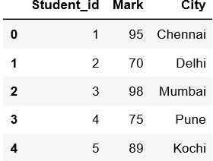The preceding code generates the following output:

Figure : The first five rows of the first DataFrame

To print the first five rows of the second DataFrame, add the following code: df2.head()

The preceding code generates the following output:

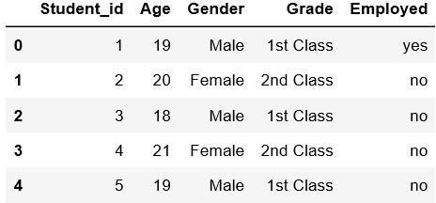

Figure : The first five rows of the second DataFrame

Student_id is common to both datasets. Perform data integration on both the DataFrames with respect to the Student_id column using the pd.merge() function, and then print the first 10 values of the new DataFrame: df = pd.merge(df1, df2, on = 'Student_id') df.head(10)

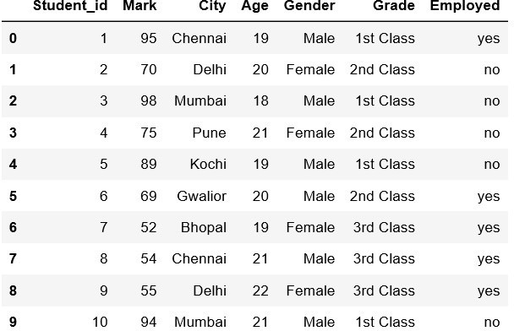

Figure : First 10 rows of the merged DataFrame

Here, the data of the df1 DataFrame is merged with the data of the df2 DataFrame. The merged data is stored inside a new DataFrame called df.

We have now learned how to perform data integration. In the next section, we'll explore another pre-processing task, data transformation.

1. **Data transformation**

Previously, we saw how we can combine data from different sources into a unified dataframe. Now, we have a lot of columns that have different types of data. Our goal is to transform the data into a machine-learning-digestible format. All machine learning algorithms are based on mathematics. So, we need to convert all the columns into numerical format. Before that, let's see all the different types of data we have.

Taking a broader perspective, data is classified into numerical and categorical data:

* Numerical: As the name suggests, this is numeric data that is quantifiable.
* Categorical: The data is a string or non-numeric data that is qualitative in nature.

Numerical data is further divided into the following:

* Discrete: To explain in simple terms, any numerical data that is countable is called discrete, for example, the number of people in a family or the number of students in a class. Discrete data can only take certain values (such as 1, 2, 3, 4, etc).
* Continuous: Any numerical data that is measurable is called continuous, for example, the height of a person or the time taken to reach a destination. Continuous data can take virtually any value (for example, 1.25, 3.8888, and 77.1276).

Categorical data is further divided into the following:

* Ordered: Any categorical data that has some order associated with it is called ordered categorical data, for example, movie ratings (excellent, good, bad, worst) and feedback (happy, not bad, bad). You can think of ordered data as being something you could mark on a scale.
* Nominal: Any categorical data that has no order is called nominal categorical data. Examples include gender and country.

From these different types of data, we will focus on categorical data. In the next section, we'll discuss how to handle categorical data.

Handling Categorical Data

There are some algorithms that can work well with categorical data, such as decision trees. But most machine learning algorithms cannot operate directly with categorical data. These algorithms require the input and output both to be in numerical form. If the output to be predicted is categorical, then after prediction we convert them back to categorical data from numerical data. Let's discuss some key challenges that we face while dealing with categorical data:

* High cardinality: Cardinality means uniqueness in data. The data column, in this case, will have a lot of different values. A good example is User ID – in a table of 500 different users, the User ID column would have 500 unique values.
* Rare occurrences: These data columns might have variables that occur very rarely and therefore would not be significant enough to have an impact on the model.
* Frequent occurrences: There might be a category in the data columns that occurs many times with very low variance, which would fail to make an impact on the model.
* Won't fit: This categorical data, left unprocessed, won't fit our model.

**Encoding**

To address the problems associated with categorical data, we can use encoding. This is the process by which we convert a categorical variable into a numerical form. Here, we will look at three simple methods of encoding categorical data.

**Replacing**

This is a technique in which we replace the categorical data with a number. This is a simple replacement and does not involve much logical processing. Let's look at an exercise to get a better idea of this.

Exercise 6: Simple Replacement of Categorical Data with a Number

In this exercise, we will use the student dataset that we saw earlier. We will load the data into a pandas dataframe and simply replace all the categorical data with numbers. Follow these steps to complete this exercise:

In AirQuality dataset, applying Simple Replacement of Categorical Data with a Number.

df['type'].value_counts()

|  |  |
| --- | --- |
| RRO | 179013 |
| I | 148069 |
| RO | 86791 |
| S | 15010 |
| RIRUO | 1304 |
| R | 158 |

The column type in the dataframe has 6 unique values, which we will be replacing with numbers.

df['type'].replace({"RRO":1, "I":2, "RO":3,"S":4,"RIRUO":5,"R":6},

inplace= True) df['type']

|  |  |
| --- | --- |
| 0 | 1.0 |
| 1 | 2.0 |
| 2 | 1.0 |
| 3 | 1.0 |
| 4 | 2.0 |

...

435734 5.0

435735 5.0

|  |  |
| --- | --- |
| 435736 | 5.0 |
| 435737 | 5.0 |
| 435738 | 5.0 |

Name: type, Length: 435735, dtype: float64

**Converting Categorical Data to Numerical Data Using Label Encoding**

This is a technique in which we replace each value in a categorical column with numbers from 0 to N-1. For example, say we've got a list of employee names in a column. After performing label encoding, each employee name will be assigned a numeric label. But this might not be suitable for all cases because the model might consider numeric values to be weights assigned to the data. Label encoding is the best method to use for ordinal data. The scikit-learn library provides LabelEncoder(), which helps with label encoding.

**df['state'].value_counts()**

|  |  |
| --- | --- |
| **Maharashtra** | **60382** |
| **Uttar Pradesh** | **42816** |
| **Andhra Pradesh** | **26368** |
| **Punjab** | **25634** |
| **Rajasthan** | **25589** |
| **Kerala** | **24728** |
| **Himachal Pradesh** | **22896** |
| **West Bengal** | **22463** |
| **Gujarat** | **21279** |
| **Tamil Nadu** | **20597** |
| **Madhya Pradesh** | **19920** |
| **Assam** | **19361** |
| **Odisha** | **19278** |
| **Karnataka** | **17118** |
| **Delhi** | **8551** |
| **Chandigarh** | **8520** |
| **Chhattisgarh** | **7831** |
| **Goa** | **6206** |
| **Jharkhand** | **5968** |
| **Mizoram** | **5338** |
| **Telangana** | **3978** |
| **Meghalaya** | **3853** |
| **Puducherry** | **3785** |
| **Haryana** | **3420** |
| **Nagaland** | **2463** |
| **Bihar** | **2275** |
| **Uttarakhand** | **1961** |
| **Jammu & Kashmir** | **1289** |
| **Daman & Diu** | **782** |
| **Dadra & Nagar Haveli** | **634** |
| **Uttaranchal** | **285** |
| **Arunachal Pradesh** | **90** |
| **Manipur** | **76** |
| **Sikkim** | **1** |

**Name: state, dtype: int64**

**from sklearn.preprocessing import LabelEncoder labelencoder=LabelEncoder() df["state"]=labelencoder.fit_transform(df["state"]) df.head(5)**

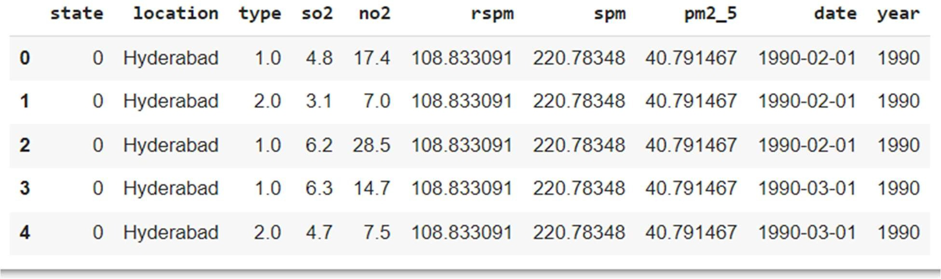

**One Hot Encoding**

In label encoding, categorical data is converted to numerical data, and the values are assigned labels (such as 1, 2, and 3). Predictive models that use this numerical data for analysis might sometimes mistake these labels for some kind of order (for example, a model might think that a label of 3 is "better" than a label of 1, which is incorrect). In order to avoid this confusion, we can use one-hot encoding. Here, the label-encoded data is further divided into n number of columns. Here, n denotes the total number of unique labels generated while performing label encoding. For example, say that three new labels are generated through label encoding. Then, while performing one-hot encoding, the columns will be divided into three parts. So, the value of n is 3.

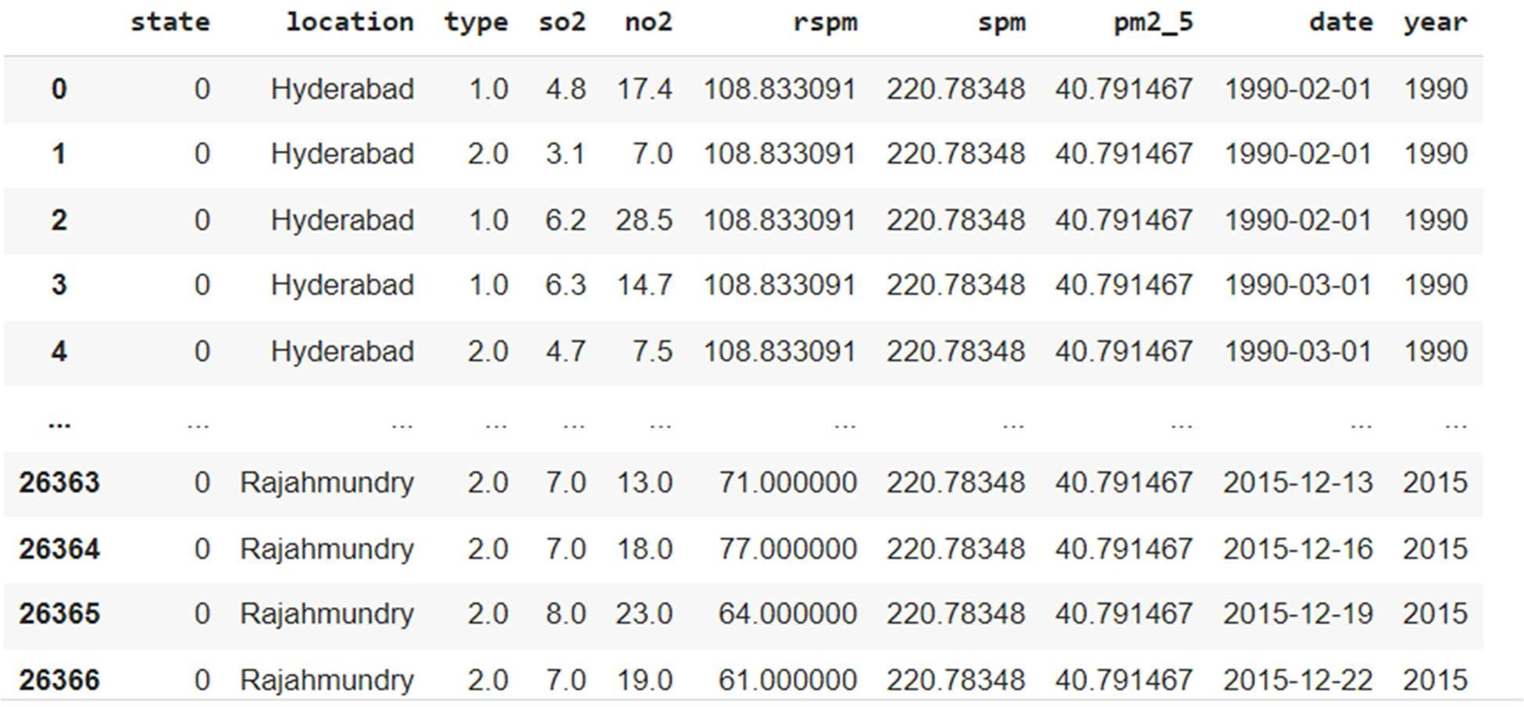**dfAndhra=df[(df['state']==0)] dfAndhra**

**dfAndhra['location'].value_counts()**

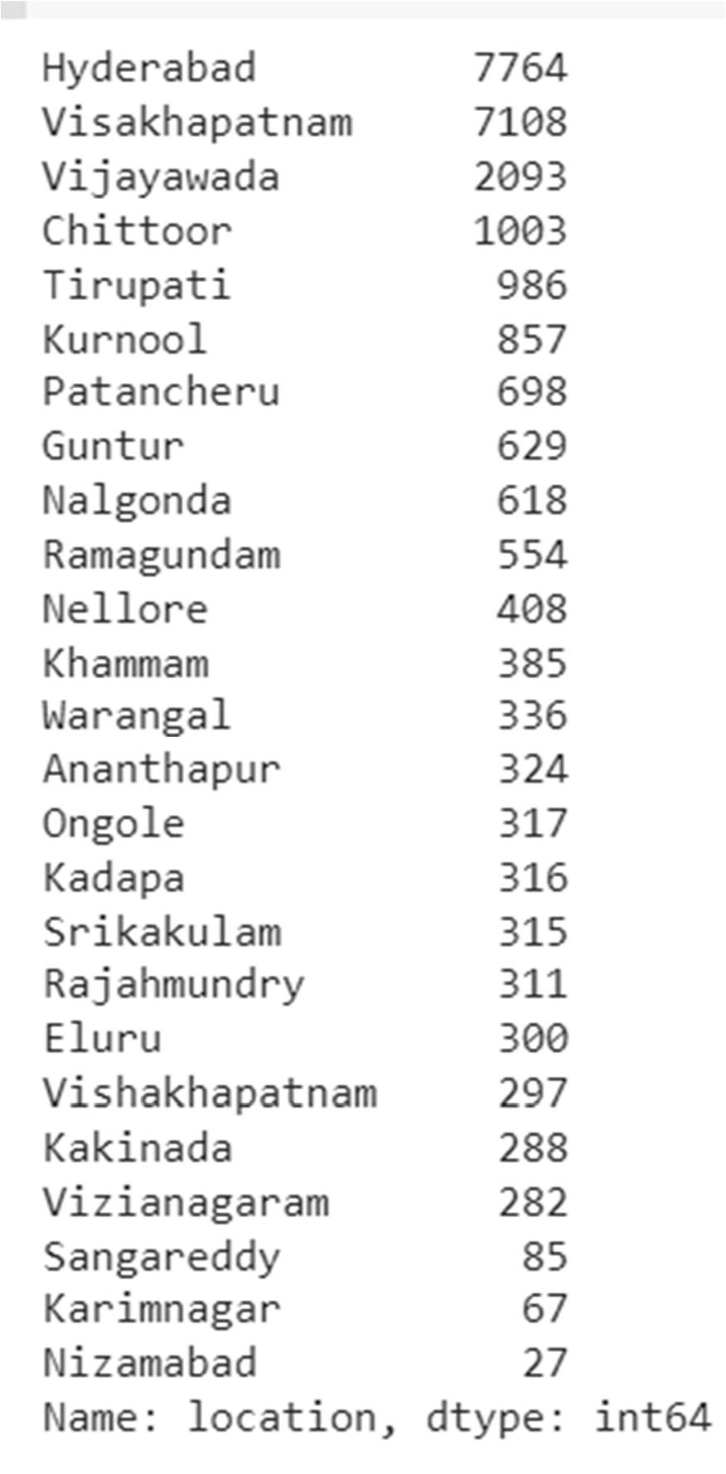

**from sklearn.preprocessing import OneHotEncoder onehotencoder=OneHotEncoder(sparse=False,handle_unknown='error',drop='fi rst')**

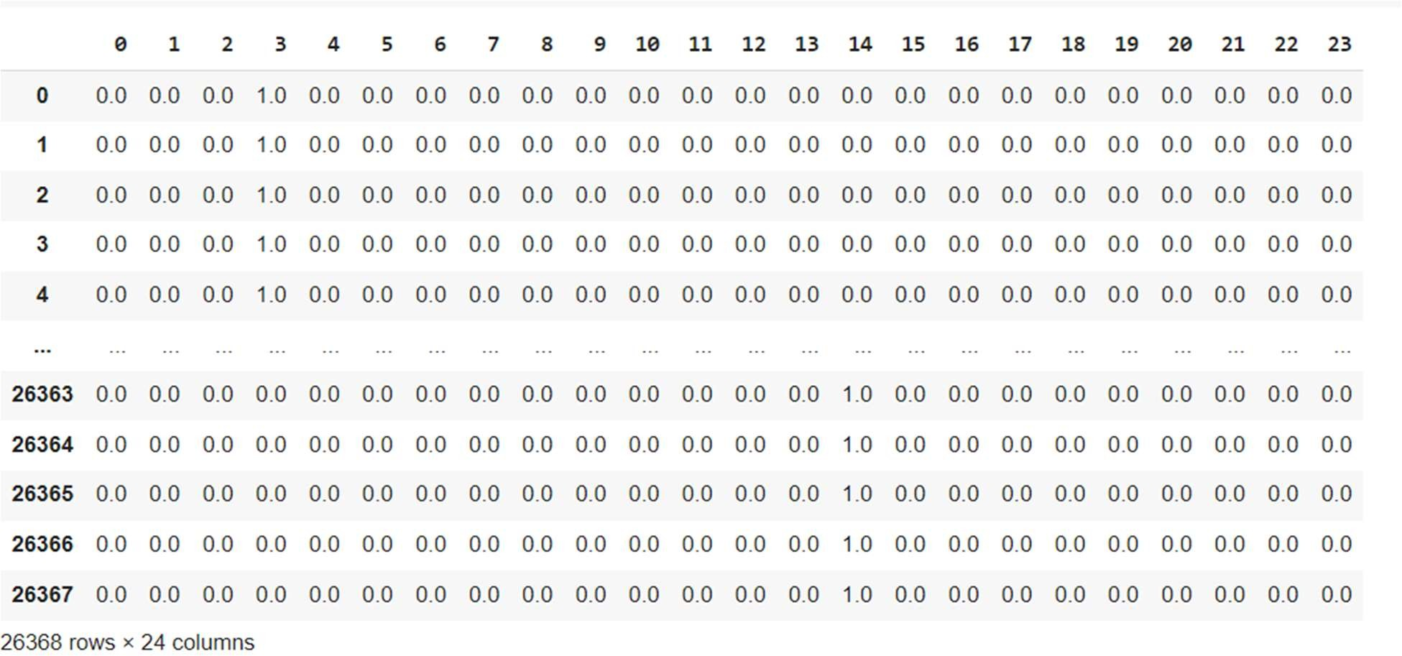**pd.DataFrame(onehotencoder.fit_transform(dfAndhra[["location"]]))**

You have successfully converted categorical data to numerical data using the OneHotEncoder method.

1. **Error Correction**

In heart dataset it can be observed that feature ‘ca’ should range from 0–3, however, df.nunique() listed 0–4. So let's find the ‘4’ and change them to NaN.

df['ca'].unique()

array([0, 2, 1, 3, 4], dtype=object)

df[df['ca']==4]

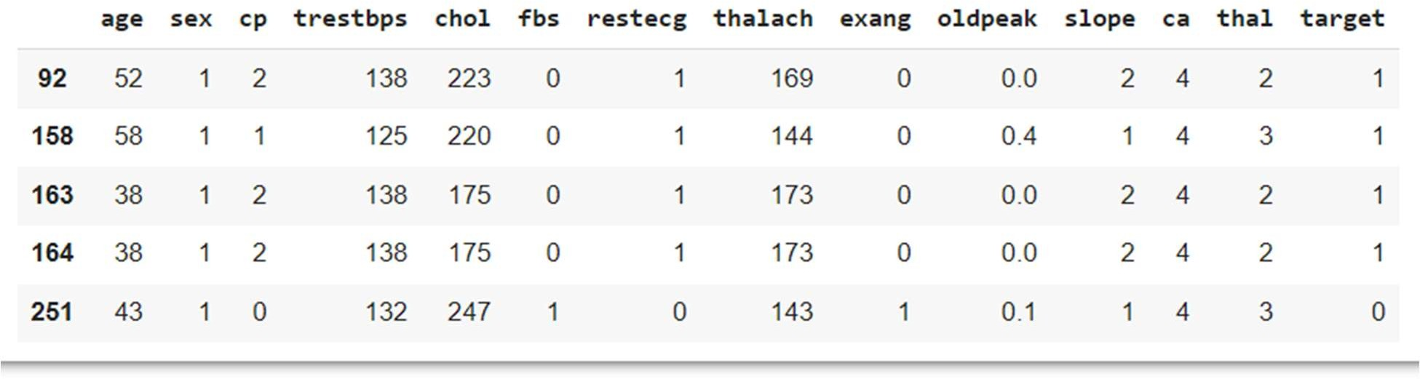

df.loc[df['ca']==4,'ca']=np.NaN

Similarly, Feature ‘thal’ ranges from 1–3, however, df.nunique() listed 0–3. There are two values of ‘0’. They are also changed to NaN using above mentioned technique.

Now, we can replace changed NaN values(missing values).

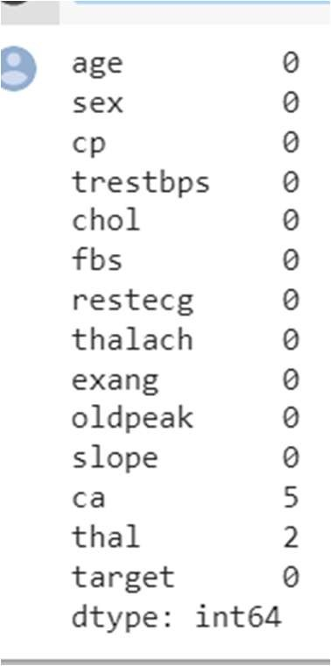df.isna().sum()

df = df.fillna(df.median()) df.isnull().sum()

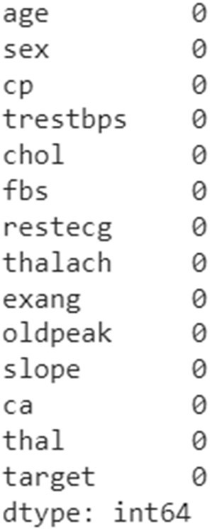

1. **Data model building**

Once you've pre-processed your data into a format that's ready to be used by your model, you need to split up your data into train and test sets. This is because your machine learning algorithm will use the data in the training set to learn what it needs to know. It will then make a prediction about the data in the test set, using what it has learned. You can then compare this prediction against the actual target variables in the test set in order to see how accurate your model is. The exercise in the next section will give more clarity on this.

We will do the train/test split in proportions. The larger portion of the data split will be the train set and the smaller portion will be the test set. This will help to ensure that you are using enough data to accurately train your model.

In general, we carry out the train-test split with an 80:20 ratio, as per the Pareto principle. The Pareto principle states that "for many events, roughly 80% of the effects come from 20% of the causes." But if you have a large dataset, it really doesn't matter whether it's an 80:20 split or 90:10 or 60:40. (It can be better to use a smaller split set for the training set if our process is computationally intensive, but it might cause the problem of overfitting – this will be covered later in the book.)

Create a variable called X to store the independent features. Use the drop() function to include all the features, leaving out the dependent or the target variable, which in this case is named ‘target’ for heart dataset. Then, print out the top five instances of the variable. Add the following code to do this:

**X = df.drop('target', axis=1) X.head()**

**The preceding code generates the following output:**

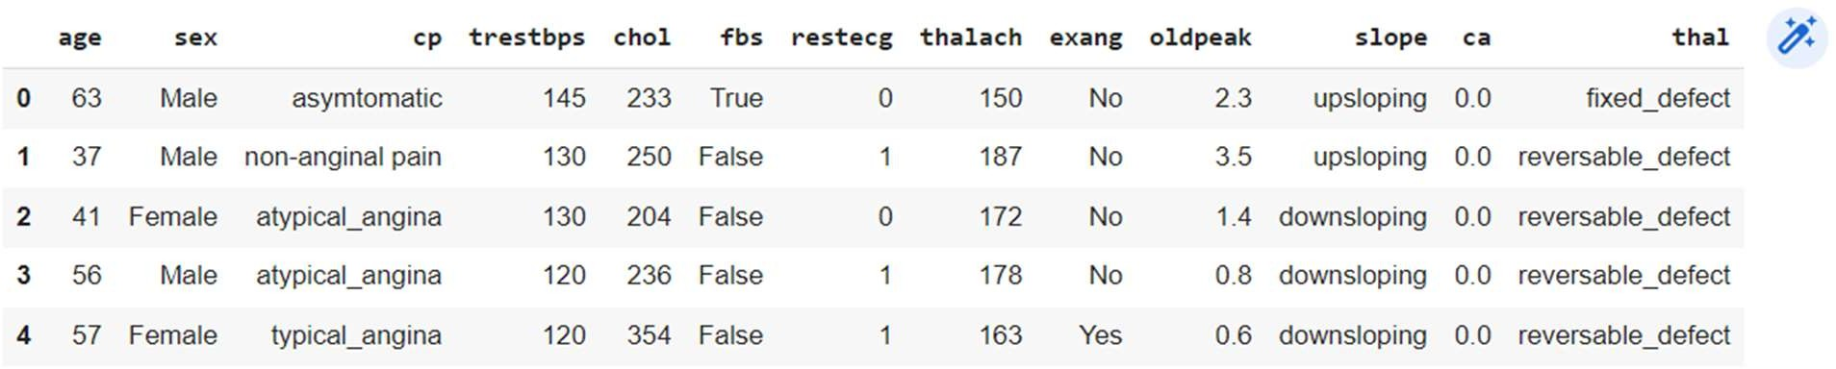

Figure : Dataframe consisting of independent variables

* 1. **Print the shape of your new created feature matrix using the X.shape command: X.shape**

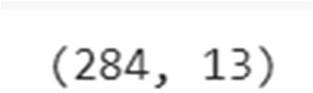**The preceding code generates the following output:**

Figure : Shape of the X variable

In the preceding figure, the first value indicates the number of observations in the dataset (284), and the second value represents the number of features (13).

* 1. Similarly, we will create a variable called y that will store the target values. We will use indexing to grab the target column. Indexing allows us to access a section of a larger element. In this case, we want to grab the column named Price from the df dataframe and print out the top 10 values. Add the following code to implement this:

**y = df['target'] y.head(10)**

**The preceding code generates the following output:**

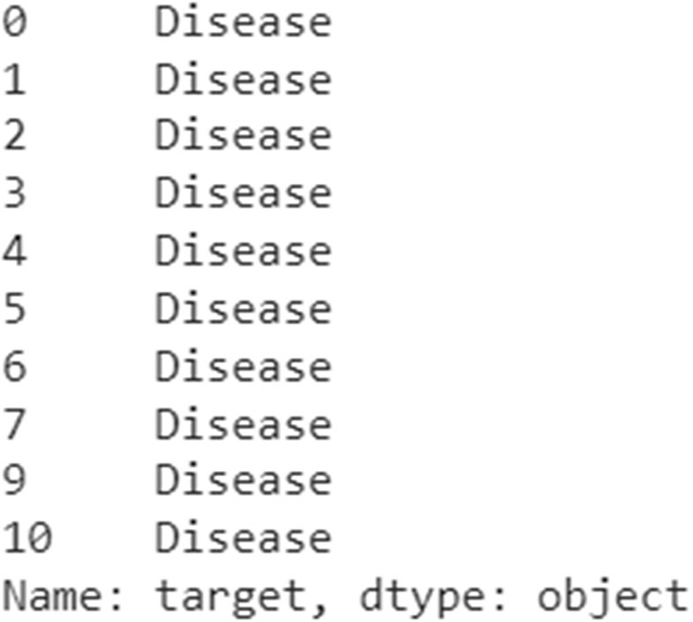

Figure : Top 10 values of the y variable

* 1. Print the shape of your new variable using the y.shape command:

**y.shape**

The preceding code generates the following output:

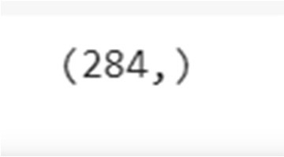

Figure : Shape of the y variable

The shape should be one-dimensional, with a length equal to the number of observations (284).

* 1. Make train/test sets with an 80:20 split. To do so, use the train_test_split() function from the sklearn.model_selection package. Add the following code to do this: from sklearn.model_selection import train_test_split

from sklearn import preprocessing

df=df.apply(preprocessing.LabelEncoder().fit_transform)

from sklearn.model_selection import train_test_split **X_train, X_test, y_train, y_test = train_test_split(X, y, test_size=0.2, random_state=0)**

In the preceding code, test_size is a floating-point value that defines the size of the test data. If the value is 0.2, then it is an 80:20 split. test_train_split splits the arrays or matrices into train and test subsets in a random way. Each time we run the code without random_state, we will get a different result.

* 1. Print the shape of X_train, X_test, y_train, and y_test. Add the following code to do this:

**print("X_train : ",X_train.shape) print("X_test : ",X_test.shape) print("y_train : ",y_train.shape) print("y_test : ",y_test.shape)**

**The preceding code generates the following output:**

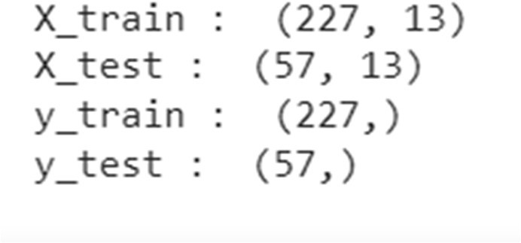

Figure : Shape of train and test datasets

You have successfully split the data into train and test sets.

**In the next section, you will complete an activity wherein you'll perform pre-processing on a dataset.**

***Supervised Learning***

Supervised learning is a learning system that trains using labeled data (data in which the target variables are already known). The model learns how patterns in the feature matrix map to the target variables. When the trained machine is fed with a new dataset, it can use what it has learned to predict the target variables. This can also be called predictive modeling.

Supervised learning is broadly split into two categories. These categories are as follows:

Classification mainly deals with categorical target variables. A classification algorithm helps to predict which group or class a data point belongs to.

When the prediction is between two classes, it is known as binary classification. An example is predicting whether or not a person has a heart disease (in this case, the classes are yes and no).

from sklearn.tree import DecisionTreeClassifier from sklearn import metrics

clf = DecisionTreeClassifier() clf = clf.fit(X_train, y_train) y_pred = clf.predict(X_test) print(y_pred)



If the prediction involves more than two target classes, it is known as multi-classification; for example, predicting all the items that a customer will buy.

Regression deals with numerical target variables. A regression algorithm predicts the numerical value of the target variable based on the training dataset.

Linear regression measures the link between one or more predictor variables and one outcome variable. For example, linear regression could help to enumerate the relative impacts of age, gender, and diet (the predictor variables) on height (the outcome variable).

Time series analysis, as the name suggests, deals with data that is distributed with respect to time, that is, data that is in a chronological order. Stock market prediction and customer churn prediction are two examples of time series data. Depending on the requirement or the necessities, time series analysis can be either a regression or classification task.

***Unsupervised Learning***

Unlike supervised learning, the unsupervised learning process involves data that is neither classified nor labeled. The algorithm will perform analysis on the data without guidance. The job of the machine is to group unclustered information according to similarities in the data. The aim is for the model to spot patterns in the data in order to give some insight into what the data is telling us and to make predictions.

An example is taking a whole load of unlabeled customer data and using it to find patterns to cluster customers into different groups. Different products could then be marketed to the different groups for maximum profitability.

Unsupervised learning is broadly categorized into two types:

* Clustering: A clustering procedure helps to discover the inherent patterns in the data.
* Association: An association rule is a unique way to find patterns associated with a large amount of data, such as the supposition that when someone buys product 1, they also tend to buy product 2.

***CONCLUSION:***

This assignment covers the most crucial step in Machine learning is data preprocessing.

94

**References:**

**[1]What is Data Cleaning? How to Process Data for Analytics and Machine Learning Modeling? | by Awan-Ur-Rahman | Towards Data Science**

**Assignment: 7**

**Aim:** Visualize the data using R/Python by plotting the graphs for assignment no. 2 and 3

**OBJECTIVE:**

1. To understand and apply the analytical concept of Big data using Python.
2. To study detailed data visualization techniques in Python programing.

**SOFTWARE REQUIREMENTS:**

1. Ubuntu 16.04 / 18.04

2. Python

**THEORY:**

1. **R – Pie Charts**

In R the pie chart is created using the pie() function which takes positive numbers as a vector input. The additional parameters are used to control labels, color, title etc.

**Syntax**

The basic syntax for creating a pie-chart using the R is – pie(x, labels, radius, main, col, clockwise)

Following is the description of the parameters used –

* + x is a vector containing the numeric values used in the pie chart.
  + labels is used to give description to the slices.
  + radius indicates the radius of the circle of the pie chart.(value between −1 and +1).
  + main indicates the title of the chart.
  + col indicates the color palette.
  + clockwise is a logical value indicating if the slices are drawn clockwise or anti clockwise.

**Example**

A very simple pie-chart is created using just the input vector and labels. The below script will create and save the pie chart in the current R working directory.

# Create data for the graph. X<- c(21, 62, 10, 53)

labels<- c(“London”, “New York”, “Singapore”, “Mumbai”) 42

# Give the chart file a name. png(file = “city.jpg”)

# Plot the chart. Pie(x,labels)

# Save the file. Dev.off()

When we execute the above code, it produces the following result –

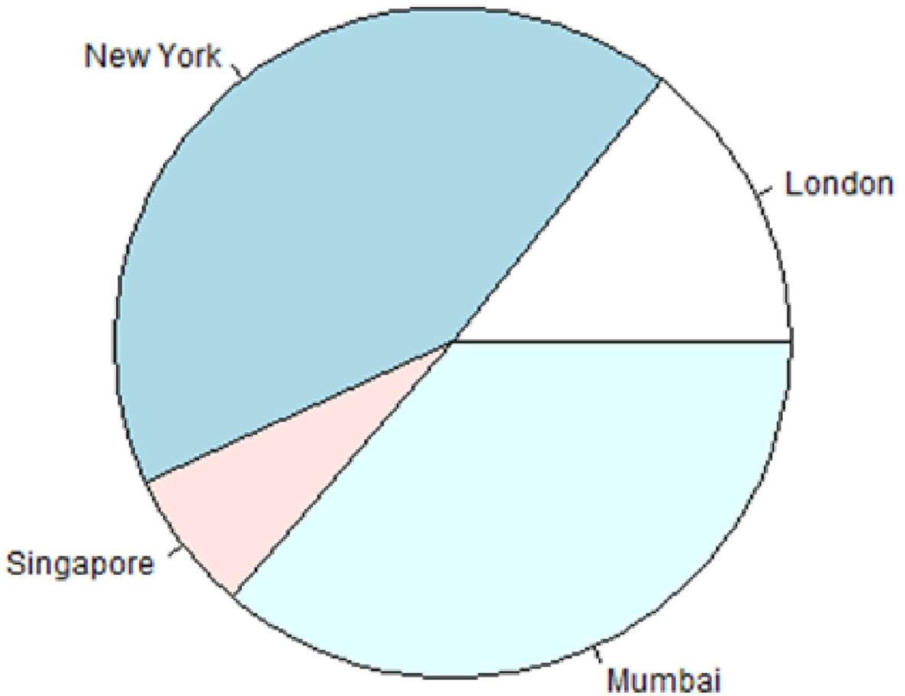

1. R – Bar Charts

Fig 1. Pie Chart

A bar chart represents data in rectangular bars with length of the bar proportional to the value of the variable. R uses the function **barplot()** to create bar charts. R can draw both vertical and horizontal bars in the bar chart. In bar chart each of the bars can be given different colors.

**Syntax**

The basic syntax to create a bar-chart in R is – barplot(H, xlab, ylab, main, names.arg, col) Following is the description of the parameters used –

* + **H** is a vector or matrix containing numeric values used in bar chart.
  + **xlab**is the label for x axis.
  + **ylab**is the label for y axis.
  + **main**is the title of the bar chart.
  + **names.arg**is a vector of names appearing under each bar.
  + **col**is used to give colors to the bars in the graph.

**Example**

A simple bar chart is created using just the input vector and the name of each bar. The below script will create and save the bar chart in the current R working directory. # Create the data for the chart.

H <- c(7,12,28,3,41)

# Give the chart file a name. png(file = “barchart.png”)

# Plot the bar chart. Barplot(H)

# Save the file. Dev.off()

When we execute the above code, it produces the following result –

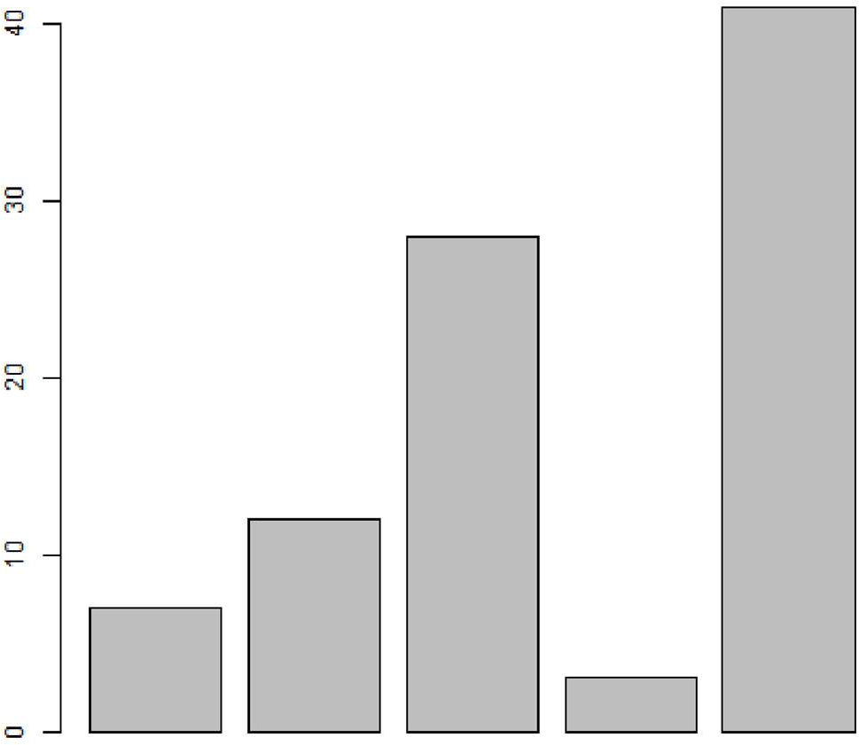

Fig. 2. Bar Chart

1. **R – Boxplots**

Boxplots are a measure of how well distributed is the data in a data set. It divides the data set into three quartiles. This graph represents the minimum, maximum, median, first quartile and third quartile in the data set. It is also useful in comparing the distribution of data across data sets by drawing boxplots for each of them.

Boxplots are created in R by using the **boxplot()** function.

**Syntax**

The basic syntax to create a boxplot in R is – boxplot(x, data, notch, varwidth, names, main) Following is the description of the parameters used –

* + **x** is a vector or a formula.
  + **data** is the data frame.
  + **notch** is a logical value. Set as TRUE to draw a notch.
  + **varwidth** is a logical value. Set as true to draw width of the box proportionate to the sample size.
  + **names** are the group labels which will be printed under each boxplot.
  + **main** is used to give a title to the graph.

**Example**

We use the data set “mtcars” available in the R environment to create a basic boxplot. Let’s look at the columns “mpg” and “cyl” in mtcars.

Input <- mtcars[,c(‘mpg’,’cyl’)] print(head(input))

When we execute above code, it produces following result –

|  |  |  |
| --- | --- | --- |
|  | mpg | cyl |
| Mazda RX4 | 21.0 | 6 |
| Mazda RX4 Wag | 21.0 | 6 |
| Datsun 710 | 22.8 | 4 |
| Hornet 4 Drive | 21.4 | 6 |
| Hornet Sportabout | 18.7 | 8 |
| Valiant | 18.1 | 6 |
| **Creating the Boxplot** |  |  |

The below script will create a boxplot graph for the relation between mpg (miles per gallon) and cyl (number of cylinders).

45

# Give the chart file a name.

png(file = “boxplot.png”) # Plot the chart.

Boxplot(mpg ~ cyl, data = mtcars, xlab = “Number of Cylinders”, ylab = “Miles Per Gallon”, main = “Mileage Data”)

# Save the file. Dev.off()

When we execute the above code, it produces the following result –

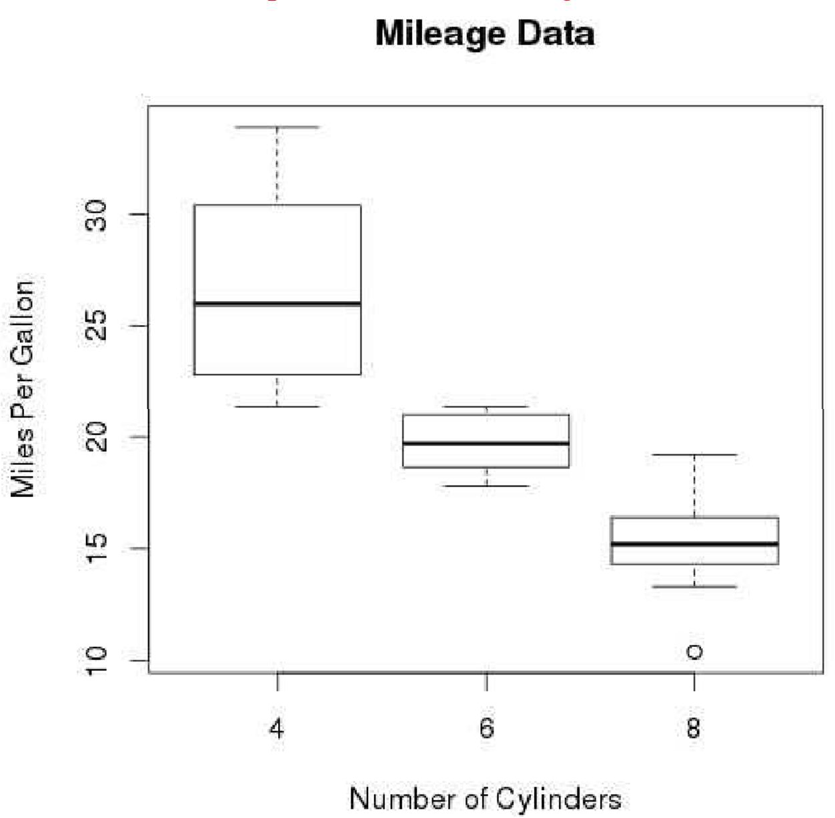

Fig. 3. Box Plot

1. **R – Histograms**

A histogram represents the frequencies of values of a variable bucketed into ranges. Histogram is similar to bar chat but the difference is it groups the values into continuous ranges. Each bar in histogram represents the height of the number of values present in that range.

R creates histogram using **hist()** function. This function takes a vector as an input and uses some more parameters to plot histograms.

**Syntax**

The basic syntax for creating a histogram using R is – hist(v,main,xlab,xlim,ylim,breaks,col,border) Following is the description of the parameters used –

* + **v** is a vector containing numeric values used in histogram.
  + **main** indicates title of the chart.
  + **col** is used to set color of the bars.
  + **border** is used to set border color of each bar.
  + **xlab** is used to give description of x-axis.
  + **xlim** is used to specify the range of values on the x-axis.
  + **ylim** is used to specify the range of values on the y-axis.
  + **breaks** is used to mention the width of each bar.

**Example**

A simple histogram is created using input vector, label, col and border parameters.

The script given below will create and save the histogram in the current R working directory.

# Create data for the graph.

V<- c(9,13,21,8,36,22,12,41,31,33,19)

# Give the chart file a name. png(file = “histogram.png”) # Create the histogram.

Hist(v,xlab = “Weight”,col = “yellow”,border = “blue”) # Save the file.

Dev.off()

When we execute the above code, it produces the following result –

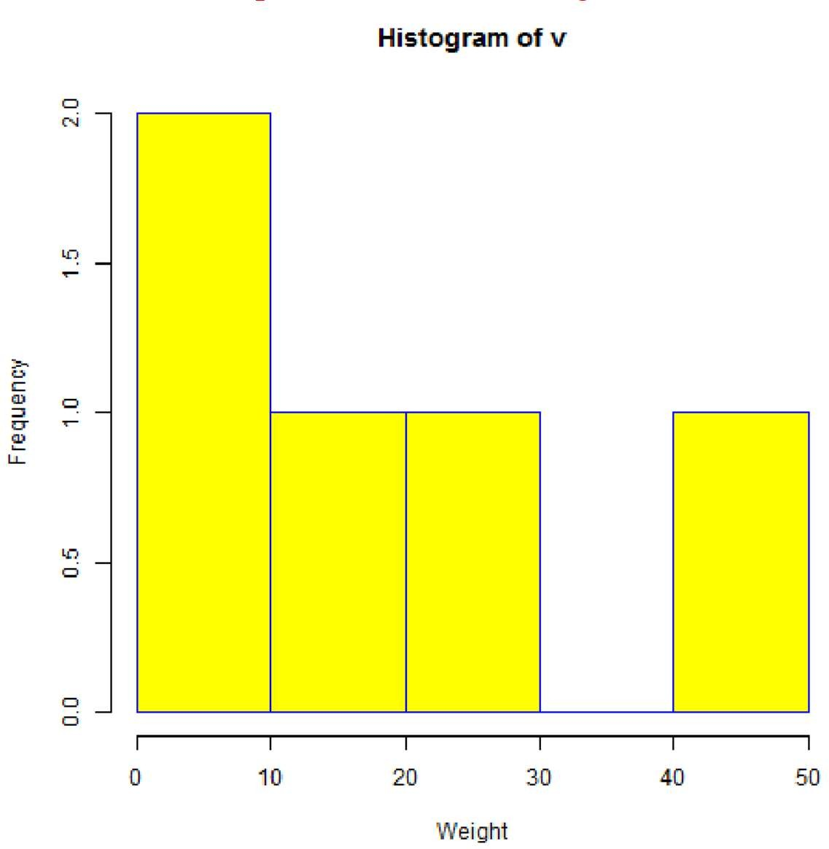

Fig. 4 Hostogram

**Syntax**

The basic syntax to create a line chart in R is – plot(v,type,col,xlab,ylab)

Following is the description of the parameters used –

* + **v** is a vector containing the numeric values.
  + **type** takes the value “p” to draw only the points, “l” to draw only the lines and “o” to draw both points and lines.
  + **xlab** is the label for x axis.
  + **ylab** is the label for y axis.
  + **main** is the Title of the chart.
  + **col** is used to give colors to both the points and lines.

**Example**

A simple line chart is created using the input vector and the type parameter as “O”. The below script will create and save a line chart in the current R working directory.

# Create the data for the chart. V<- c(7,12,28,3,41)

# Give the chart file a name. png(file = “line_chart.jpg”) # Plot the bar chart.

Plot(v,type = “o”) # Save the file.

Dev.off()

When we execute the above code, it produces the following result –

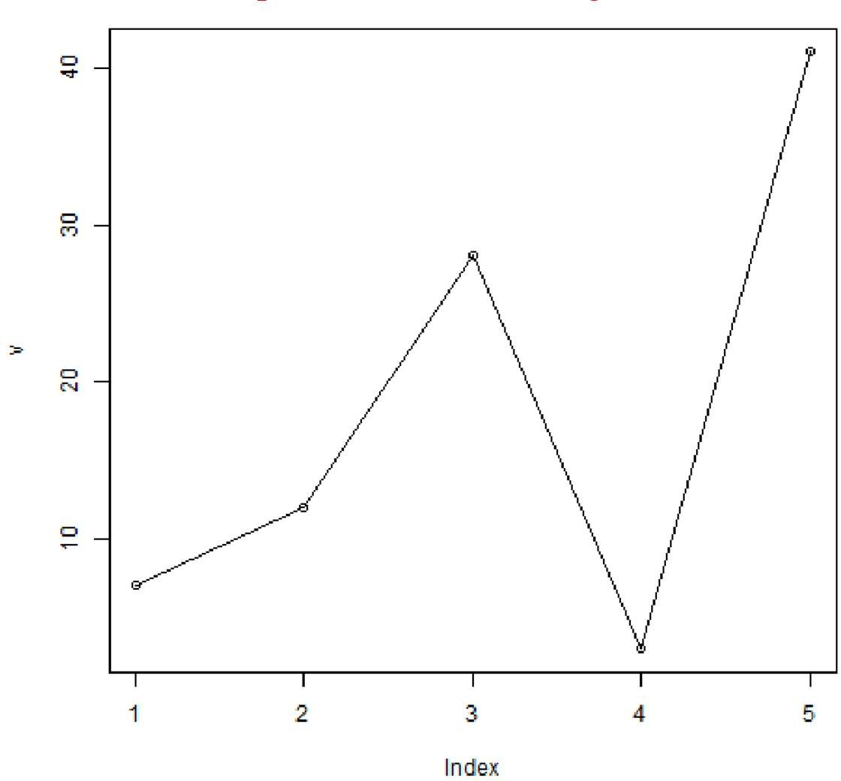

Fig. 5. Line Chart

1. R – Scatter plots

Scatterplots show many points plotted in the Cartesian plane. Each point represents the values of two variables. One variable is chosen in the horizontal axis and another in the vertical axis. The simple scatterplot is created using the plot( ) function.

Syntax:

The basic syntax for creating scatter plot in R is – plot(x, y, main, xlab,ylab, xlim, ylim, axes) Following is the description of the parameters used –

* + **x** is the data set whose values are the horizontal coordinates.
  + **y** is the data set whose values are the vertical coordinates.
  + **main** is the tile of the graph.
  + **xlab** is the label in the horizontal axis.
  + **ylab** is the label in the vertical axis.
  + **xlim** is the limits of the values of x used for plotting.
  + **ylim** is the limits of the values of y used for plotting.
  + **axes** indicates whether both axes should be drawn on the plot.

**Example**

We use the data set **“mtcars”** available in the R environment to create a basic scatterplot. Let’s use the columns “wt” and “mpg” in mtcars.

Input <- mtcars[,c(‘wt’,’mpg’)] print(head(input))

When we execute the above code, it produces the following result –

|  |  |  |  |  |
| --- | --- | --- | --- | --- |
|  | Wt |  | mpg |  |
| Mazda RX4 | 2.620 |  | 21.0 |
| Mazda RX4 Wag | 2.875 |  | 21.0 |
| Datsun 710 | 2.320 |  | 22.8 |
| Hornet 4 Drive |  | 3.215 |  | 21.4 |
| Hornet Sportabout | 3.440 |  | 18.7 |  |
| Valiant |  | 3.460 |  | 18.1 |

**Creating the Scatter plot**

The below script will create a scatterplot graph for the relation between wt(weight) and mpg(miles per gallon).

# Get the input values.

Input <- mtcars[,c(‘wt’,’mpg’)] # Give the chart file a name. png(file = “scatterplot.png”)

# Plot the chart for cars with weight between 2.5 to 5 and mileage between 15 and 30. Plot(x = input$wt,y = input$mpg,

xlab = “Weight”, ylab = “Milage”, xlim = c(2.5,5), ylim = c(15,30),

main = “Weight vs Milage”

)

# Save the file. Dev.off()

When we execute the above code, it produces the following result –

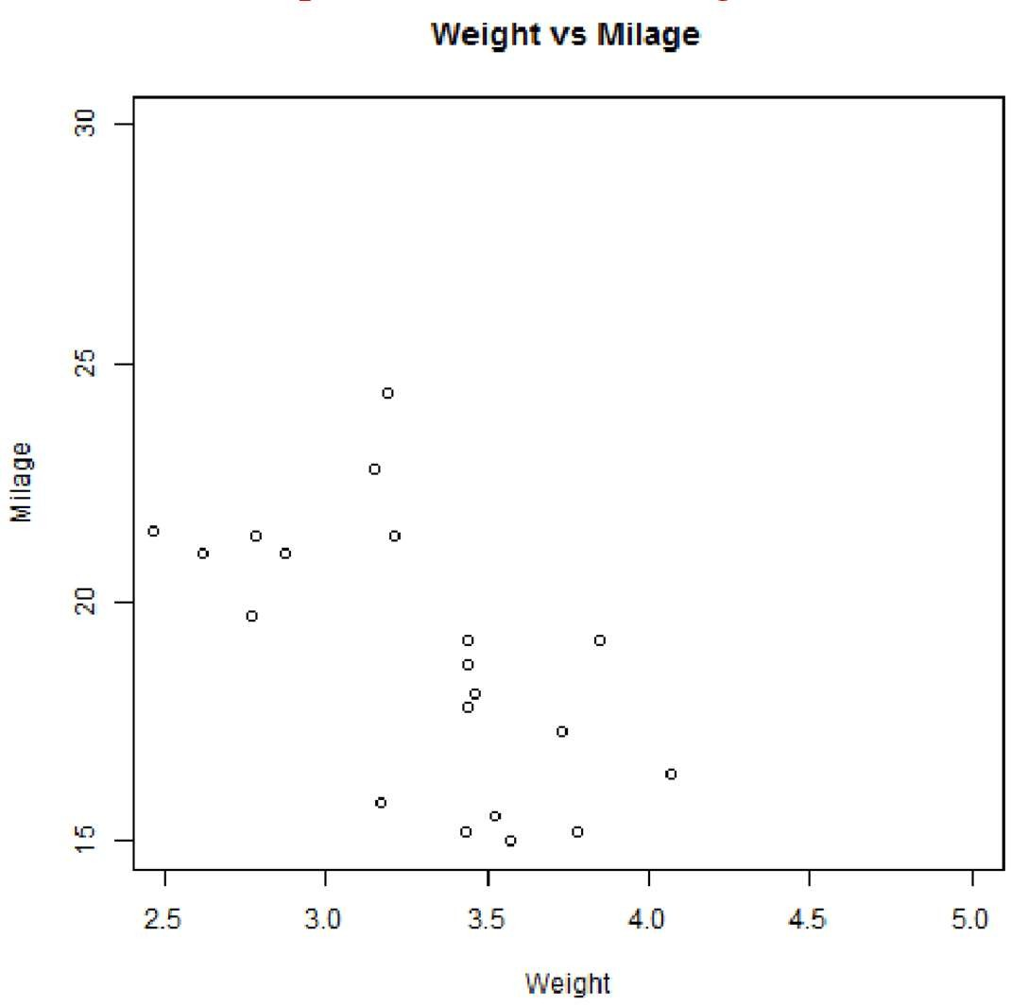

Fig. 6 Scatter Plot

1. **Scatter plot Matrices**

When we have more than two variables and we want to find the correlation between one variable versus the remaining ones we use scatterplot matrix. We use pairs() function to create matrices of scatterplots.

**Syntax**

The basic syntax for creating scatterplot matrices in R is – pairs(formula, data)

Following is the description of the parameters used –

* + **formula** represents the series of variables used in pairs.
  + **data** represents the data set from which the variables will be taken.

**Example**

Each variable is paired up with each of the remaining variable. A scatterplot is plotted for each pair.

# Give the chart file a name.

png(file = “scatterplot_matrices.png”)

# Plot the matrices between 4 variables giving 12 plots. # One variable with 3 others and total 4 variables.

Pairs(~wt+mpg+disp+cyl,data = mtcars,

main = “Scatterplot Matrix”) # Save the file.

Dev.off()

When the above code is executed we get the following output.

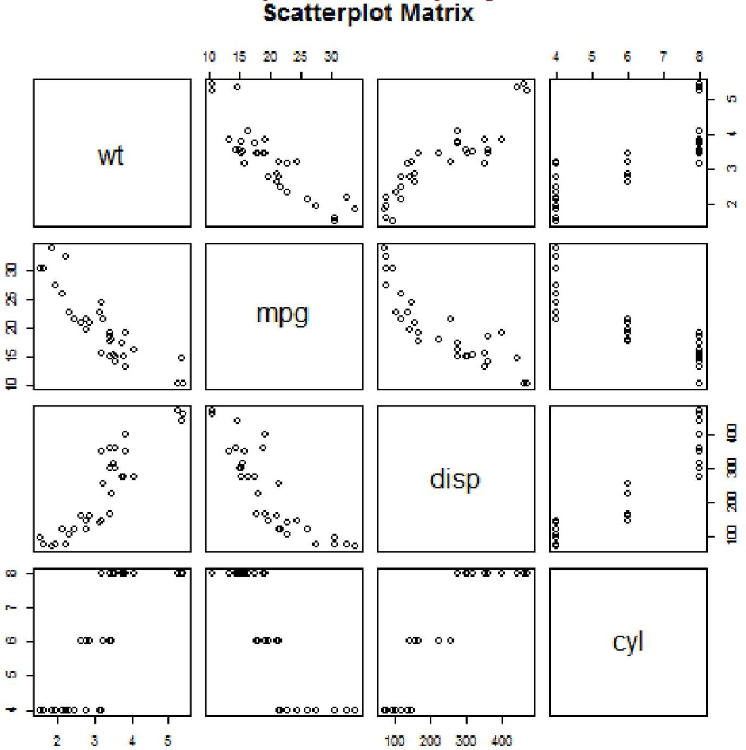

Fig. 7 Scatter Plot Matrix

**CONCLUSION:** Thus we have learnt Visualize the data using R/Python by plotting the graphs.

Assignment: 8

**AIM:** Perform different data visualization operations using Tableau

**PROBLEM STATEMENT /DEFINITION**

Study following data visualization operations using Tableau on Adult, Iris datasets or retail dataset.

1. 1D (Linear) Data visualization
2. 2D (Planar) Data Visualization
3. 3D (Volumetric) Data Visualization
4. Temporal Data Visualization
5. Multidimensional Data Visualization
6. Tree/ Hierarchical Data visualization
7. Network Data visualization

Perform the data visualization operations using Tableau to get answers to various business questions on Retail dataset.

1. Find and Plot top 10 products based on total sale
2. Find and Plot product contribution to total sale
3. Find and Plot the month wise sales in year 2010 in descending order
4. Find and Plot most loyal customers based on purchase order
5. Find and Plot yearly sales comparison
6. Find and Plot country wise total sales price and show on Geospatial graph
7. Find and Plot country wise popular product
8. Find and Plot bottom 10 products based on total sale
9. Find and Plot top 5 purchase order
10. Find and Plot most popular products based on sales
11. Find and Plot half yearly sales for the year 2011
12. Find and Plot country wise total sales quantity and show on Geospatial graph

**OBJECTIVE:**

To learn specialized data visualization tools.

To learn different types of data visualization techniques.

**SOFTWARE REQUIREMENTS:**

1. Ubuntu 16.04 / 18.04

1. Tableau

**THEORY:**

**Introduction:**

Data visualization or data visualization is viewed by many disciplines as a modern equivalent of visual communication. It involves the creation and study of the visual representation of data, meaning “information that has been abstracted in some schematic form, including attributes or variables for the units of information”.

Data visualization refers to the techniques used to communicate data or information by encoding it as visual objects (e.g., points, lines or bars) contained in graphics. The goal is to communicate information clearly and efficiently to users. It is one of the steps in data analysis or data science 1D/Linear

Examples:

* + lists of data items, organized by a single feature (e.g., alphabetical order) (not commonly visualized)

2D/Planar (especially geospatial) Examples (geospatial):

* + **choropleth**

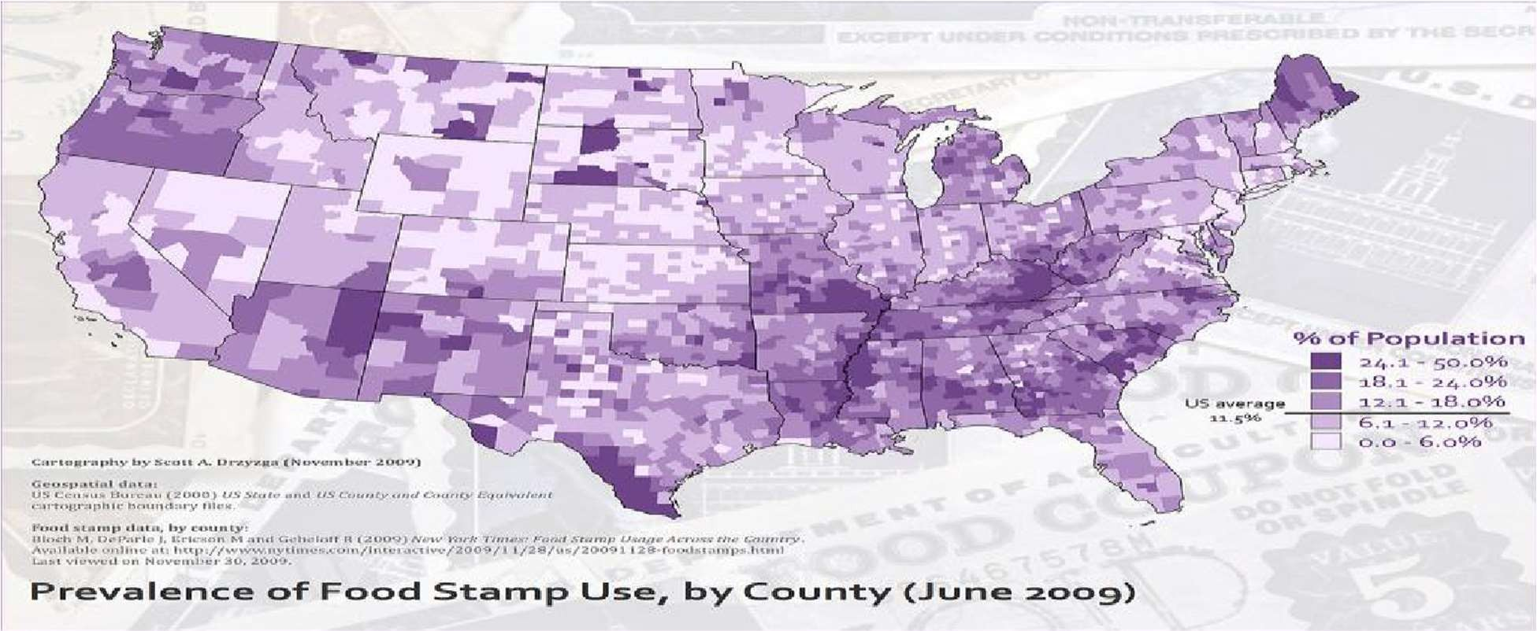

Fig. 1. Geospatial Graph

**3D/Volumetric:**

Broadly, examples of scientific visualization:

* + 3D computer models

In 3D computer graphics, **3D modeling** (or **three-dimensional modeling**) is the process of developing a mathematical representation of any *surface* of an object (either inanimate or living) in three dimensions via specialized software. The product is called a **3D model**. Someone who works with 3D models may be referred to as a **3D artist**. It can be displayed as a two-dimensional image through a process called *3D rendering* or used in a computer simulation of physical phenomena. The model can also be physically created using 3D printing devices.

* + surface and volume rendering

Rendering is the process of generating an image from a model, by means of computer programs. The model is a description of three-dimensional objects in a strictly defined language or data structure. It would contain geometry, viewpoint, texture, lighting, and shading information. The image is a digital image or raster graphics image. The term may be by analogy with an "artist's rendering" of a scene. 'Rendering' is also used to describe the process of calculating effects in a video editing file to produce final video output.

Volume rendering is a technique used to display a 2D projection of a 3D discretely sampled data set. A typical 3D data set is a group of 2D slice images acquired by a CT or MRI scanner. Usually these are acquired in a regular pattern (e.g., one slice every millimeter) and usually have a regular number of image pixels in a regular pattern. This is an example of a regular volumetric grid, with each volume element, or voxel represented by a single value that is obtained by sampling the immediate area surrounding the voxel.

* + Computer Simulations

Computer simulation is a computer program, or network of computers, that attempts to simulate an abstract model of a particular system. Computer simulations have become a useful part of mathematical modeling of many natural systems in physics, and computational physics, chemistry and biology; human systems in economics, psychology, and social science; and in the process of engineering and new technology, to gain insight into the operation of those systems, or to observe their behavior.[6] The simultaneous visualization and simulation of a system is called visualization.

**Temporal**

Examples:

* + **Timeline**

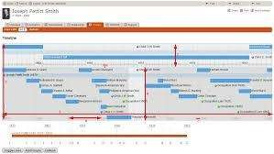

Fig.2 Timeline Graph Tools: SIMILE Timeline, TimeFlow, Timeline JS, Excel

Image: Friendly, M. & Denis, D. J. (2001). Milestones in the history of thematic cartography, statistical graphics, and data visualization.Web document, [http://www.datavis.ca/milestones/.Accessed:](http://www.datavis.ca/milestones/.Accessed) August 30, 2012.

* + **Time series:**

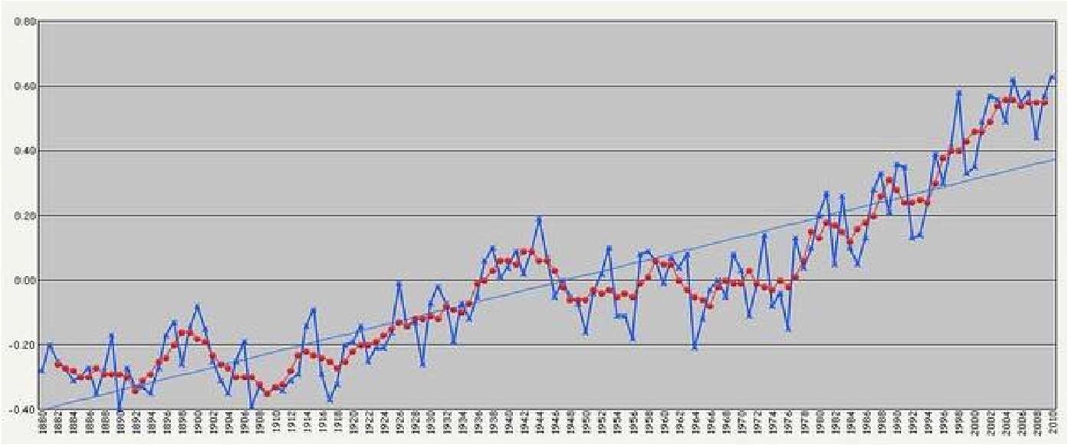

Fig.3Time Series

**Multidimensional:**

Examples (category proportions, counts):

* + **Histogram**

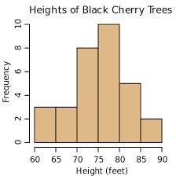

* + **pie chart**

Fig. 4 Histogram

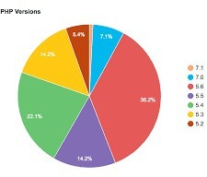

**Tree/Hierarchical Examples:**

* + **general tree visualization**

**Fig. 5 Pie Chart**

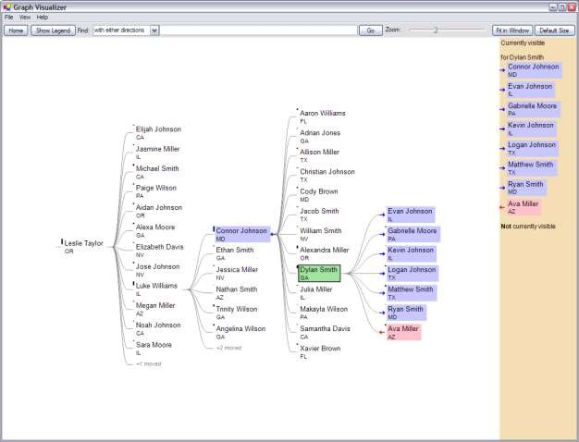

* + **Hierarchical Visualization:**

Fig. 6 Tree Graph

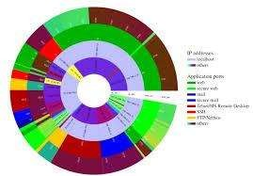

Fig. 7 Hierarchical Graph

* + 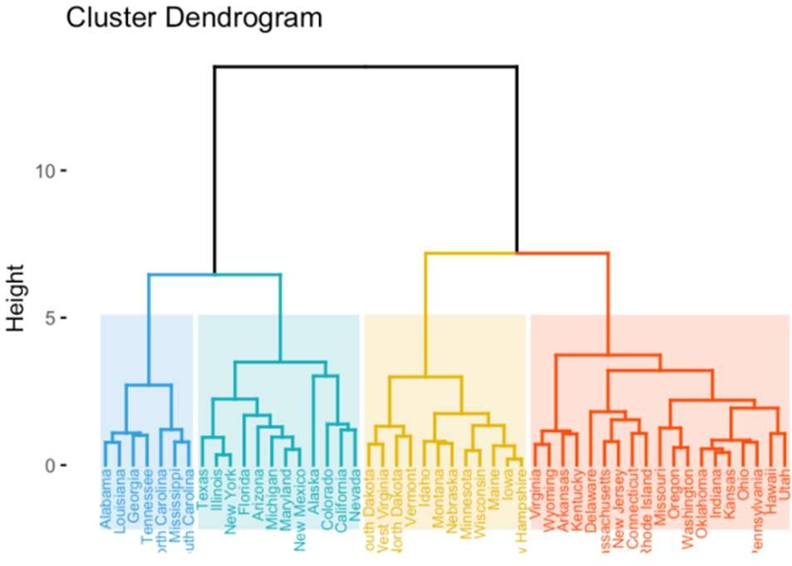**Dendrogram:**

Fig. 8 Dendogram

* + **Network:**
    - **node-link diagram (link-based layout algorithm)**

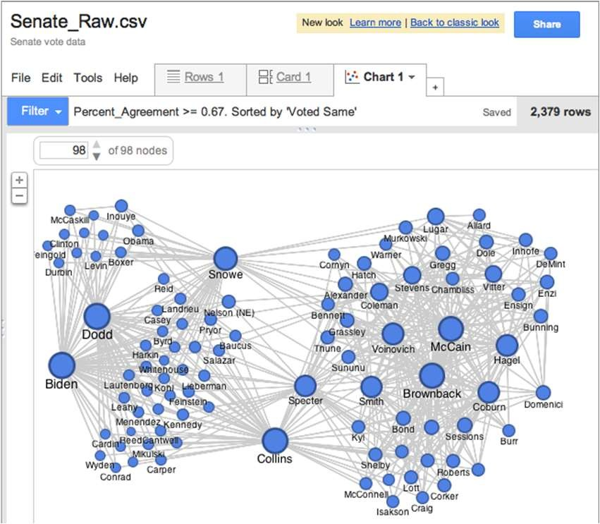

Fig. 9 Network Graph

* + - **matrix:**

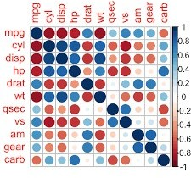

Fig. 10 Matrix Graph

* + - **node-link diagram (link-based layout algorithm)**

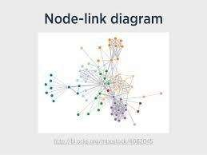

Fig. 11 Node Link Graph

**Tableau:**

Tableau is a Business Intelligence tool for visually analyzing the data. Users can create and distribute an interactive and shareable dashboard, which depict the trends, variations, and density of the data in the form of graphs and charts. Tableau can connect to files, relational and Big Data sources to acquire and process data. The software allows data blending and real-time collaboration, which makes it very unique. It is used by businesses, academic researchers, and many government organizations for visual data

analysis. It is also positioned as a leader Business Intelligence and Analytics Platform in Gartner Magic Quadrant.

**Tableau Features:**

Tableau provides solutions for all kinds of industries, departments, and data environments. Following are some unique features which enable Tableau to handle diverse scenarios.

* + **Speed of Analysis** − As it does not require high level of programming expertise, any user with access to data can start using it to derive value from the data.
  + **Self-Reliant** − Tableau does not need a complex software setup. The desktop version which is used by most users is easily installed and contains all the features needed to start and complete data analysis.
  + **Visual Discovery** − The user explores and analyzes the data by using visual tools like colors, trend lines, charts, and graphs. There is very little script to be written as nearly everything is done by drag and drop.
  + **Blend Diverse Data Sets** − Tableau allows you to blend different relational, semi structured and raw data sources in real time, without expensive up-front integration costs. The users don’t need to know the details of how data is stored.
  + **Architecture Agnostic** − Tableau works in all kinds of devices where data flows. Hence, the user need not worry about specific hardware or software requirements to use Tableau.
  + **Real-Time Collaboration** − Tableau can filter, sort, and discuss data on the fly and embed a live dashboard in portals like SharePoint site or Salesforce. You can save your view of data and allow colleagues to subscribe to your interactive dashboards so they see the very latest data just by refreshing their web browser.
  + **Centralized Data** − Tableau server provides a centralized location to manage all of the organization’s published data sources. You can delete, change permissions, add tags, and manage schedules in one convenient location. It’s easy to schedule extract refreshes and manage them in the data server. Administrators can centrally define a schedule for extracts on the server for both incremental and full refreshes.

There are three basic steps involved in creating any Tableau data analysis report.

These three steps are −

* + **Connect to a data source** − It involves locating the data and using an

appropriate type of connection to read the data.

* + **Choose dimensions and measures** − This involves selecting the required columns from the source data for analysis.
  + **Apply visualization technique** − This involves applying required visualization methods, such as a specific chart or graph type to the data being analyzed.

For convenience, let’s use the sample data set that comes with Tableau installation named sample

– superstore.xls. Locate the installation folder of Tableau and go to **My Tableau Repository**. Under it, you will find the above file at **Datasources\9.2\en_US-US.**

**Connect to a Data Source**

On opening Tableau, you will get the start page showing various data sources. Under the header **“Connect”**, you have options to choose a file or server or saved data source. Under Files, choose excel. Then navigate to the file **“Sample – Superstore.xls”** as mentioned above. The excel file has three sheets named Orders, People and Returns. Choose **Orders**.

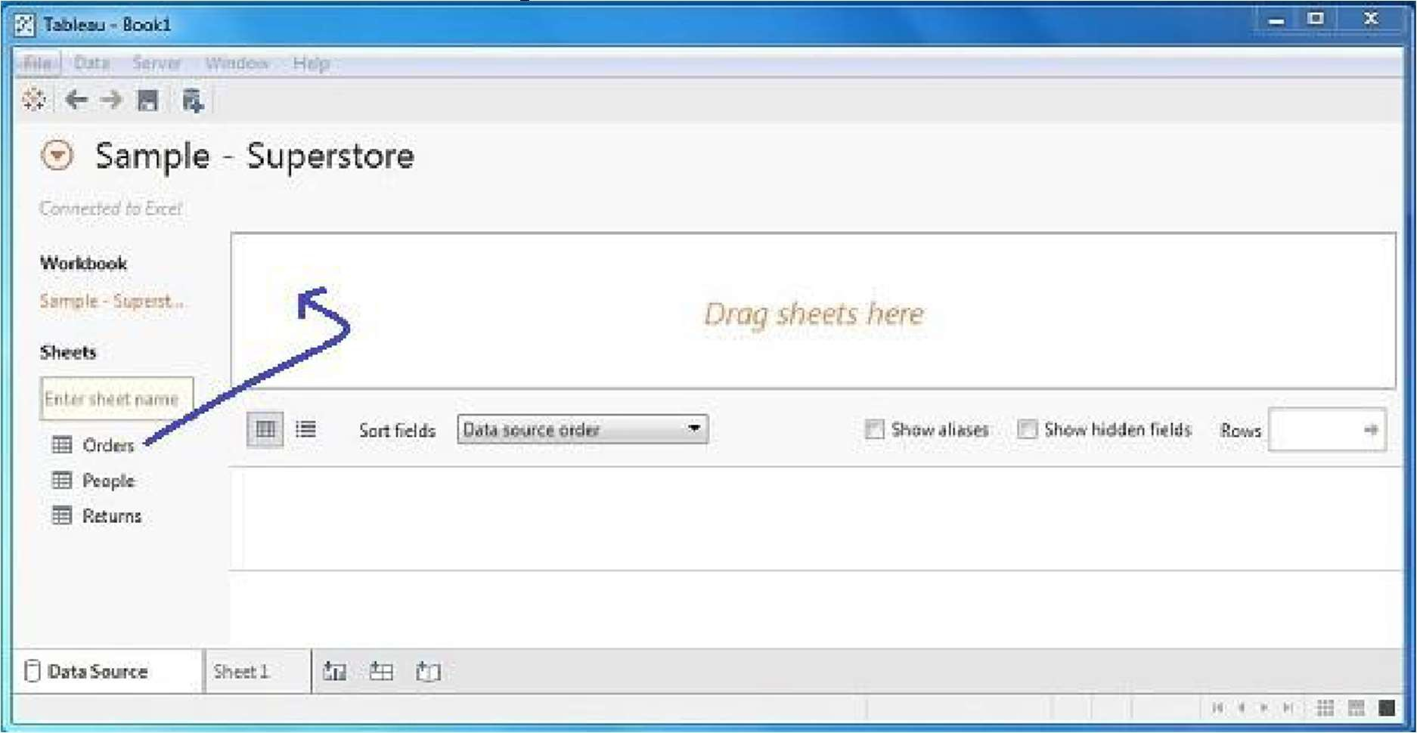

**Choose the Dimensions and Measures**

Next, choose the data to be analyzed by deciding on the dimensions and measures. Dimensions are the descriptive data while measures are numeric data. When put together, they help visualize the performance of the dimensional data with respect to the data which are measures. Choose **Category** and **Region** as the dimensions and **Sales** as the measure. Drag and drop them as shown in the following screenshot. The result shows the total sales in each category for each region.

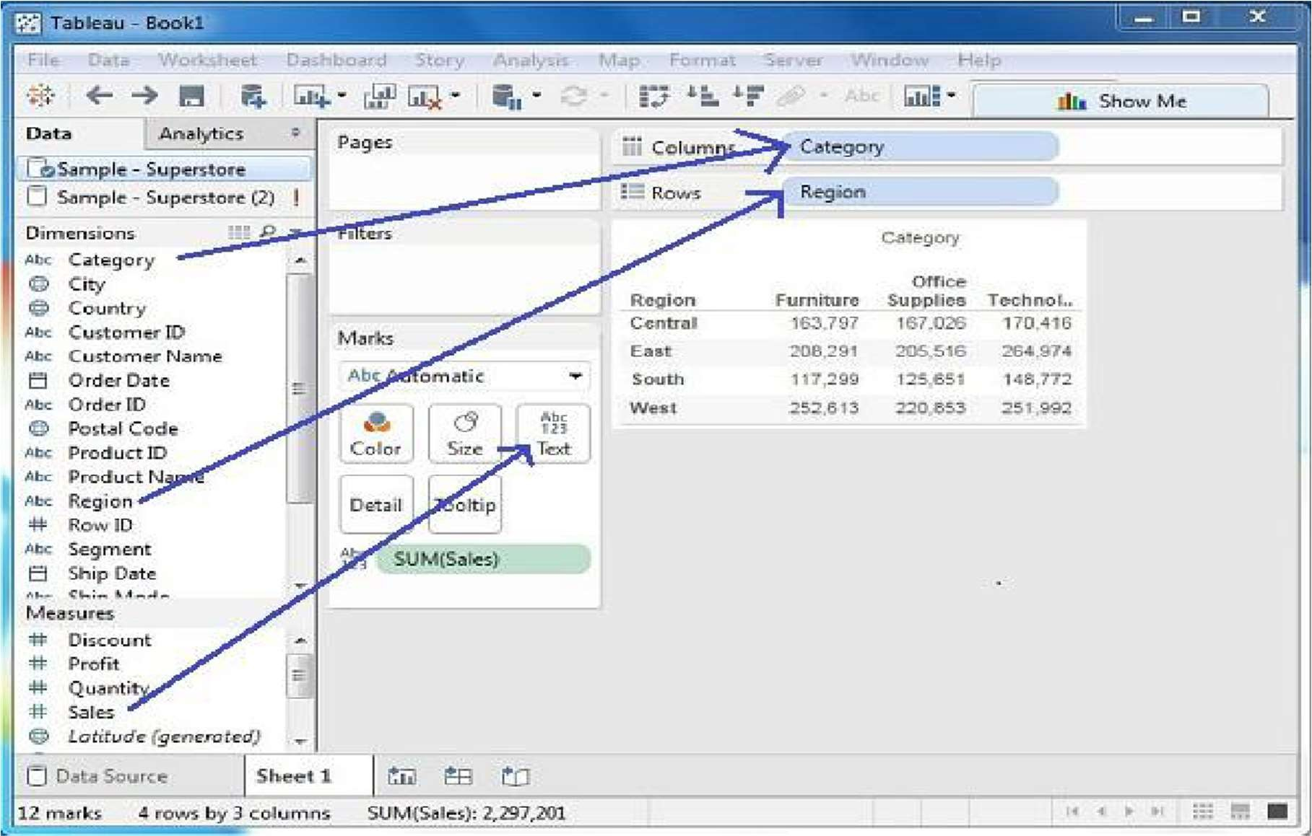

**Apply Visualization Technique**

In the previous step, you can see that the data is available only as numbers. You have to read and calculate each of the values to judge the performance. However, you can see them as graphs or charts with different colors to make a quicker judgment.

We drag and drop the sum (sales) column from the Marks tab to the Columns shelf. The table showing the numeric values of sales now turns into a bar chart automatically.

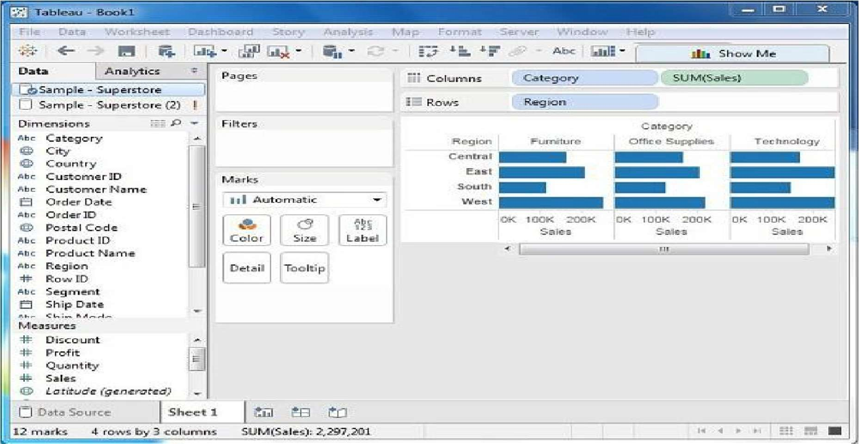

You can apply a technique of adding another dimension to the existing data. This will add more colors to the existing bar chart as shown in the following screenshot.

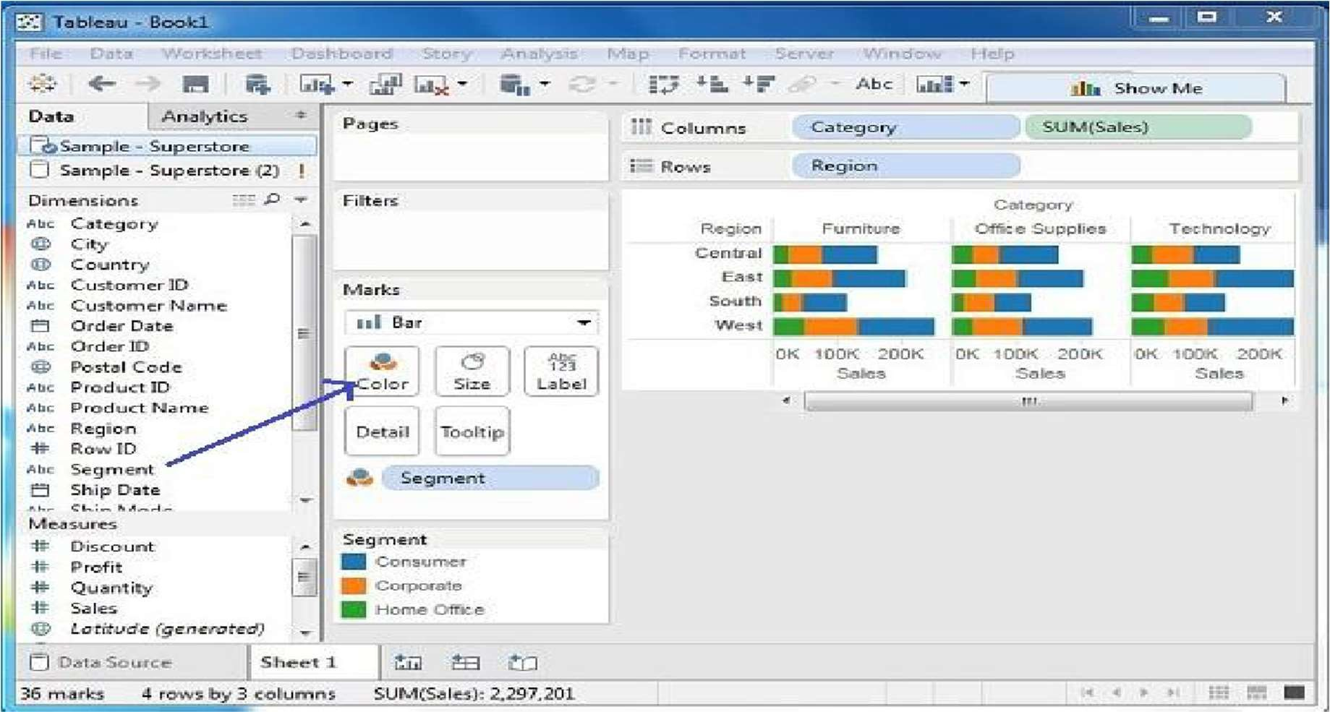

**Conclusion:** Thus we have learnt how to visualize the data in different types (1 1D (Linear) Data visualization,2D (Planar) Data Visualization, 3D (Volumetric)) Data Visualization, Temporal Data Visualization,Multidimensional Data Visualization, Tree/ Hierarchical Data visualization, Network Data visualization) by using Tableau Software.

Assignment: 9

**AIM** : To create a review scrapper for any ecommerce website

PROBLEM STATEMENT /DEFINITION

Create a review scrapper for any ecommerce website to fetch real time comments, reviews, ratings, comment tags, customer name using Python

OBJECTIVE

* To understand the concept of Web scraping
* To understand the methods used in web scraping.

THEORY:

Web scraping, web harvesting, or web data extraction is data scraping used for extracting data from websites. The web scraping software may directly access the World Wide Web using the Hypertext Transfer Protocol or a web browser. While web scraping can be done manually by a software user, the term typically refers to automated processes implemented using a bot or web crawler. It is a form of copying in which specific data is gathered and copied from the web, typically into a central local database or spreadsheet, for later retrieval or analysis. Web scraping a web page involves fetching it and extracting from it. [1]

Beautifulsoup4 library is used here to scrape the data.the required Python libraries: The request library to make network requests

To scrape data from a website, we need to extract the content of the webpage. Once the request is made to a website, the entire content of the webpage is available, and we can then evaluate the web content to extract data out from it. The content is made available in the form of plain text.

1. Thehtml5lib library for parsing HTML

Once the content is available, we need to specify the library that represents the parsing logic for the text available. We’ll be using the html5lib library to parse the text content to HTML DOM- based representation.

1. The beautifulsoup4 library for navigating the HTML tree structure

beautifulsoup4 takes the raw text content and parsing library as the input parameters. In our example, we have exposed html5lib as a parsing library. It can then be used to navigate and search for elements from the parsed HTML nodes. It can pull data out from the HTML nodes and extract/search required nodes from HTML structure.

Making the Request for the Web Content

Let's make the web request for the website to be scraped. We will be using the requests library. To start using the requests library, we need to install the third-party library using the following command

pip install requests

We will be scrapping the amazon e-commerce website for customer name,ratings and reviews. Let’s first make a request to extract the content for the specified website. request.get makes a request to the webpage, which returns back the raw HTML content.

CODE:

**from bs4 import BeautifulSoup as bs import requests**

**link='https://**[**www.amazon.in/OnePlus-Mirror-Black-128GB-Storage/product-**](http://www.amazon.in/OnePlus-Mirror-Black-128GB-Storage/product-) **reviews/B07DJHV6VZ/ref=cm_cr_dp_d_show_all_btm?ie=UTF8&reviewerType=all_ reviews'**

**page = requests.get(link) page**

**soup = bs(page.content,'html.parser') print(soup.prettify())**

**names = soup.find_all('span',class_='a-profile-name')**

**names**

**[<span class="a-profile-name">Tanmay Shukla</span>,**

**<span class="a-profile-name">Surbhi Garg</span>,**

**<span class="a-profile-name">Tanmay Shukla</span>,**

**<span class="a-profile-name">Surbhi Garg</span>,**

**<span class="a-profile-name">Saroj N.</span>,**

**<span class="a-profile-name">klknow</span>,**

**<span class="a-profile-name">abdulkadir garari</span>,**

**<span class="a-profile-name">Mani</span>,**

**<span class="a-profile-name">Anshu K.</span>,**

**<span class="a-profile-name">Sneha</span>,**

**<span class="a-profile-name">nagaraj s.</span>,**

**<span class="a-profile-name">Aakash Sinha</span>]**

**#Extracting customer names cust_name = []**

**for i in range(0,len(names)): cust_name.append(names[i].get_text())**

**Cust_name**

**['Tanmay Shukla', 'Surbhi Garg', 'Tanmay Shukla', 'Surbhi Garg', 'Saroj N.',**

**'klknow', 'abdulkadir garari', 'Mani',**

**'Anshu K.',**

**'Sneha',**

**'nagaraj s.', 'Aakash Sinha']**

**#Extracting Review title.**

**title = soup.find_all('a',class_='review-title-content') title**

**[<a class="a-size-base a-link-normal review-title a-color-base review- title-content a-text-bold" data-hook="review-title" href="/gp/customer- reviews/RG52NAY3E12BR?ASIN=B07DJHV6VZ">**

**<span>Flagship Killer</span>**

**</a>,**

**<a class="a-size-base a-link-normal review-title a-color-base review- title-content a-text-bold" data-hook="review-title" href="/gp/customer- reviews/R1EE0UTB5657D6?ASIN=B07DJHV6VZ">**

**<span>Camera quality is very poor.</span>**

**</a>,**

**<a class="a-size-base a-link-normal review-title a-color-base review- title-content a-text-bold" data-hook="review-title" href="/gp/customer- reviews/R15DF987OXR3ES?ASIN=B07DJHV6VZ">**

**<span>Worst phone</span>**

**</a>,**

**<a class="a-size-base a-link-normal review-title a-color-base review- title-content a-text-bold" data-hook="review-title" href="/gp/customer- reviews/R33GOMNOW0H21X?ASIN=B07DJHV6VZ">**

**<span>Dead on arrival</span>**

**</a>,**

**<a class="a-size-base a-link-normal review-title a-color-base review- title-content a-text-bold" data-hook="review-title" href="/gp/customer- reviews/R22HPI22GRD028?ASIN=B07DJHV6VZ">**

**<span>Not worth to buy 6T</span>**

**</a>,**

**<a class="a-size-base a-link-normal review-title a-color-base review- title-content a-text-bold" data-hook="review-title" href="/gp/customer- reviews/R1EJO3TGNM3R9X?ASIN=B07DJHV6VZ">**

**<span>Battery problem and disappointing customer support.</span>**

**</a>,**

**<a class="a-size-base a-link-normal review-title a-color-base review- title-content a-text-bold" data-hook="review-title" href="/gp/customer- reviews/RP84LWZU2465S?ASIN=B07DJHV6VZ">**

**<span>Beautiful phone</span>**

**</a>,**

**<a class="a-size-base a-link-normal review-title a-color-base review- title-content a-text-bold" data-hook="review-title" href="/gp/customer- reviews/R2LUMMIRPSJBC0?ASIN=B07DJHV6VZ">**

**<span>Only one side of speakers is working</span>**

**</a>,**

**<a class="a-size-base a-link-normal review-title a-color-base review- title-content a-text-bold" data-hook="review-title" href="/gp/customer- reviews/R17C4CZRJA22GP?ASIN=B07DJHV6VZ">**

**<span>Awesome value for the money</span>**

**</a>,**

**<a class="a-size-base a-link-normal review-title a-color-base review- title-content a-text-bold" data-hook="review-title" href="/gp/customer- reviews/R3E54TMP6XTNA4?ASIN=B07DJHV6VZ">**

**<span>OnePlust 6T McLaren Edition - Salute to Speed!</span>**

**</a>]**

#Similarly all the required fields are scraped and dataframe is formed as given below

import pandas as pd

df = pd.DataFrame() df['Customer Name']=cust_name df['Review title']=review_title df['Ratings']=rate df['Reviews']=review_content

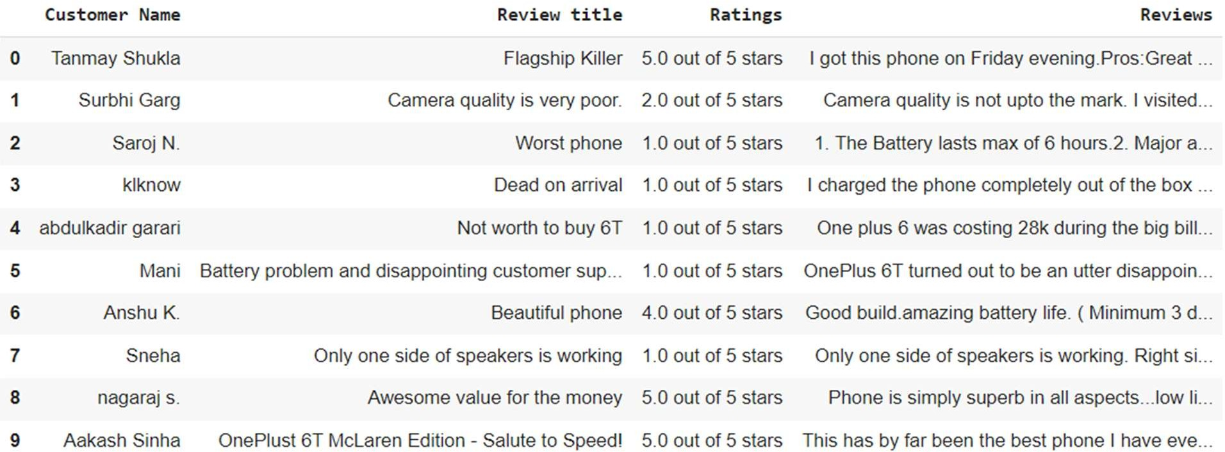df

**#dataframe is converted to csv file**

**df.to_csv(r'E:\reviews.csv',index=True)**

CONCLUSION:

Beautiful Soup was used to scrape customer reviews from amazon Website.

REFERENCES :

1. Web scraping,Wikipedia

**Part C**

**Model Implementation**

**Assignment: 09**

**Aim:** Create a review scrapper for any ecommerce website to fetch real time comments, reviews, ratings, comment tags, customer name using Python.

**Theory:**

**Example:**

**References:**

**Conclusion:** Thus we have understood the practical use of scrapper.

**Assignment: 10 AIM:** Design and Implement Mini Project in Data Science **PROBLEM STATEMENT /DEFINITION**

Design and Implement any Data science Application using R/Python. Obtain Data, Scrub data (Data cleaning), Explore data, Prepare and validate data model and Interpret data (Data Visualization). Visualize data using any visualization tool like Matplotlib, ggplot, Tableau etc. Prepare Project Report.

**OBJECTIVE:**

* 1. To explore the Data science project life cycle.
  2. To identify need of project and define problem statement.
  3. To extract and process data.
  4. To interpret and analyze results using data visualization.

**Mini Project Report Format:**

**Abstract Acknowledgement**

**List of Tables & Figures Contents**

1. **Introduction**
   1. **Purpose, Problem statement**
   2. **Scope, Objective**
   3. **Definition, Acronym, and Abbreviations**
   4. **References**
2. **Literature Survey**
   1. **Introduction**
   2. **Detail Literature survey**

**2.4 Findings of Literature survey**

1. **System Architecture and Design**
   1. **Detail Architecture**
   2. **Dataset Description**
   3. **Detail Phases 3.4Algorithms**
2. **Experimentation and Results**
   1. **Phase-wise results**
   2. **Explanation with example**
   3. **Comparison of result with standard 4.4Accuracy**
   4. **Visualization**
   5. **Tools used**
3. **Conclusion and Future scope**
   1. **Conclusion**
   2. **Future scope References**

**Annexure:**

1. GUIs / Screen Snapshot of the System Developed
2. Implementation /code